Homework
Please find below three English tasks and three Mathematics tasks for children to complete for their homework this week. Our recommendation is that children complete Task 1 for English and Maths on Tuesday, Task 2 for both on Wednesday and Task 3 for both on Thursday. This short, frequent style of homework will support children to consolidate their learning. Please find the answers on the class page. The expectation is that children mark alongside parents/carers or self-mark.

English
Task 1:  Grammar and punctuation | Task 2:  Reading – phonics cards | Task 3:  Spelling
Write the following sentences correctly using capital letters and full stops.  Remember to form your letters carefully and write on the line.  You cancome to my party  i saw a cute cat today  the girl can play the flute | Practise the following sounds:  Recapping  u-e – rude/cute  What other words can you write using this diagraph? | Follow the Look, Say, Cover, Write, Check process for the following words this week:  - some  - come  - go  - of  - he

Mathematics
Task 1:  Fluency | Task 2:  Varied Fluency | Task 3:  Reasoning
Complete the number formation sheet. | Complete the number square to practice counting to 50. | Estimate the numbers the arrows are pointing to.  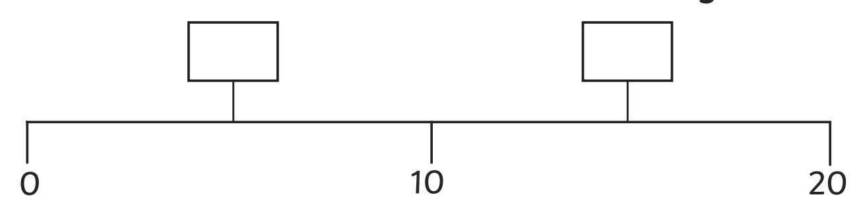

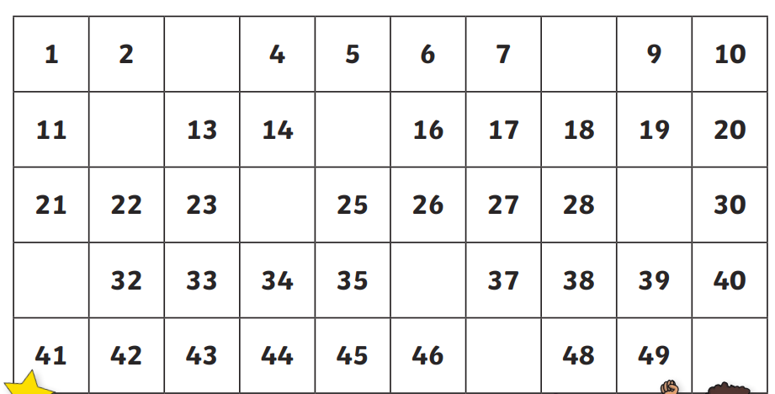
Maths

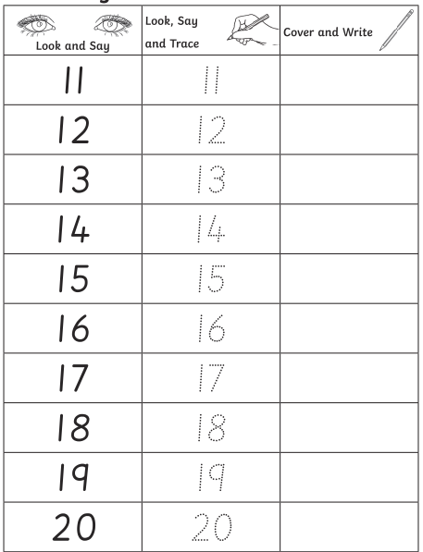

Answers

English task 1
You can come to my party.
I saw a cute cat today.
The girl can play the flute.

English task 2
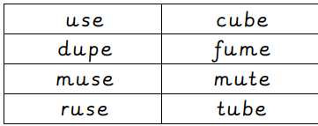

Maths


