Homework
Please find below three English tasks and three Mathematics tasks for children to complete for their homework this week. Our recommendation is that children complete Task 1 for English and Maths on Tuesday, Task 2 for both on Wednesday and Task 3 for both on Thursday. This short, frequent style of homework will support children to consolidate their learning. Please find the answers on the class page. The expectation is that children mark alongside parents/carers or self-mark.
Children are to hand in their homework on Monday morning, alongside their reading record.
English
Task 1:  Grammar and Punctuation | Task 2:  Reading/Phonics | Task 3:  Spelling Pattern
Find the Adjectives in the three sentences. Then write three sentences of your own.  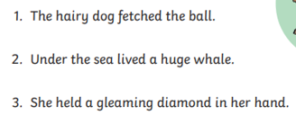 | ‘air’ and the alternatives. Write the words to match the picture.  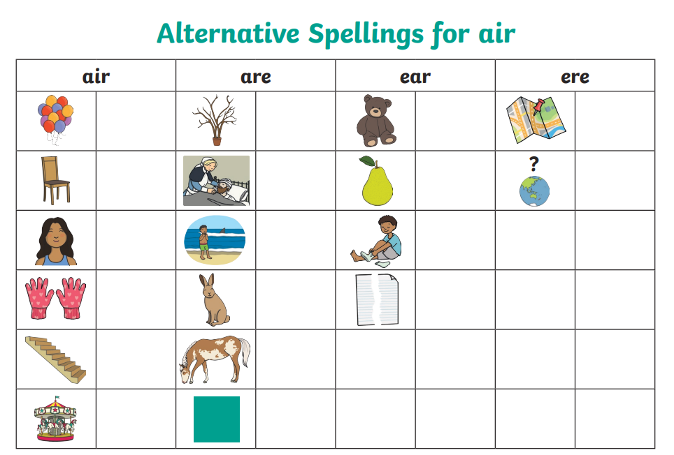. | Spellings  worm  would  tear  full  dare  where  two  school  Please practise these words throughout the week.

Mathematics
Task 1:  Fluency | Task 2:  Varied Fluency | Task 3:  Reasoning
In Maths we have been practising addition.  Build your fluency finding ten more and ten less by helicopter rescue. Select the game ‘count on and count back – across tens – 1 to 100’  www.topmarks.co.uk/learning-to-count/helicopter-rescue | Complete the varied fluency sheet.  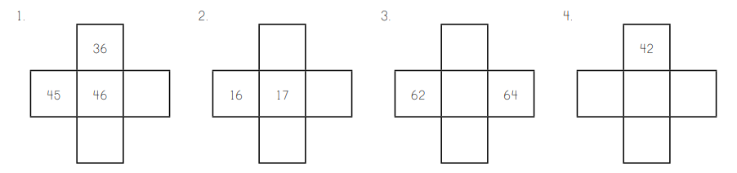  Remember you can use a 100 square to support if you need it. | Complete the reasoning problems.  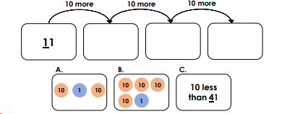

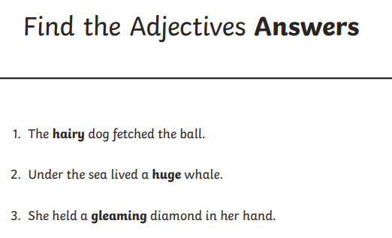

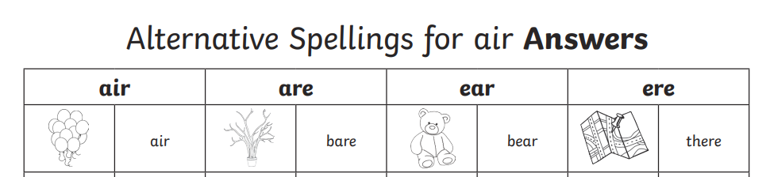

31 ©
41 (B)
21 (A)
47
27
7
18
56

