Adapted Week 8 Homework
Please find below three English tasks and three Mathematics tasks for children to complete for their homework this week. Our recommendation is that children complete Task 1 for English and Maths on Tuesday, Task 2 for both on Wednesday and Task 3 for both on Thursday. This short, frequent style of homework will support children to consolidate their learning. Please find the answers on the class page. The expectation is that children mark alongside parents/carers or self-mark.
Children are to hand in their homework on Monday morning, alongside their reading record.
English
Task 1:  Grammar and punctuation: parenthesis | Task 2:  Reading comprehension | Task 3:  Spelling Pattern
1. Add brackets around the extra information:  a) John a brave soldier helped his friends.  b) The dog a small puppy slept on the sofa.  2. Add commas in the correct places.  a) John a kind man helped the soldiers.  b) The piano which was very old stood in the room.  3. Add two dashes in the correct place.  a) John a brave medic saved his friend.  b) The battlefield a dangerous place was very noisy. | 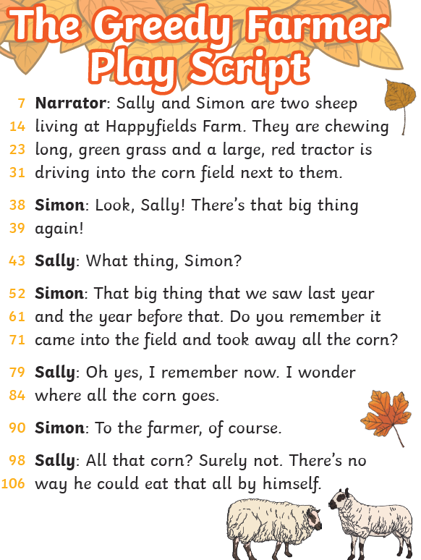 | (handwriting practise on the next page, the chosen font shows which letters should be joined).  Clothes  Cold  Door  Even  Every
Comprehension Questions
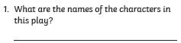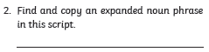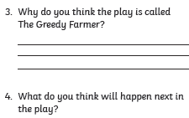

door
even
every
clothes
cold

Mathematics
Task 1:  Fluency | Task 2:  Varied Fluency | Task 3:  Reasoning
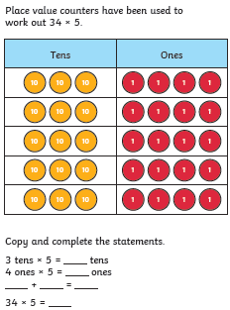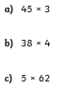 | 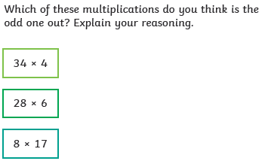 | 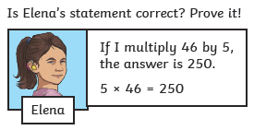

Answers
English
Grammar and punctuation  a) John (a brave soldier) helped his friends.  b) The dog (a small puppy) slept on the sofa.  a) John, a kind man, helped the soldiers.  b) The piano, which was very old, stood in the room.  a) John – a brave medic – saved his friend.  b) The battlefield – a dangerous place – was very noisy. | 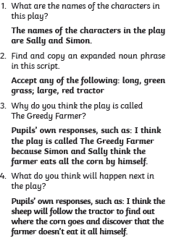
Maths
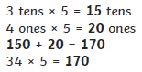
45 x 3 = 135
38 x 4 = 152
5 x 62 = 310


