Homework
Please find below three English tasks and three Mathematics tasks for children to complete for their homework this week. Our recommendation is that children complete Task 1 for English and Maths on Tuesday, Task 2 for both on Wednesday and Task 3 for both on Thursday. This short, frequent style of homework will support children to consolidate their learning. The expectation is that children mark alongside parents/carers or self-mark.

English
Task 1:  Grammar and punctuation | Task 2:  Reading – phonics cards | Task 3:  Spelling
Write the following sentences correctly using capital letters, full stops and finger spaces.  Remember to form your letters carefully and write on the line.  i need to findsome paper.  thetiger is stuck in the mud  my mum is going to the shop | Practise the following sounds: (recapping)  a – paper  i– tiger  What other words can you write using these sounds?  What objects can you find in your home with these sounds? | Follow the Look, Say, Cover, Write, Check process for the following words this week:  - Said  - Have  - Like  - They  - Sure

Mathematics
Task 1: | Task 2: | Task 3:
Practice counting to 50!  Use the number square to help if you get stuck. | Complete number formation sheet. | Draw dienes to match the numbers. Remember to think carefully about your tens and ones.  23  34  27  16  41

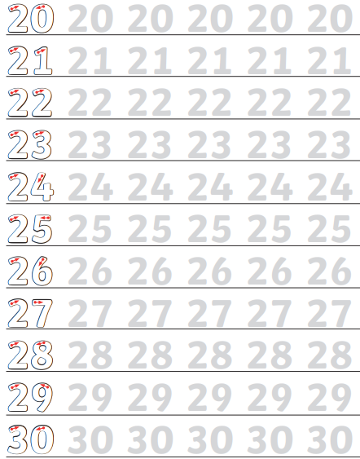

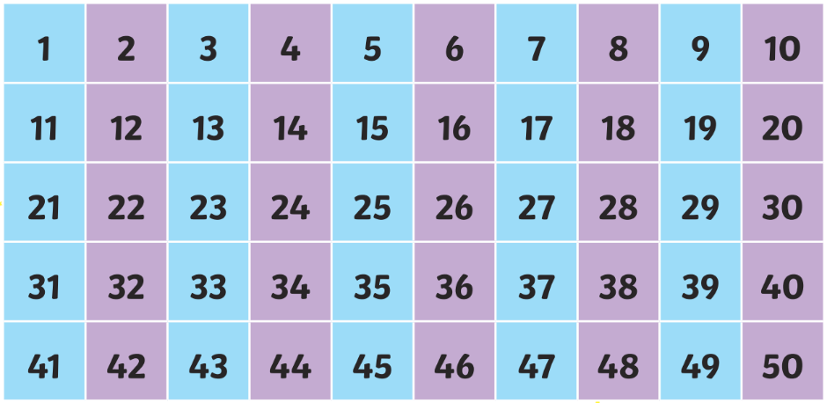

Answers English 1
I need to find some paper.
The tiger is stuck in the mud.
My mum is going to the shop.

Answers English 2

a  paper acorn table baking chasing basic later | i  wild child kind find tiger lion pilot hi ivy silent

Answers Maths 3


