Adapted Week 7 Homework
Please find below three English tasks and three Mathematics tasks for children to complete for their homework this week. Our recommendation is that children complete Task 1 for English and Maths on Tuesday, Task 2 for both on Wednesday and Task 3 for both on Thursday. This short, frequent style of homework will support children to consolidate their learning. Please find the answers on the class page. The expectation is that children mark alongside parents/carers or self-mark.
Children are to hand in their homework on Monday morning, alongside their reading record.
English
Task 1:  Grammar and punctuation: Relative clauses | Task 2:  Reading comprehension | Task 3:  Spelling Pattern
1. Circle the correct relative pronoun.  a) The soldier, who/which, was brave.  b) The dog, who / which, barked loudly.  c) The hospital, who / where, was very busy.  2. Match the sentences to the correct relative clause | 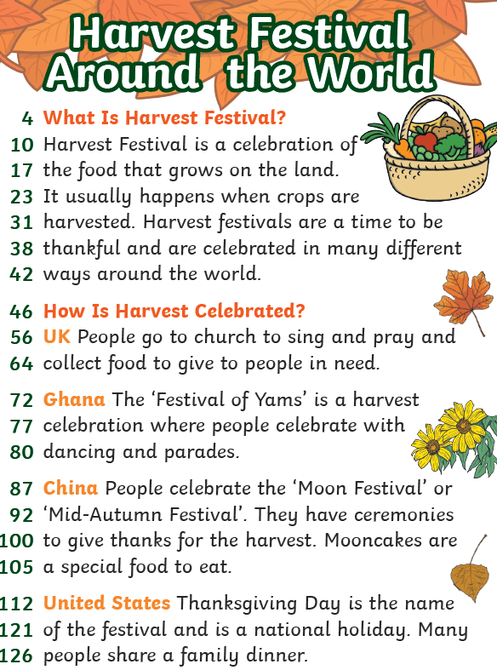 | (handwriting practise on the next page, the chosen font shows which letters should be joined).  Child  Children  Christmas  Class  Climb
  Sentence beginning |  | Relative clause
  The soldier, |  | Which was very heavy
  The bag, |  | Who help the injured man
  The hospital, |  | Where the soldiers rested

Comprehension Questions
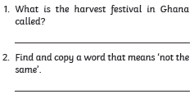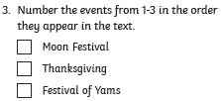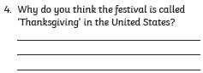

Christmas
class
climb
child
children

Mathematics
Task 1:  Fluency | Task 2:  Varied Fluency | Task 3:  Reasoning
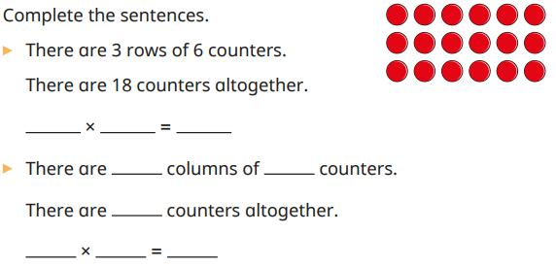 | 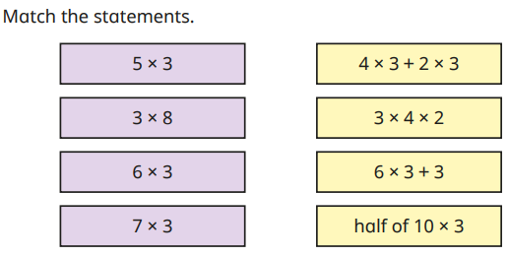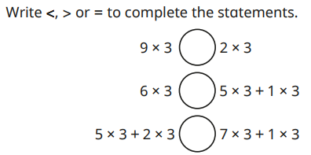 | 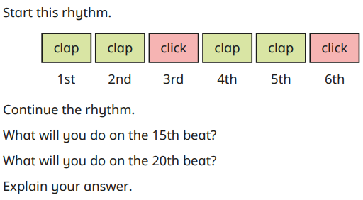

Answers
English
Grammar and punctuation  a) who, b) which, c) where. (For the dog, who can also be used when treating it as an individual.)  2.  - The soldier, who helped the injured men, …  - The bag, which was very heavy, …  - The hospital, where the soldiers rested, … |  |  | 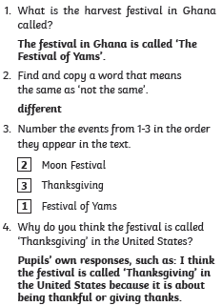
Maths
1. Complete the sentences  Rows:  There are 3 rows of 6 counters.  There are 18 counters altogether.  3 × 6 = 18  Columns:  There are 6 columns of 3 counters.  There are 18 counters altogether.  6 × 3 = 18 | 2. Match the statements  Important: The matching activity appears to contain an error. The two remaining expressions do not equal their corresponding multiplication facts.  - 6 × 3 = 18, but 6 × 3 + 3 = 21.  - 7 × 3 = 21, but 4 × 3 + 2 × 3 = 18.  3. Write <, > or =  a) 9 × 3 > 2 × 3  27 > 6  b) 6 × 3 < 5 × 3 + 1 × 3  18 = 18  Correct symbol: =  c) 5 × 3 + 2 × 3 < 7 × 3 + 1 × 3  21 < 24 | 4. Sort this rhythm  The rhythm repeats every 3 beats:  Clap – Clap – Click  - 15th beat: Click  - 20th beat: Clap  Explanation:  The rhythm repeats every 3 beats.  15 ÷ 3 = 5, so the 15th beat is the last action in the pattern: Click.  20 ÷ 3 = 6 remainder 2, so the 20th beat is the second action in the pattern: Clap.
  Multiplication | Matching statement
  5 × 3 | Half of 10 × 3
  3 × 8 | 3 × 4 × 2
  6 × 3 | 6 × 3 + 3 (not equal)
  7 × 3 | 4 × 3 + 2 × 3 (not equal)

