Homework
Please find below three English tasks and three Mathematics tasks for children to complete for their homework this week. Our recommendation is that children complete Task 1 for English and Maths on Tuesday, Task 2 for both on Wednesday and Task 3 for both on Thursday. This short, frequent style of homework will support children to consolidate their learning.
English
Task 1:  Grammar and punctuation | Task 2:  Reading – phonics cards | Task 3:  Spelling
Write the following sentences correctly using capital letters, finger spaces and full stops.  Remember to form your letters carefully and write on the line.  It was rainingtoday  the toywas left on the floor  my mum said i can go tothe park | Practise the following sounds: (recapping)  Oy – toy  Ai - rain  What other words can you write using these sounds?  What objects can you find in your home with these sounds? | Follow the Look, Say, Cover, Write, Check process for the following words this week:  - By  - Be  - Push  - Go  - As  - Is

Mathematics
Task 1:  Fluency | Task 2:  Varied Fluency | Task 3:  Reasoning
Collect different items from around your house or outside. For example:  - Toys  - Spoons  - Socks  - Leaves  - Stones  - Crayons  Put the items into groups and count them carefully.  Practice counting to 20 or above. | See attached number formation sheet. | Complete the number lines by filling in the missing numbers. Take your time and make sure each digit is written in the correct place.

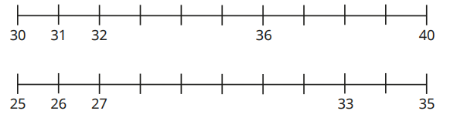

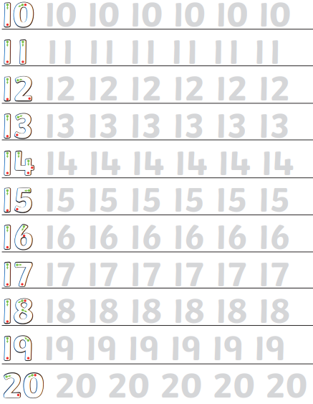

Answers English task 1
It was raining today.
The toy was left on the floor.
My mum said I can go to the park.

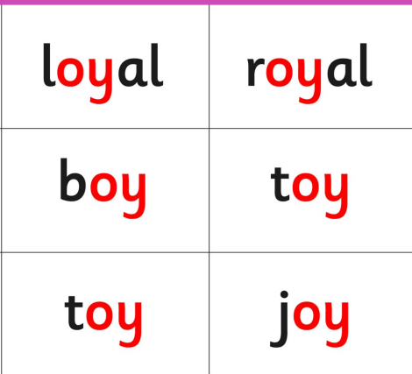
Answers English Task 2


