Homework
Please find below three English tasks and three Mathematics tasks for children to complete for their homework this week. Our recommendation is that children complete Task 1 for English and Maths on Tuesday, Task 2 for both on Wednesday and Task 3 for both on Thursday. This short, frequent style of homework will support children to consolidate their learning.
English
Task 1:  Grammar and punctuation | Task 2:  Reading – phonics cards | Task 3:  Spelling
Write the following sentences correctly using capital letters, finger spaces and full stops.  Remember to form your letters carefully and write on the line.  i went tothe shop to get a blue book  the big dogran after the rabbit  we can sit in the sun today | Practise the following sounds: (recapping)  Ue (oo/yoo) – blue/rescue  ie – pie  What other words can you write using these sounds?  What objects can you find in your home with these sounds? | Follow the Look, Say, Cover, Write, Check process for the following words this week:  - All  - Was  - He  - No  - And  - the

Mathematics
Task 1:  Fluency | Task 2:  Varied Fluency | Task 3:  Reasoning
Practice counting to 50!  Here is a YouTube video we like to use in school – only use YouTube with an adult.  I Can Count to 50 NOW! | Jack Hartmann (youtube.com) | See attached number formation sheet. | Collect items from around your home (socks, pencils, pasta shells) make groups, and compare them using the language greater than and less than.  e.g.      is greater than

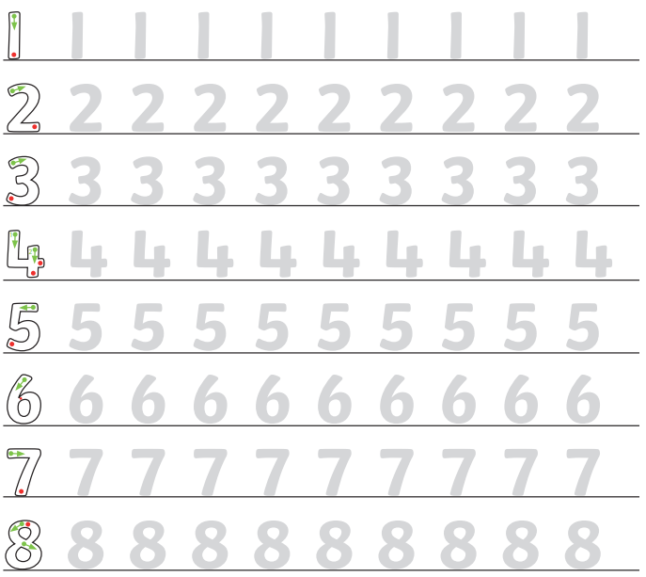

Answers English task 1
I went to the shop to get a blue book.
The big dog ran after the rabbit.
We can sit in the sun today.
Answers English Task 2
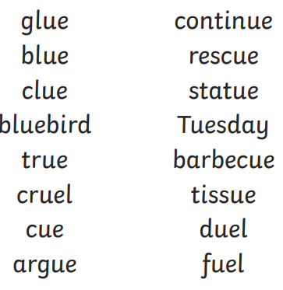
Tried
Cried
Lie
Pie
tie

