Adapted Week 5 Homework
Please find below three English tasks and three Mathematics tasks for children to complete for their homework this week. Our recommendation is that children complete Task 1 for English and Maths on Tuesday, Task 2 for both on Wednesday and Task 3 for both on Thursday. This short, frequent style of homework will support children to consolidate their learning. Please find the answers on the class page. The expectation is that children mark alongside parents/carers or self-mark.
Children are to hand in their homework on Monday morning, alongside their reading record.
English
Task 1:  Grammar and punctuation: relative clauses | Task 2:  Reading comprehension | Task 3:  Spelling Pattern
- Choose the best relative pronoun.  The soldier, ___ was tired, walked back to camp.  who / which  - Finish the relative clause.  Edward, who was __________, walked beside me.  Ideas: tired / worried / cold / kind  - Add extra information using who.  The medic helped the soldier.  The medic, who was __________, helped the soldier.  Ideas: brave / worried / kind / tired  - The soldier walked towards the building.  Add extra information about the soldier using who.  The soldier, __________________________, walked towards the building. | 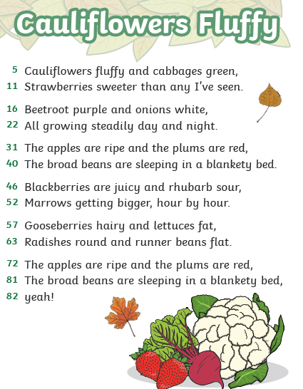 | (handwriting practise on the next page, the chosen font shows which letters should be joined).  After  Again  Any  Bath  Beautiful

Comprehension Questions
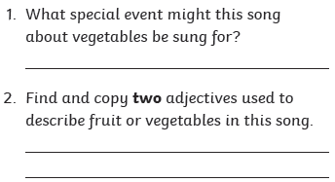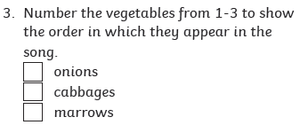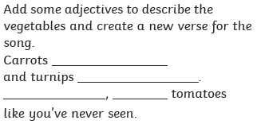


any
bath
beautiful
again
after

Mathematics
Task 1:  Fluency | Task 2:  Varied Fluency | Task 3:  Reasoning
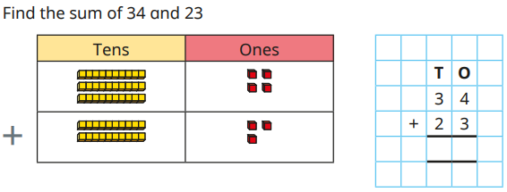  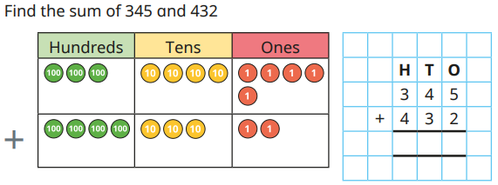 | 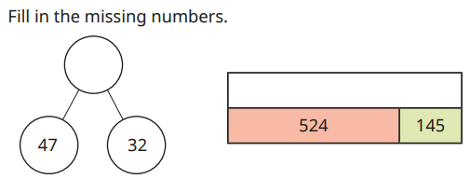 | 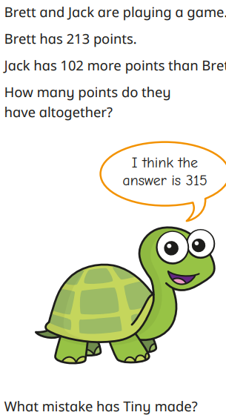

Answers
English
Grammar and punctuation  NB Words added to the line may be different. We have suggested an example to support you.  - Who  - Tired  - Worried  - ,who carried his rifle, |  | 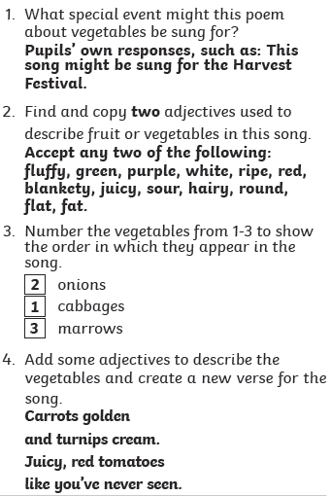
Maths
- 57  - 777 | - 79  - 669 |  | Jack has 102 more points, so he has 315 points.  Jack and Brett have 315 + 213 points’ altogether which is 528.

