Homework
Please find below three English tasks and three Mathematics tasks for children to complete for their homework this week. The expectation is that children mark alongside parents/carers or self-mark.

English
Task 1: | Task 2: | Task 3:
Write the following sentences correctly using capital letters and full stops.  Remember to form your letters carefully and write on the line.  i like to read my book  i can see my toys  the dog wants to play | Letter formation practice – see attached sheet | Follow the Look, Say, Cover, Write, Check process for the following words this week:  - Are  - You  - Of  - To  - Has  - Put

Mathematics
Task 1:  Fluency | Task 2:  Varied Fluency | Task 3:  Reasoning
Practice your number formation by writing your numbers to 20!  You could use crayons, chalk or any thing you would like! | 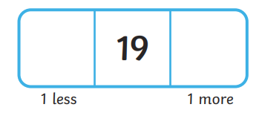  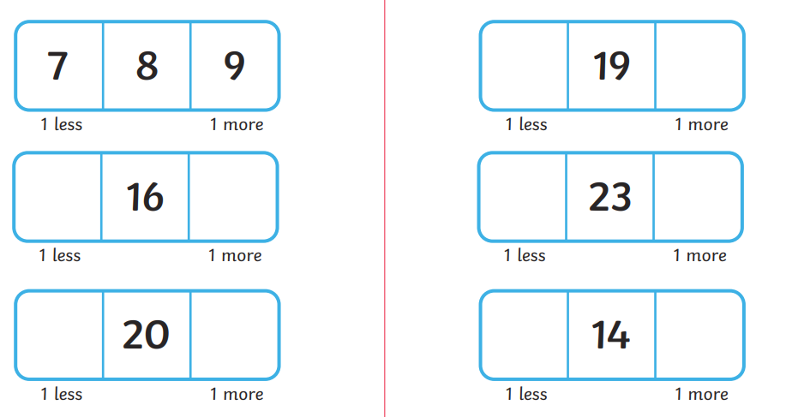 | What are my missing numbers?
  11 |  |  | 14
   | 16 |  | 18

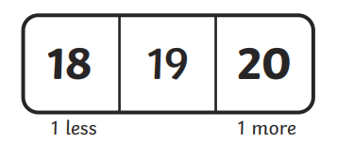
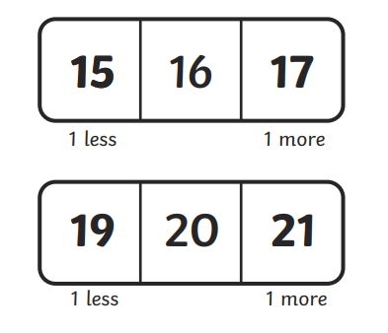
Answers Maths Task 2

Answers Maths Task 3
11 | 12 | 13 | 14
15 | 16 | 17 | 18

Answers English Task 1

I like to read my book.
I can see my toys.
The dog wants to play.



