Adapted Week 4 Homework
Please find below three English tasks and three Mathematics tasks for children to complete for their homework this week. Our recommendation is that children complete Task 1 for English and Maths on Tuesday, Task 2 for both on Wednesday and Task 3 for both on Thursday. This short, frequent style of homework will support children to consolidate their learning. Please find the answers on the class page. The expectation is that children mark alongside parents/carers or self-mark.
Children are to hand in their homework on Monday morning, alongside their reading record.
English
Task 1:  Grammar and punctuation: | Task 2:  Reading comprehension | Task 3:  Spelling Pattern
LI: To improve a sentence using a noun phrase  Copy these sentences into your books and underline the noun phrases.  Add an adjective to create your own noun phrases.  For example: The sun was in the sky becomes the hot sun was in the blue sky.  - The scared Pilgrims sailed the ……. sea to America.  - Above them in the ……. clouds, flew squawking gulls.  - As they got closer, they noticed the rocky land and …… trees.  - In the distance, a friendly Squanto noticed the …………….. Pilgrims.  - It was a ……………. day when they landed in the new world. | 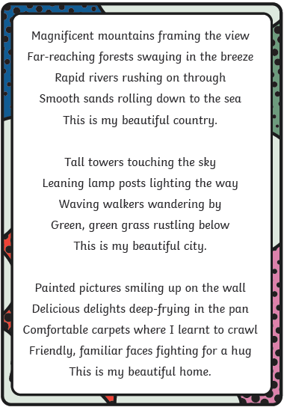 | (handwriting practise on the next page, the chosen font shows which letters should be joined).  Referred  Embarrased  Preferred  Occurred  Recognising  Interfering  Happiest  Funnier  Runner  Shiny

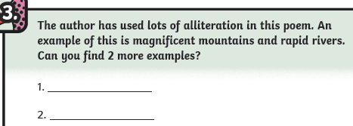
Comprehension Questions
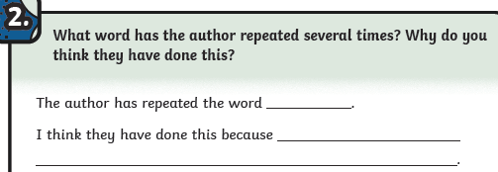

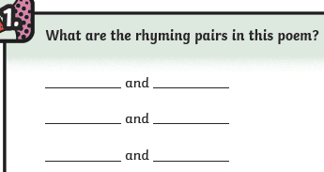
interfering
recognising
Funnier
happiest
occurred
preferred
f
f
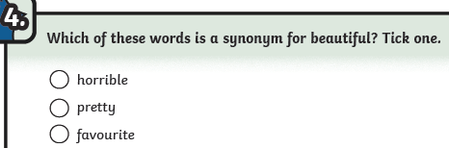

Mathematics
Task 1:  Fluency | Task 2:  Varied Fluency | Task 3:  Reasoning
- What numbers do these pictures represent?  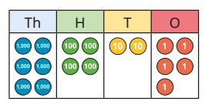  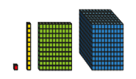  - Draw the place value counters for this number:  424  - Draw the Dienes for this number:  356 | - Is this true or false?  54 = 4 tens and 5 ones.  - Write the number with 5 hundreds, 2 tens and 6 ones.  - Make any three digit number with 2 tens  - What is the value of the underlined digit?  3 8 4 | Tiny says that 99 is bigger than 400 because is has two 9s. Is he correct?

Answers
English
Grammar and punctuation  NB Words added to the dotted line may be different. We have suggested an example to support you.  - The scared Pilgrims sailed the treacherous sea to America.  - Above them in the dark clouds, flew squawking gulls.  - As they got closer, they noticed the rocky land and tall, slim trees.  - In the distance, a friendly Squanto noticed the exhausted Pilgrims.  - It was a cold day when they landed in the new world. |  | 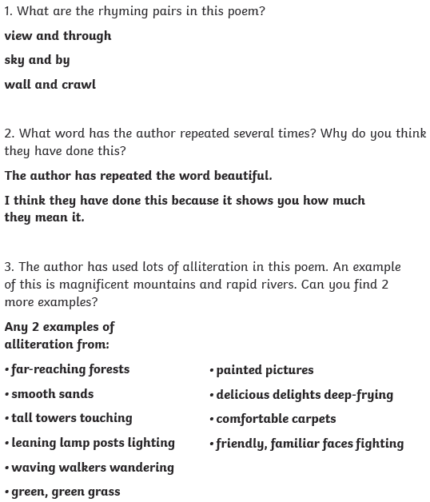  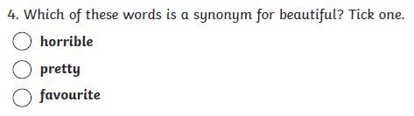
Maths

- 425 (Place value counters); 111 (Dienes) | - False  - 526  - Any three digit number that has 2 in the middle eg 521 or 626  - 3 hundred |  | Tiny says that 99 is bigger than 400 because is has two 9s. Is he correct?  eg No, 400 is a three digit number. It has 4 hundred which is bigger than 9 tens.

