Homework
Please find below three English tasks and three Mathematics tasks for children to complete for their homework this week. Our recommendation is that children complete Task 1 for English and Maths on Tuesday, Task 2 for both on Wednesday and Task 3 for both on Thursday. This short, frequent style of homework will support children to consolidate their learning.
English
Task 1:  Grammar and punctuation | Task 2:  Reading – phonics cards | Task 3:  Spelling
Write the following sentences correctly using capital letters and full stops.  Remember to form your letters carefully and write on the line.  i want to play in the park  it is a sunny day  can we stay for longer | Practise the following sounds:  ou - cloud  ea – teach  ay – play  What other words can you write using these sounds?  Or  what objects can you find in your home with these sounds? | Follow the Look, Say, Cover, Write, Check process for the following words this week:  - Pure  - They  - We  - Into  - His  - pull

Mathematics
Task 1:  Fluency | Task 2:  Varied Fluency | Task 3:  Reasoning
Practice your number formation by writing your numbers to 20.  You could use crayons, chalk or anything you would like! | Circle the amount you count  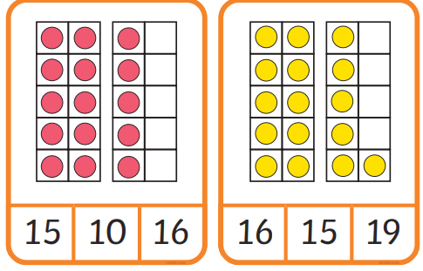  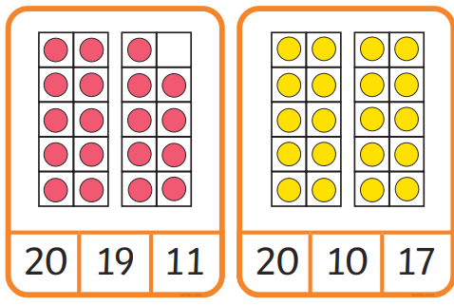 | Fill in the missing parts  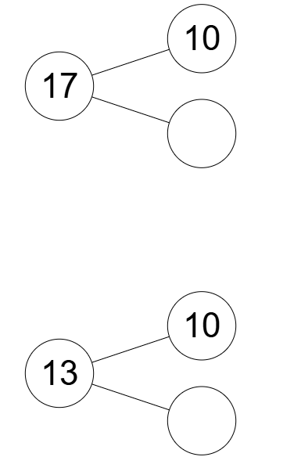  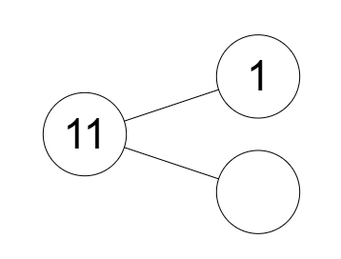

Answers
English task one
I want to play in the park.
It is a sunny day.
Can we stay for longer?

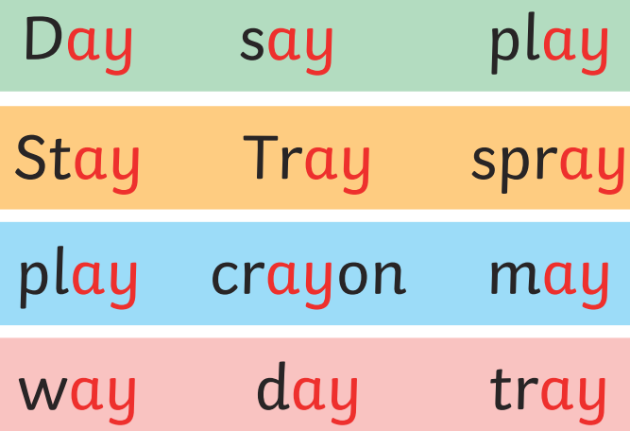
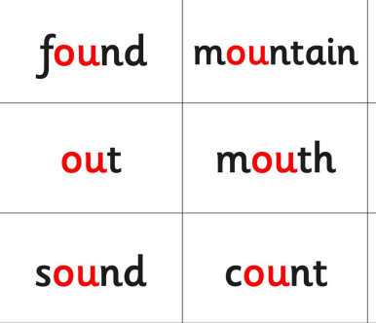
English task two – possible words

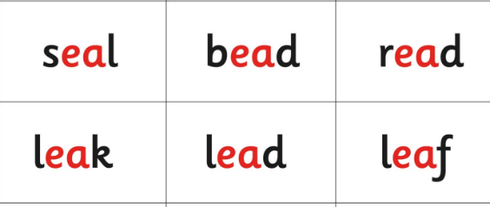

Answers
Maths task 2
15, 16, 19, 20

Maths task 3
7, 3, 10

