Homework
Please find below three English tasks and three Mathematics tasks for children to complete for their homework this week. Our recommendation is that children complete Task 1 for English and Maths on Tuesday, Task 2 for both on Wednesday and Task 3 for both on Thursday. This short, frequent style of homework will support children to consolidate their learning.

English
Task 1:  Grammar and punctuation | Task 2:  Reading – phonics cards | Task 3:  Spelling
Write the following sentences correctly using capital letters and full stops.  Remember to form your letters carefully and write on the line.  i found a sheep in the park  the queen has a big crown  my cheeks are cold | Practise the following sounds:  ee- sheep  qu- queen  th - teeth  What objects can you find in your home with these sounds? | Follow the Look, Say, Cover, Write, Check process for the following words this week:  - Sure  - My  - Me  - She  - Her  - Full

Mathematics
Task 1:  Fluency | Task 2:  Varied Fluency | Task 3:  Reasoning
Practice counting to 20 forwards and backwards!  This is a video we like to use in class to help us!  Count to 20 Forward and Backwards | Jack Hartmann (youtube.com) | Can you write these numbers as words?  For example, 10 – ten  13  15  16  7  3  4  Challenge – can you write all your numbers to 20? | Question on next page

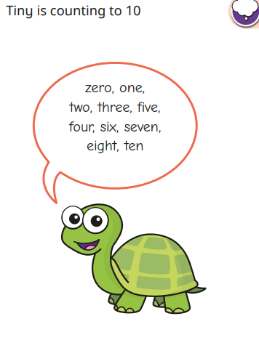

What mistake has Tiny made?

Can you help him fix it?

Answers

English Task 1
I found a sheep in the park.
The queen has a big crown.
My cheeks are cold.

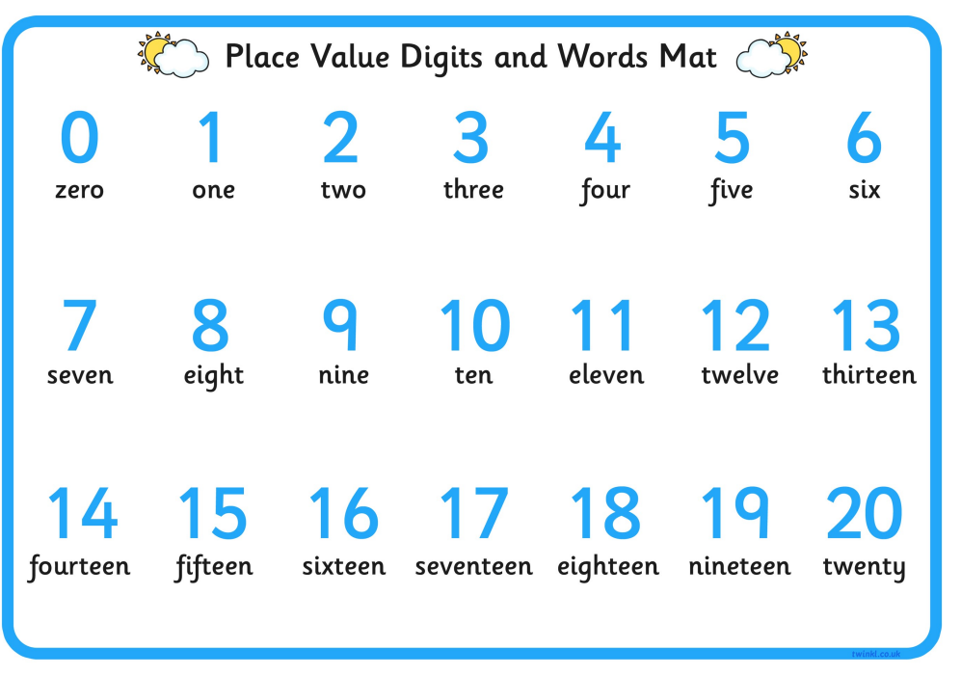

4 and 5 are in the wrong order

