Year 4 Homework Spring 1st w/c 29.06.2026
Please find below three English tasks and three Mathematics tasks for children to complete for their homework this week. Our recommendation is that children complete Task 1 for English and Maths on Tuesday, Task 2 for both on Wednesday and Task 3 for both on Thursday. This short, frequent style of homework will support children to consolidate their learning. Please find the answers on the class page. The expectation is that children mark alongside parents/carers or self-mark.
Children are to hand in their MARKED homework in their pink homework books on Monday morning, alongside their reading record.
English
Task 1:  Grammar and punctuation | Task 2:  Reading comprehension | Task 3:  Spelling Pattern
LI: To revise using punctuation correctly.  Look carefully at the following paragraph – Write the paragraph in your homework book and include the correct punctuation.  the wyrmstooth crown  chapter one  of crowns and caverns  guster the dragon lay in the mouth of his cave he itched his back itched and his belly itched  his fingers and his toes itched even his eyes and ears and nose itched it was unbearable guster felt like this every autumn while the leaves on the trees flushed into their autumn finery gusters green summer scales slowly changed to copper this was a mountain dragon trick which kept them safe from human eyes humans couldn’t spot green scales against the grass red scales against autumn leaves or white scales against snow guster thought that humans must be very stupid guster rolled on the rocky ground he scratched his back and scraped his shoulders his head wriggled and his legs flailed it did no good if only there were some way to soothe his scaly skin guster twisted to his feet ma he yelled into the darkness im going swimming | LI: To read and comprehend.  This week is the beginning of Wimbledon Tennis tournament in London. Read the information about Wimbledon and answer the following questions.  - How many players currently participate in Wimbledon?  - Draw 4 lines to match the correct facts:  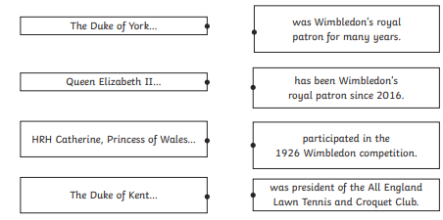  - What colour were the tennis balls at Wimbledon initially?  - Look at the section called The Royal Family. Find and copy one word that means the same as ‘took part in’  - Look at the section called The Royal Family.  What do you think was the author’s  intention when they used the phrase  strong ties? Explain your answer.  - Summarise what you have learnt  about Wimbledon in 25 words or fewer. | LI: To practise spelling words  league  tongue  guide  intrigue  plague  cheque  antique  barbeque  unique  mosque  Please practise the spellings using the Look Cover Spell Write methods  Spelling and tables tests will be held in class each Friday to monitor your progress.
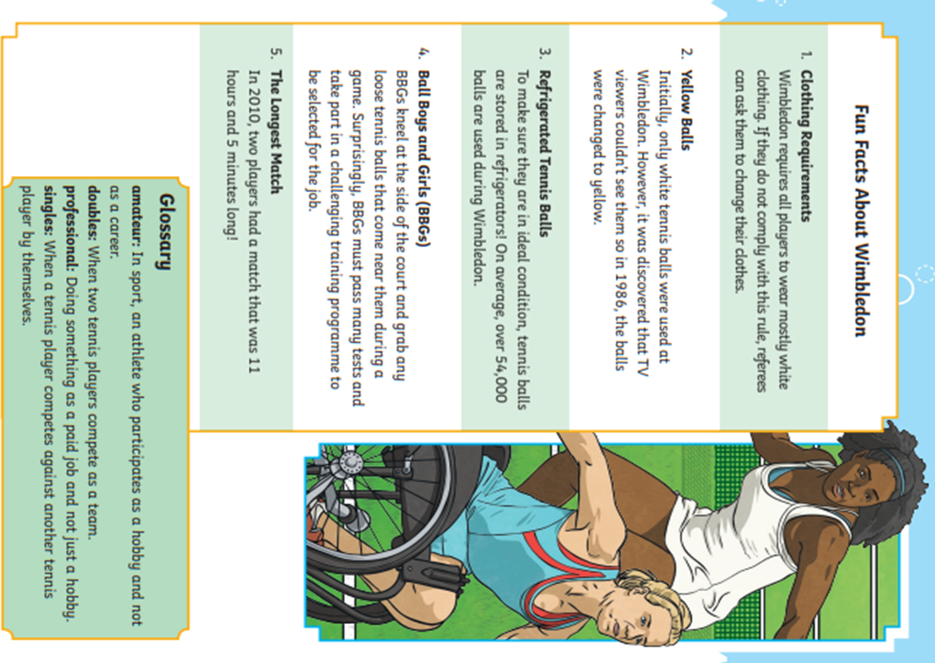
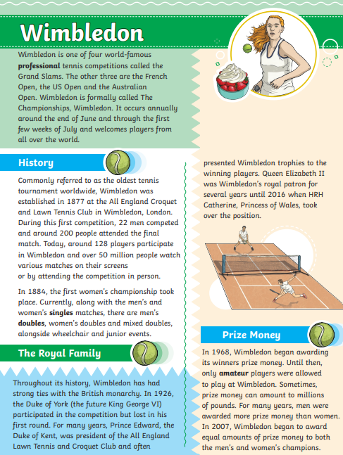

Mathematics
LI: To read and plot points using co-ordinates
Task 1:  Fluency | Task 2:  Varied fluency | Task 3:  Problem solving and reasoning
Practise locating points using the Billy Bug website as shown below. There is a link on the Year 4 webpage. It will self-mark  Alternatively, you could play Battleships. Remember to label the lines with numbers starting at zero and not the spaces between the lines as in the screen shot below.  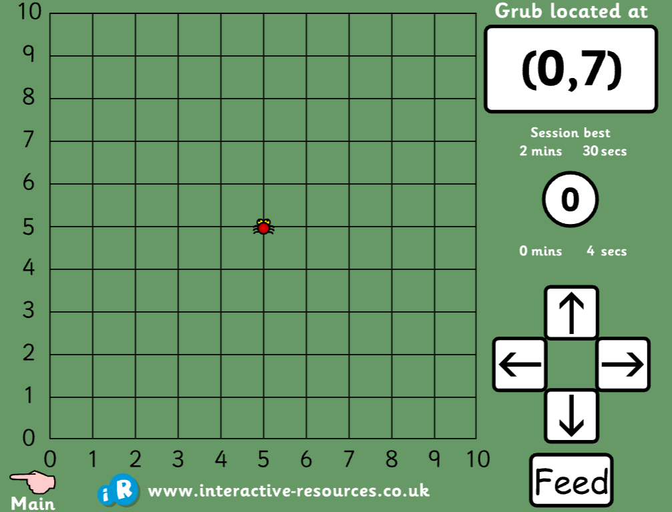 | 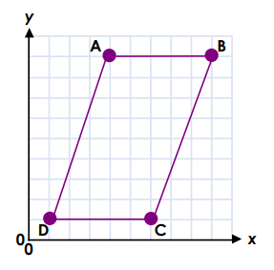  True or false?  A is at (9.4)  D is (1,1)  C is (1,6)  B is at 9,9  Using this grid, write the co-ordinates that spell BASE.  What do these co-ordinates spell?  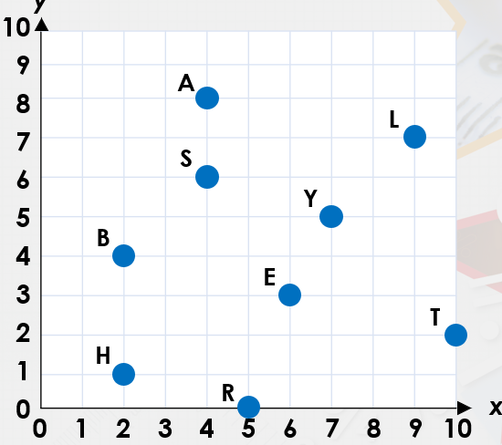 | What has Billy done wrong?  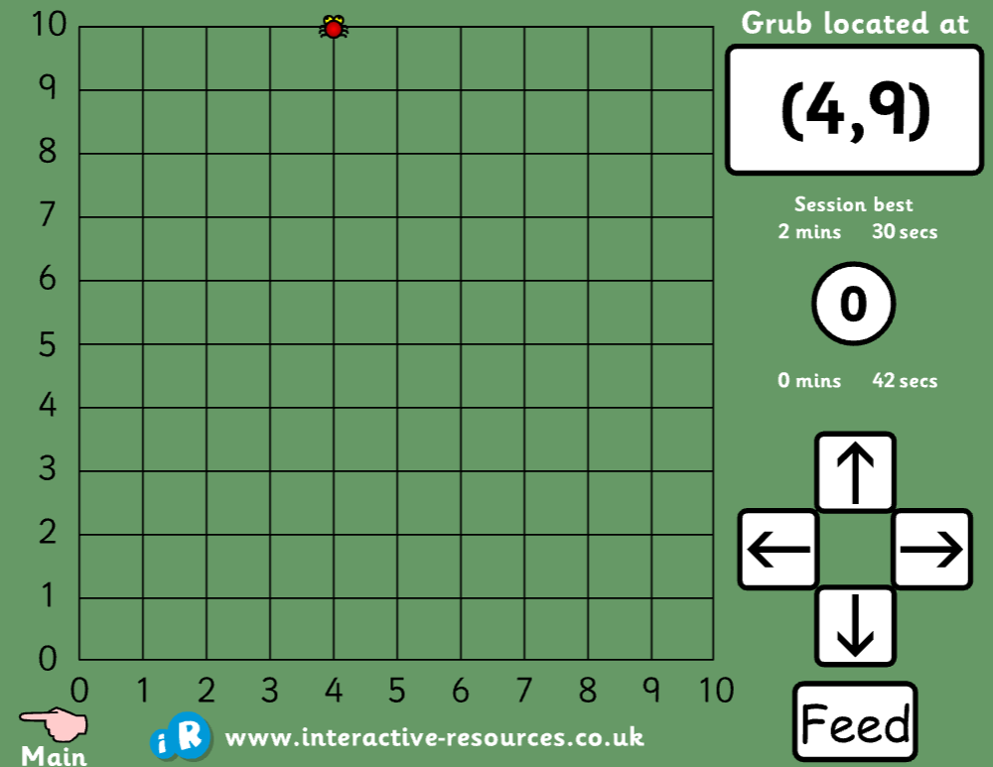  How can you use the co-ordinates Bily Big is on (4,9) to help locate the next bug at (8,2)  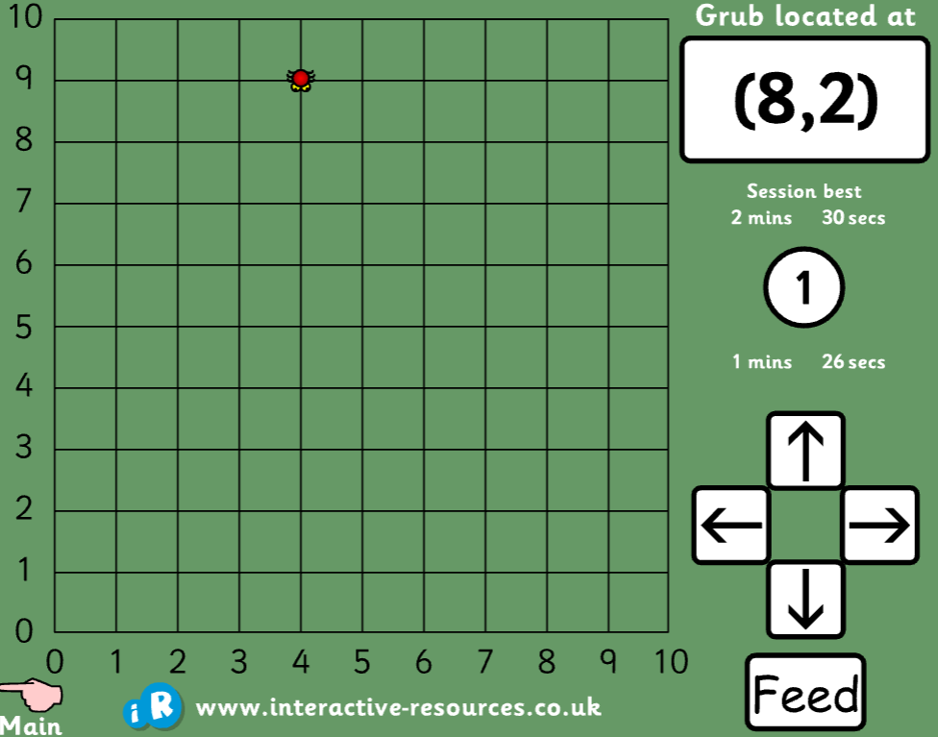  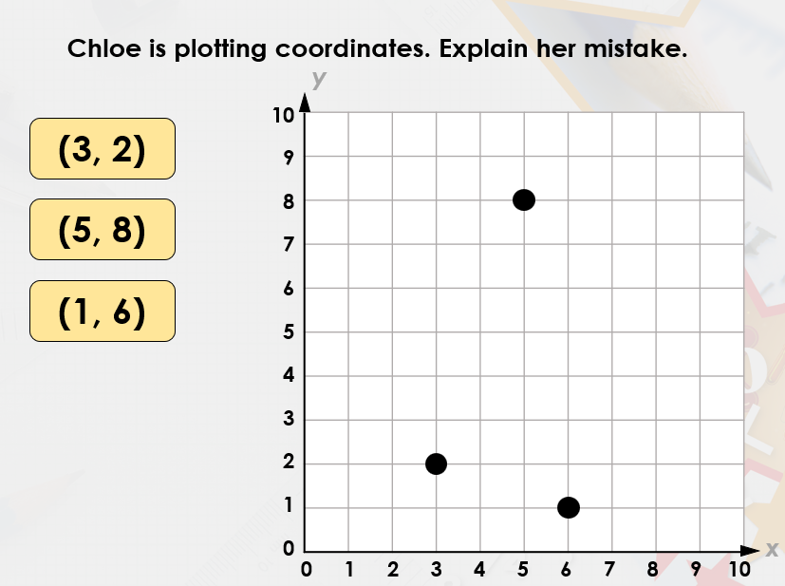

English Answers:
Tuesday:
The Wyrmstooth Crown’
Of Crowns and Caverns
Guster the dragon lay in the mouth of his cave. He itched. His back itched and his belly
itched. His fingers and his toes itched. Even his eyes and ears and nose itched. It was unbearable. Guster felt like this every autumn. While the leaves on the trees flushed into their autumn finery, Guster’s green summer scales slowly changed to copper. This was a mountain dragon trick which kept them safe from human eyes. Humans couldn’t spot green scales against the grass, red scales against autumn leaves or white scales against snow. Guster thought that humans must be very stupid. Guster rolled on the rocky ground. He scratched his back and scraped his shoulders. His head wriggled and his legs flailed. It did no good. If only there were some way to soothe his scaly skin...
Guster twisted to his feet. “Ma?” he yelled into the darkness. “I’m going swimming.”

Wednesday:
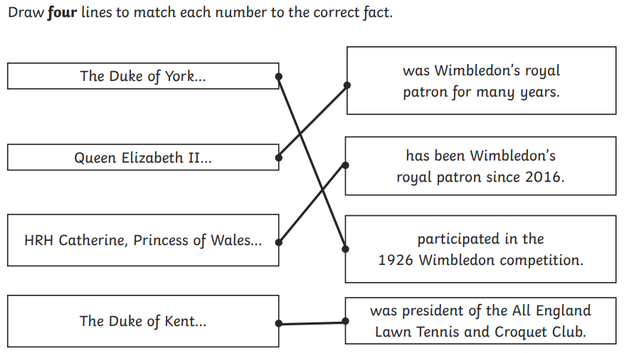
- 128

- White
- Participated
- Pupils’ own responses, such as: I think the author intended to show that the Royal
Family is very involved with Wimbledon and has been for a very long time.
- Pupils’ own responses, such as: Wimbledon is the oldest tennis tournament in the
- world. It takes place in London during the early summer and is watched by millions
- of people.
Maths Answers
Varied Fluency
A is at (9.4) True
D is (1,1) True
C is (1,6) False as the x and y are in the wrong order
B is at 9,9 False as it needs brackets
BASE = (2,4), (4,8), (4,6), (6,3) LATE = (9,7), (4,8), (10,2) (6,3)
Reasoning/ Problem Solving
He is at (4,10)
The x goes from 4 to 8 so just count on 4 squares. The y is on 9 so go down 7 to get to 2.
Choe has used the y co-ordinate to go across instead of up/down

