Year 3 Homework Summer 2nd Term Week 4 22.6.26
Please find below three English tasks and three Mathematics tasks for children to complete for their homework this week.
It should be completed in the pink homework book that was sent home at the start of the year. Please complete in pencil or blue handwriting pen. Any lines drawn (such as when underlining the date) should be in pencil WITH a ruler/ straight edge.
Each week remember to write and underline the date and rule off the last’s week’s work. This will reinforce the presentation standards we have in class. There is no need to print this sheet. Please only write the answers in the homework book.
Our recommendation is that children complete Task 1 for English and Maths on Tuesday, Task 2 for both on Wednesday and Task 3 for both on Thursday. This short, frequent style of homework will support children to consolidate their learning. Spellings and tables will be tested on Friday. Homework is due on Friday.
The expectation is that children mark alongside parents/carers or self-mark. We use a green pen to tick answers in class and make corrections in purple pen, but please use any pen you have available at home. Answers are below the questions.
Children are to show their completed MARKED homework on FRIDAY morning, alongside their red reading record to show they have read aloud to someone at home.
English
Task 1:  Grammar and punctuation | Task 2:  Reading comprehension | Task 3:  Spelling Pattern/ Tables Focus
LI: To identify conjunctions  Find the conjunction (It is introducing the subordinate clause):  - The sea sparkled because the sun was shining.  - When the lighthouse beam appeared, the ship changed course.  - The cliffs looked mysterious as the mist rolled in.  - Although the waves were rough, the boat continued.  - The beach was quiet after the storm ended.  Do you think subordinate classes always end a sentence?  Now mark your answers.  Remember to read your reading book with someone at home and record this in your reading record. | LI: To  The United Kingdom has hundreds of lighthouses around its coastline. For many years, these tall towers have helped ships travel safely through dangerous waters. Lighthouses are usually built on cliffs, rocky islands, or near busy harbours where ships need guidance.  A lighthouse works by shining a powerful light from the top of the tower. The light can often be seen from many miles away. Each lighthouse has its own pattern of flashes, which helps sailors identify their location.  Some of the most famous lighthouses in the UK include Eddystone Lighthouse, which stands on rocks in the English Channel, and Bell Rock Lighthouse, one of the world’s oldest surviving sea-washed lighthouses.  In the past, lighthouse keepers lived and worked in the towers. Their job was to maintain the light, clean the equipment, and ensure everything worked correctly. Today, most lighthouses are automatically controlled.  Many lighthouses have become popular tourist attractions. Visitors enjoy learning about their history, climbing the towers, and enjoying spectacular views of the sea.  - Why were lighthouses built around the UK coastline?  - Where are lighthouses usually located?  - What shines from the top of a lighthouse?  - How does each lighthouse help sailors identify their location?  - What was the job of a lighthouse keeper?  - What does the word navigation mean in the report?  - a) Travelling and finding the correct route  - b) Building ships  - c) Fishing at sea  Now mark your answers.  Remember to read your reading book with someone at home and record this in your reading record. | To revise x12 and revise spellings  rain, rein, reign, which, witch, their, there, they’re, caught, court  You do not need to record this task in your homework book.  Remember to read your reading book with someone at home and record this in your reading record.

Mathematics

Task 1:  Fluency | Task 2:  Varied Fluency | Task 3:  Reasoning
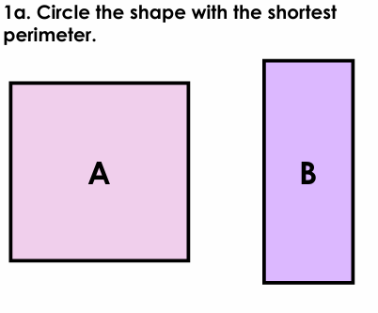  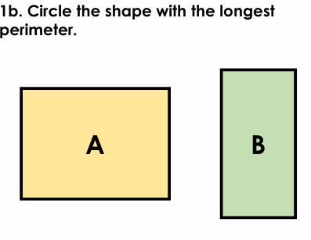  If each square is 1cm, work out the following perimeters…  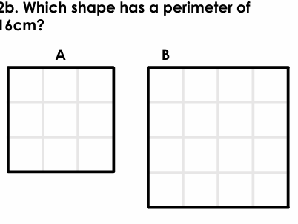  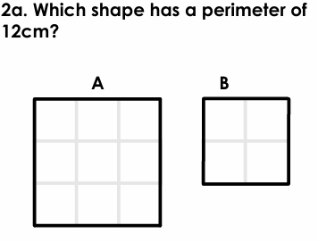 | Can you practice drawing your own 2D shapes and working out their perimeter?  For example: Can you draw a square with 4 cm sides? What is its perimeter?  Can you draw a triangle with two 8cm sides and one 4cm side? What is the perimeter?  Can you draw a rectangle with 10cm sides and 3cm sides? What is the perimeter? | 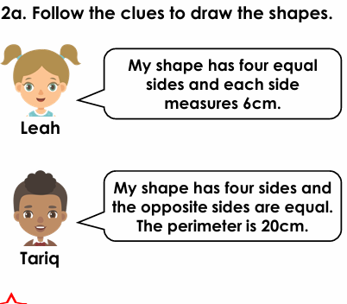  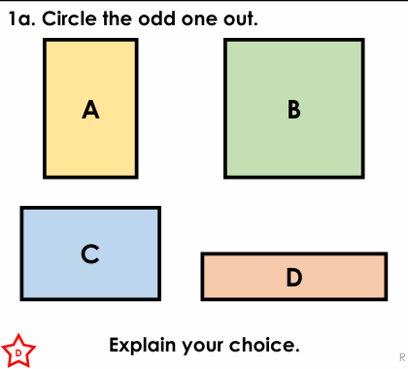

Maths Answers
Fluency answers: B, A, A, B
Varied fluency answers:
Reasoning answers:
B is the odd one out because it has a perimeter of 12cm, whereas the other shapes have a perimeter of 10cm.
Leah’s shape is a square with a 24cm perimeter and Tariq’s shape is a rectangle. Tariq’s shape, various answers, for example: 4cm, 6cm, 4cm, 6cm.

English Answers
Grammar and punctuation
- The sea sparkled because the sun was shining.
- When the lighthouse beam appeared, the ship changed course.
- The cliffs looked mysterious as the mist rolled in.
- Although the waves were rough, the boat continued.
- The beach was quiet after the storm ended.
- Subordinate clauses do not have to be at the end of the sentence.

Reading Comprehension (wording may be different)
- To help ships travel safely through dangerous waters.
- On cliffs, rocky islands, or near harbours.
- A powerful light.
- Each lighthouse has its own pattern of flashes.
- To maintain the light, clean the equipment, and ensure everything worked correctly.
- a

