Homework Summer 2 Week 4 – 29.06.26
Children are to hand in their homework on Monday morning, alongside their reading record.
English
Task 1: Grammar and Punctuation  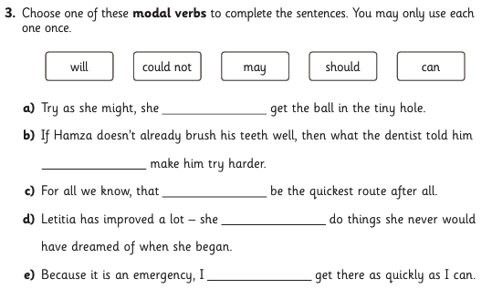 | Task 2: Reading Comprehension  See below  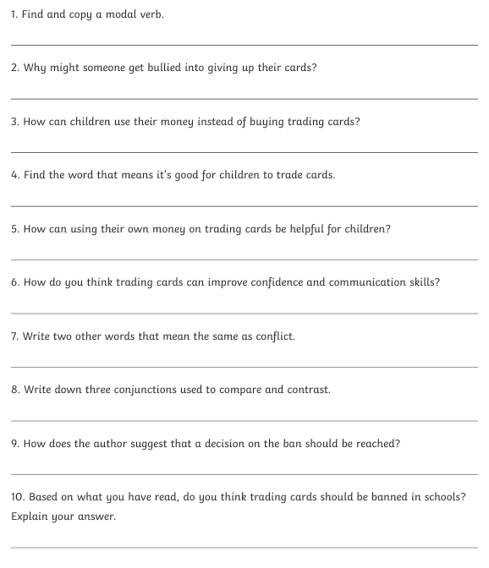 | Task 3:  Spelling  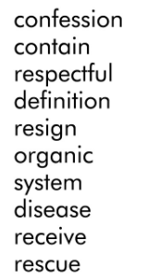

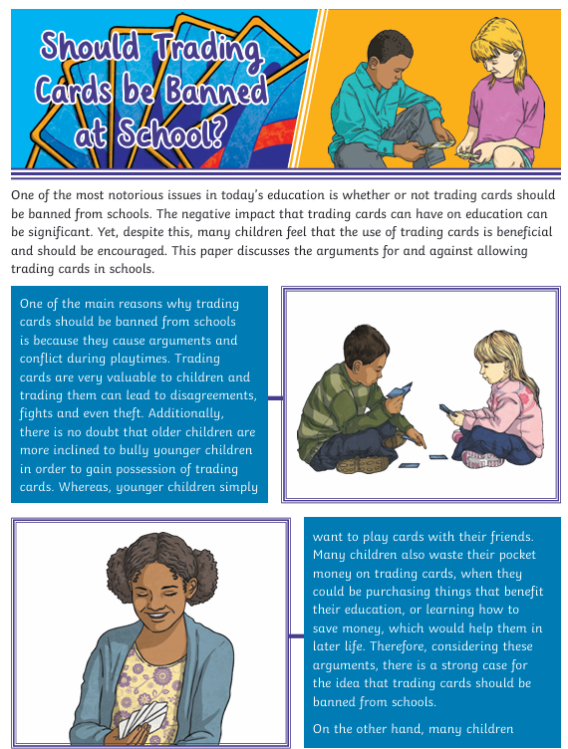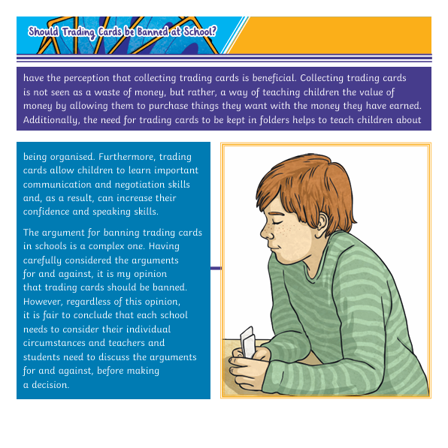

Mathematics
Task 1:  Fluency | Task 2:  Varied Fluency | Task 3:  Reasoning
Practise your timestables  We will be having a timestable test next week Monday when we do our spelling test. | 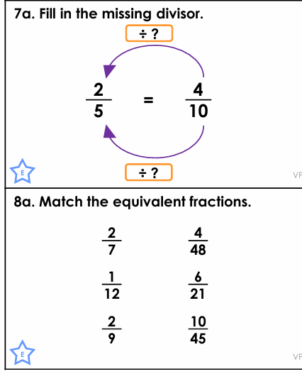 | 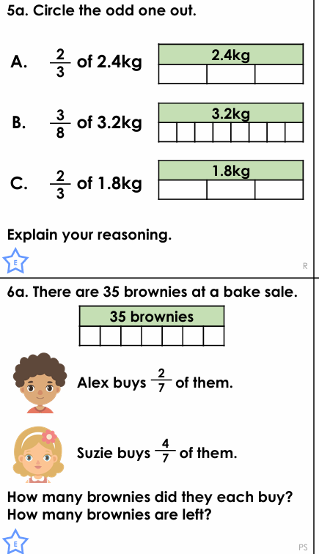

Answers
English

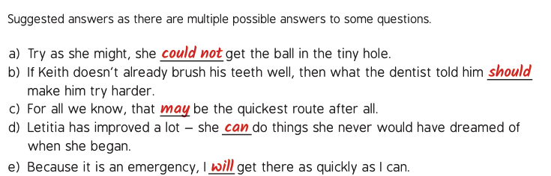
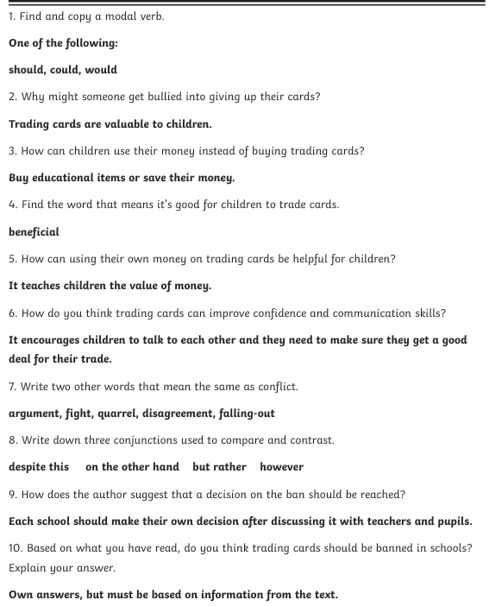

Maths
Fluency

Varied Fluency
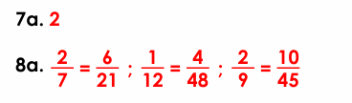

Reasoning and Problem


