Homework Summer 2 Week 3 – 15.06.26
Children are to hand in their homework on Monday morning, alongside their reading record.
English
Task 1: Grammar and Punctuation  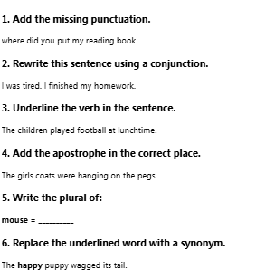 | Task 2: Reading Comprehension  Read the text  Last Saturday, Oliver visited a science museum with his grandparents. The museum was busy because a new space exhibition had just opened. Oliver enjoyed exploring the interactive displays and learning about planets and astronauts.  One of his favourite activities was using a virtual reality headset to experience what life might be like on the Moon. Before leaving, he bought a small model rocket from the gift shop. On the journey home, Oliver talked excitedly about everything he had learned and said he hoped to visit again soon.  Questions  1. Retrieval  Who did Oliver visit the museum with?  2. Vocabulary  What does the word interactive suggest about the displays?  3. Inference  Why was the museum busy?  4. Evidence  Find a sentence that shows Oliver enjoyed the visit.  5. Sequence  Put these events in order:  - Oliver used a virtual reality headset.  - Oliver travelled home.  - Oliver bought a model rocket.  - Oliver arrived at the museum.  6. Explanation  Why do you think Oliver wanted to visit again? | Task 3:  Spelling  average  calculate  statistics  timetable  passenger  journey  favourite  important  knowledge  opportunity

Mathematics
Task 1:  Fluency | Task 2:  Varied Fluency | Task 3:  Reasoning
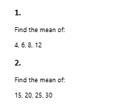 | 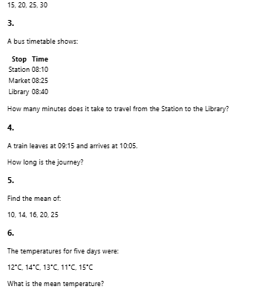 | 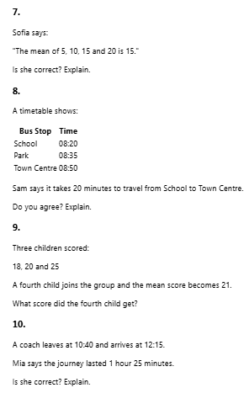

Answers
English

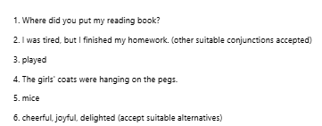
- His grandparents.
- The displays could be used, touched, explored or interacted with.
- A new space exhibition had just opened.
- "Oliver enjoyed exploring the interactive displays and learning about planets and astronauts."

  - Oliver arrived at the museum.
  - Oliver used a virtual reality headset.
  - Oliver bought a model rocket.
  - Oliver travelled home.
- Because he enjoyed the museum and found it interesting

Maths



