Year 4 Homework Summer 2 Week 3 – 15.06.2026 – 19.06.2026
Please find below three English tasks and three Mathematics tasks for children to complete for their homework this week. Our recommendation is that children complete Task 1 for English and Maths on Tuesday, Task 2 for both on Wednesday and Task 3 for both on Thursday. This short, frequent style of homework will support children to consolidate their learning. Please find the answers on the class page. The expectation is that children mark alongside parents/carers or self-mark.
Children are to hand in their MARKED homework in their pink homework books on Monday morning, alongside their reading record.
English
Task 1:  Grammar and punctuation | Task 2:  Reading comprehension | Task 3:  Spelling Pattern
LI: To revise co-ordinating conjunctions  In English there are seven coordinating conjunctions which can be used to join sentences.  They are easy to use by remembering: FANBOYS  For And Nor But Or Yet So  For each sentence, add the best conjunction:  1. The builder worked really hard on the project ___________the house would sell for the highest possible price at auction.  2. My dog. Sasha, refuses to eat chicken____________ does she like the taste of sausages.  3. The flowers in the garden were beautiful_______________ I couldn’t go close to them because of my allergies.  For each set of sentences below, choose the best conjunction (you may need to  rewrite it slightly):  1. Benjamin played with his cat. Mary walked her dog.  2. My friend used live bait when he went fishing. He thinks it catches the biggest fish.  3. I wanted to go to the movies. Mum wouldn’t allow me.  4. It was a rainy day. The students ate their lunch inside. | LI: To read and comprehend  Read the poem, ‘Layers of the Rainforest’ and answer the following questions:  - Whose viewpoint is the poem written from?  - Find and copy one example of alliteration from the poem.  - What is the air like in the tree’s canopy layer?  - Give an alternative title for the poem.  - . …. the composting leaves I devour.  Explain what is meant by this phrase.  - 8. Explain how you know that this poem begins at the top of the tree and ends at the bottom.  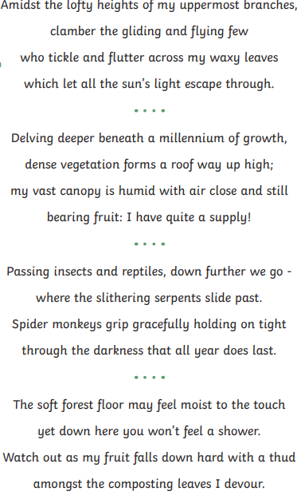 | LI: To practise spelling words  energy  energetic  giant  gigantic  legend  legendary  bridge  length  gentle  gently  Please practise the spellings using the Look Cover Spell Write methods  Spelling and tables tests will be held in class each Friday to monitor your progress.

Mathematics
LI: To identify triangles, quadrilaterals and other polygons.

Task 1:  Fluency | Task 2:  Varied fluency | Task 3:  Problem solving and reasoning
Name these shapes:  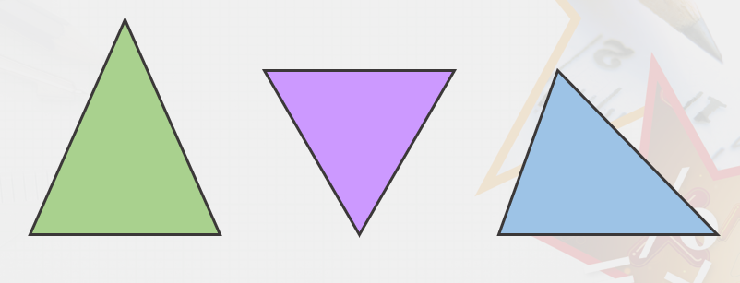  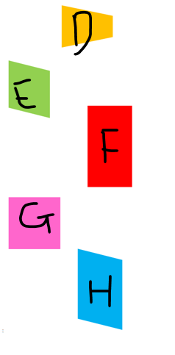 | 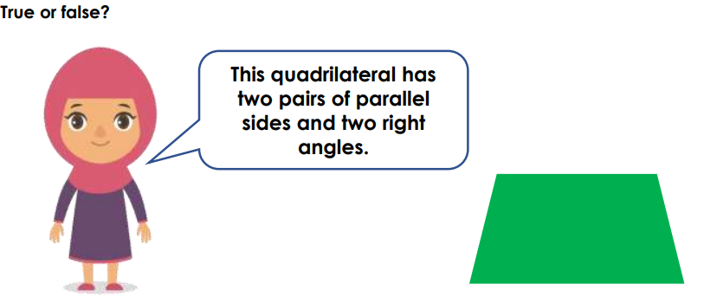  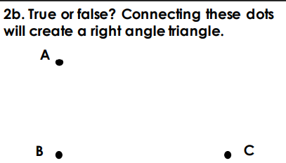  Find the isosceles triangles:  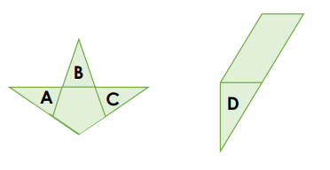 | Use the dotty paper below to draw and name 5 different polygons. Say if it is regular or irregular. If you have drawn a triangle or quadrilateral, then give all its names.  Remember you have to have straight sides (use a ruler) and enclose a space (all the sides touching).

English Answers:
Tuesday: 1. So 2. Nor 3. yet/but
1. Example answer: Benjamin played with his cat and Mary walked her dog.
2. Example answer: My friend used live bait when he went fishing for he thinks it catches the biggest fish.
3. Example answer: I wanted to go to the movies but Mum would not allow me to leave the house.
4. Example answer: It was a rainy day so the students ate their lunch inside.
Wednesday: Reading comprehension
1. trees
2. Find and copy one example of alliteration from the poem.
Accept any of the following: delving deeper; slithering serpents slide; grip gracefully;
forest floor; fruit falls
3. What is the air like in the tree’s canopy layer?
Accept any of the following: humid; close; still.
4. Give an alternative title for the poem.
Pupils’ own responses, such as: Journeying Down a Rainforest Tree.
5. …. the composting leaves I devour.
Explain what is meant by this phrase.
Pupils’ own responses, such as: This means that the tree hungrily eats the leaves that
are rotting and decaying on the forest floor.
6. Explain how you know that this poem begins at the top of the tree and ends at the bottom.
Pupils’ own responses, such as: I know this because the first verse begins with the
‘lofty’ and ‘uppermost branches’. The poet then talks about ‘delving deeper’ and going
‘down’ and the last verse ends on the forest floor.

Maths Answers
Fluency
D- trapezium (one pair of parallel sides)
E – rhombus (parallelogram with equal sides. A parallelogram has 2 pair of sides parallel)
F – rectangle (AKA oblong and parallelogram. Rectangles have 4 right angles)
G – square (all sides equal but can also be a rectangle and parallelogram)
H – parallelogram (just a parallelogram as it has no right angles and the sides are different lengths)
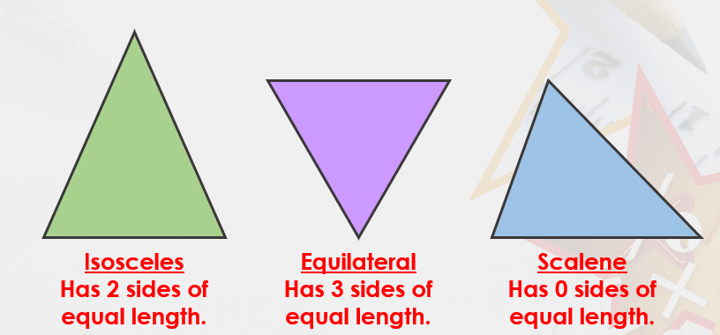

Varied Fluency
False
True
A, B and C
Reasoning/ Problem Solving
Various answers. Check your drawings against the definitions above and below:




