Year 3 Homework Summer 2nd Term Week 3 15.6.26
Please find below three English tasks and three Mathematics tasks for children to complete for their homework this week.
It should be completed in the pink homework book that was sent home at the start of the year. Please complete in pencil or blue handwriting pen. Any lines drawn (such as when underlining the date) should be in pencil WITH a ruler/ straight edge.
Each week remember to write and underline the date and rule off the last’s week’s work. This will reinforce the presentation standards we have in class. There is no need to print this sheet. Please only write the answers in the homework book.
Our recommendation is that children complete Task 1 for English and Maths on Tuesday, Task 2 for both on Wednesday and Task 3 for both on Thursday. This short, frequent style of homework will support children to consolidate their learning. Spellings and tables will be tested on Friday. Homework is due on Friday.
The expectation is that children mark alongside parents/carers or self-mark. We use a green pen to tick answers in class and make corrections in purple pen, but please use any pen you have available at home. Answers are below the questions.
Children are to show their completed MARKED homework on FRIDAY morning, alongside their red reading record to show they have read aloud to someone at home.
English
Task 1:  Grammar and punctuation | Task 2:  Reading comprehension | Task 3:  Spelling Pattern/ Tables Focus
LI: To use conjunctions  Here are some conjunctions (joining words):  because, although, while, as, after, before, since, as, if, even though  Copy these simple sentences into your books USING A CONJUNCTION to make them into one longer/ complex sentence.  - The seagulls called. The boat continued its journey.  - The lighthouse shone. It was day.  - The cliffs were crumbling. The waves smashed against the cliffs.  - The sailors felt relieved. The lighthouse could be seen in the distance.  - The boat continued its journey. The sea was choppy.  - The wind started to blow. The lightning flashed.  Now mark your answers.  Remember to read your reading book with someone at home and record this in your reading record. | LI: To answer questions about a poem  The Sea’s Secret Song  The sea is a silver blanket,  Spread wide beneath the sky.  It wraps the world in whispers  As the seabirds drift and fly.  The waves are restless dancers,  Leaping across the shore.  They twirl in sparkling costumes  And return for one more encore.  The ocean is an ancient library,  Its pages deep and blue.  Each shell and hidden current  Holds stories old and new.  Comprehension Questions  - What metaphor is used in the first verse to describe the sea?  - What two things does the poet say seabirds do?  - Why are the waves compared to “restless dancers”?  - What does the poet say the dancers wear?  - What does the metaphor “the ocean is an ancient library” suggest about the sea?  Now mark your answers.  Remember to read your reading book with someone at home and record this in your reading record. | To revise x12 and revise spellings  beauty, beautiful, caught, island, February, answer, build, guide, Wednesday, straight  You do not need to record this task in your homework book.  Remember to read your reading book with someone at home and record this in your reading record.

Mathematics

Task 1:  Fluency | Task 2:  Varied Fluency | Task 3:  Reasoning
With a ruler, I want you to collect 5 objects from around your house.  Can you measure each object to the nearest cm and mm and label this in your homework book.  Can you order your 5 objects from smallest to largest? | Compare these lengths using < > =  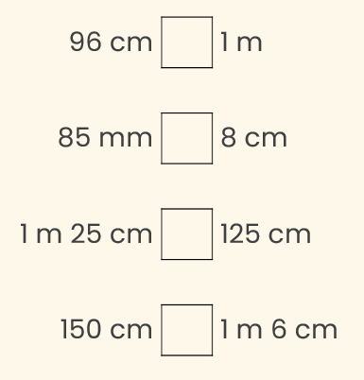  Order these lengths from shortest to longest –  175cm, 900mm, 2m5cm, 185cm  1m9cm, 950mm, 175cm, 1m15cm | 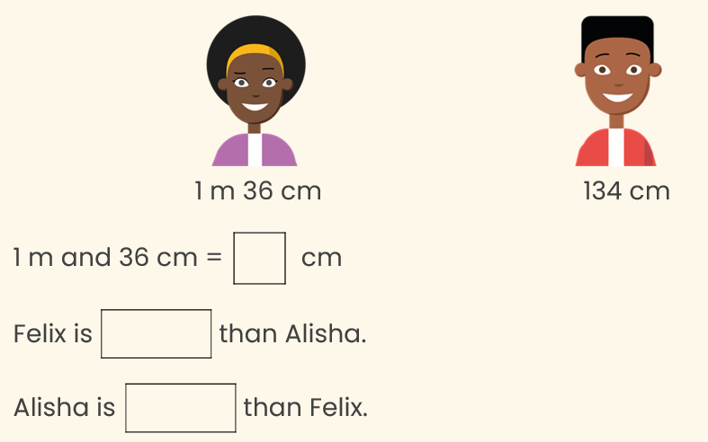  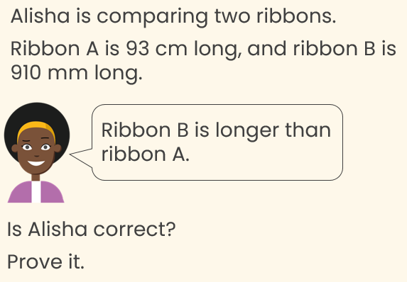

Maths Answers
Fluency answers:
Varied fluency answers:
<
>
=
>
900mm, 175cm, 185cm, 2m5cm
950mm, 1m9cm, 1m15cm, 175cm

Reasoning answers:
Alisha is incorrect because 910 mm = 91 cm, and 93 cm is longer than 91 cm.
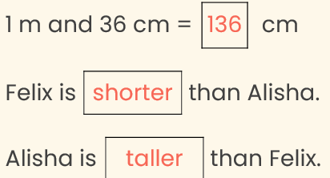

English Answers
Grammar and punctuation (There are many answers but it should make sense)
- The seagulls called while the boat continued its journey.
- The lighthouse shone even though it was day.
- The cliffs were crumbling because the waves smashed against the cliffs.
- The sailors felt relieved as the lighthouse could be seen in the distance.
- The boat continued its journey although the sea was choppy.
- The wind started to blow before the lightning flashed.

Reading Comprehension (wording may be different)
- What metaphor is used in the first verse to describe the sea? ‘Is a silver blanket’
- What two things does the poet say seabirds do? Drift and fly
- Why are the waves compared to “restless dancers”? It is constantly moving AND it is as energetic/ graceful/ rhythmic as a dancer. (Please encourage your child to give a reason for each word)
- What does the poet say the dancers wear? Sparkling costumes
- What does the metaphor “the ocean is an ancient library” suggest about the sea? It is old AND it holds lots of stories and secrets like a library holds lots of stories.

