Year 4 Homework Summer 2 w/c 08.06.2026
Please find below three English tasks and three Mathematics tasks for children to complete for their homework this week. Our recommendation is that children complete Task 1 for English and Maths on Tuesday, Task 2 for both on Wednesday and Task 3 for both on Thursday. This short, frequent style of homework will support children to consolidate their learning. Please find the answers on the class page. The expectation is that children mark alongside parents/carers or self-mark.
Children are to hand in their MARKED homework in their pink homework books on Monday morning, alongside their reading record.
English
Task 1:  Grammar and punctuation | Task 2:  Reading comprehension | Task 3:  Spelling Pattern
LI: To Practise using subordinating conjunctions.  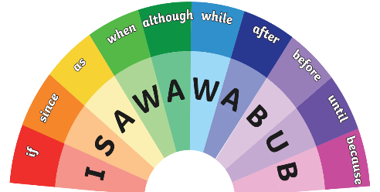  This week we will be practising using subordinating conjunctions – they are words that help us to add extra information to a sentence and extend them further for explanation. Ten of the most frequent subordinating conjunctions can be remembered with the silly mnemonic – ‘I saw a wabub.’  Compose 6 sentences using different subordinating conjunctions. Eg: I dressed for summer today although it was freezing cold! | LI: To read and comprehend  This term in geography, we will be thinking about God’d wonderful world and the environment that we live in. We will be thinking carefully about how we can make a difference to the planet and help protect the world around us.  Read the information about, ‘World Earth Day’ and the answer the following questions:  - How long can it take for a plastic bag to degrade in landfill?  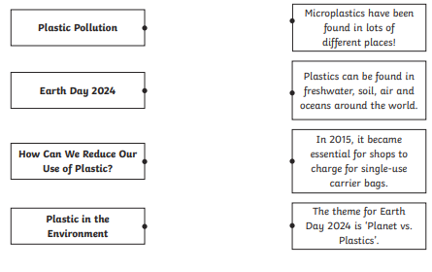  - Draw four lines and match the sub-heading to the correct sentence from the section.  3. Using the text, explain two reasons why plastic is bad for the environment.  4. Fill in the missing word.  You could save 156 plastic bottles every year by choosing a _______________bottle!  5. Look at the section with the sub-heading How Can We Reduce Our Use of Plastic?  Find and copy one word which means the same as ‘put a limit on’.  6. Why do you think that so many people celebrate Earth Day?  7. The government is beginning to tackle the plastic problem…  Why do you think the author chose to use the word ‘tackle’? | LI: To practise spelling words  courage  courageous  adventure  adventurous  continue  continuous  glamour  glamorous  outrage  outrageous  Please practise the spellings using the Look Cover Spell Write methods  Spelling and tables tests will be held in class each Friday to monitor your progress.

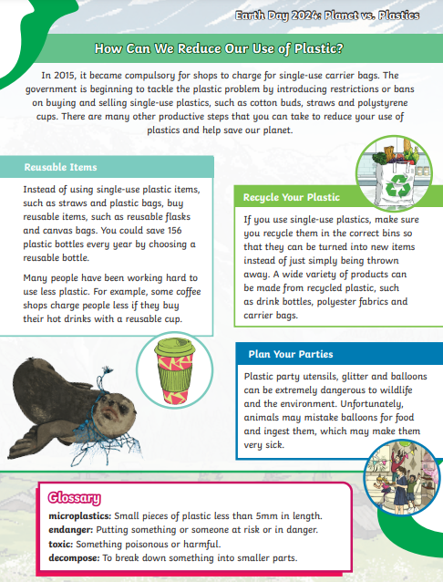
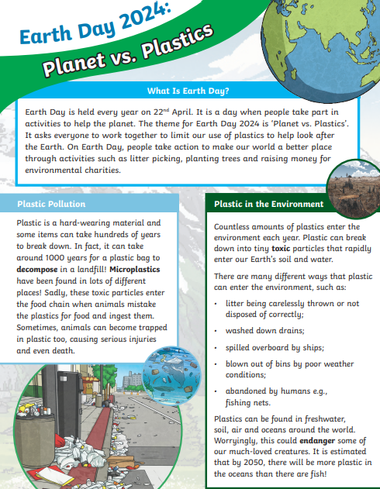
Mathematics
LI: To recall multiplication and division facts
Task 1:  Fluency | 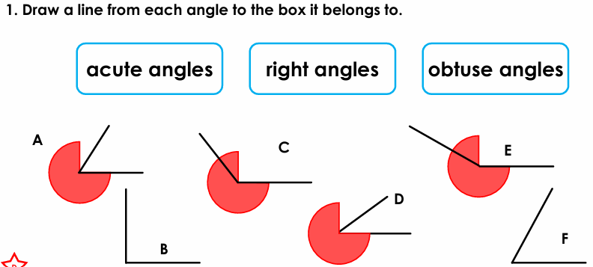
Task 2:  Varied fluency | 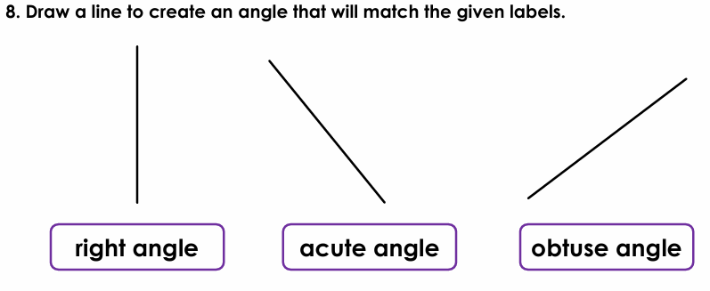
Task 3:  Problem solving and reasoning | 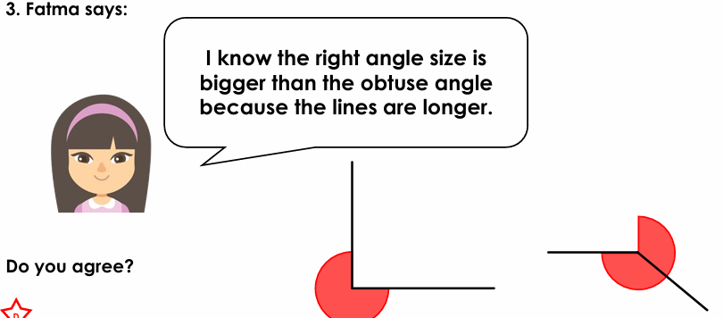

English Answers:
Tuesday: children’s individual sentences
Wednesday:
- 1000 years
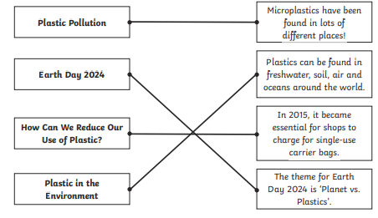

3. List two reasons why plastic is bad for the environment.
Accept any two of the following:
• endangering wildlife;
• microplastics been found in lots of different places;
• animals ingesting plastics;
• entering oceans;
• not being easily degraded and taking up space.
4. reusable
5. restrictions
6. Pupils’ own responses, such as: I think that so many people celebrate Earth Day because
people want to help look after the planet and make it a better place for everyone in
the future.
7. Pupils’ own responses, such as: I think that the author chose to use the word ‘tackle’
because it suggests fighting against plastic pollution to make a difference.
Maths Answers
Task 1: Acute angles – A, D, F; right angles – B; obtuse angles – C, E
Task 2:
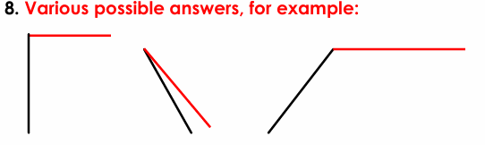
Task 3:
3. Fatma is incorrect. The obtuse angle size is bigger. The length of the lines are irrelevant.

