Homework Summer 2 Week 2 – 08.06.26
Children are to hand in their homework on Monday morning, alongside their reading record.
English
Task 1: Grammar and Punctuation  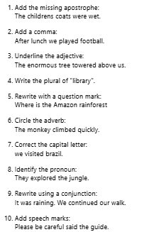 | Task 2: Reading Comprehension  The Amazon Rainforest  The Amazon Rainforest is the largest tropical rainforest in the world. It covers parts of nine countries in South America, although most of it is in Brazil. The rainforest is home to millions of species of plants, insects and animals.  The Amazon River flows through the rainforest and is one of the longest rivers on Earth. The rainforest helps regulate the Earth's climate by absorbing carbon dioxide and producing oxygen.  Many indigenous communities have lived in the Amazon for thousands of years. They use their knowledge of the rainforest to hunt, fish and gather food. However, parts of the rainforest are being destroyed through deforestation. Trees are cut down to make space for farming, roads and buildings.  Scientists believe it is important to protect the Amazon because it supports biodiversity and plays a key role in the global environment.  Questions  What is the Amazon Rainforest?  Which continent is it located in?  In which country is most of the Amazon found?  Name two types of living things found there.  What river flows through the rainforest?  Why is the Amazon important for the Earth's climate?  Who has lived in the rainforest for thousands of years?  What does the word "deforestation" mean?  Give one reason trees are cut down.  Do you think protecting the Amazon is important? Explain your answer using evidence from the text. | Task 3:  Spelling  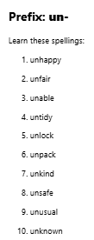

Mathematics
Task 1:  Fluency | Task 2:  Varied Fluency | Task 3:  Reasoning
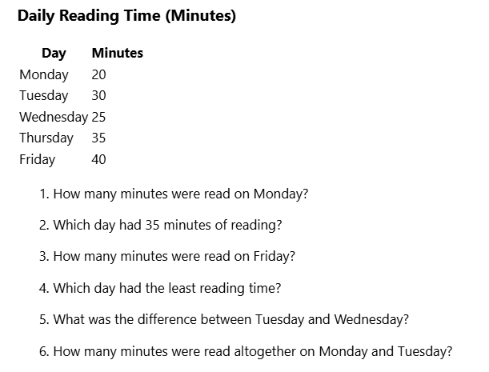 | 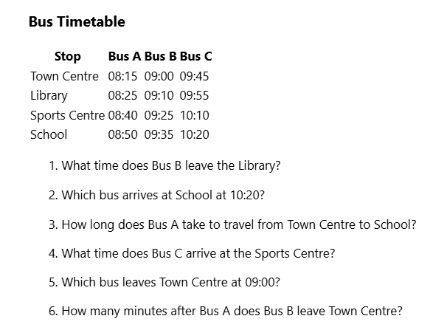 | 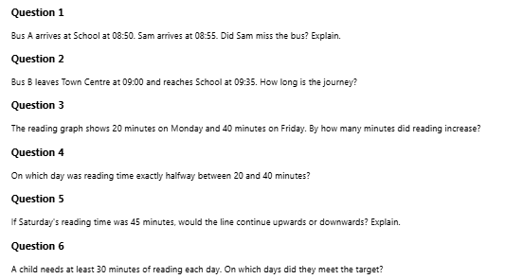

Answers
Maths
Fluency

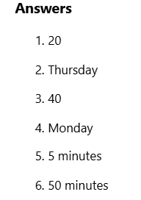
Varied Fluency
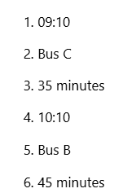
Reasoning
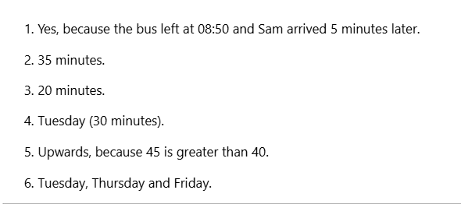

English

Grammar and punctuation

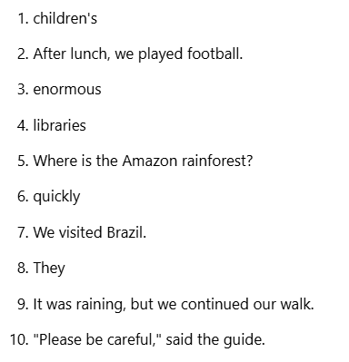

Reading comprehension


