Year 3 Homework Summer 2nd Week 1 1.6.26
Please find below three English tasks and three Mathematics tasks for children to complete for their homework this week.
It should be completed in the pink homework book that was sent home at the start of the year. Please complete in pencil or blue handwriting pen. Any lines drawn (such as when underlining the date) should be in pencil WITH a ruler/ straight edge.
Each week remember to write and underline the date and rule off the last’s week’s work. This will reinforce the presentation standards we have in class. There is no need to print this sheet. Please only write the answers in the homework book.
Our recommendation is that children complete Task 1 for English and Maths on Tuesday, Task 2 for both on Wednesday and Task 3 for both on Thursday. This short, frequent style of homework will support children to consolidate their learning. Spellings and tables will be tested on Friday. Homework is due on Friday.
The expectation is that children mark alongside parents/carers or self-mark. We use a green pen to tick answers in class and make corrections in purple pen, but please use any pen you have available at home. Answers are below the questions.
Children are to show their completed MARKED homework on FRIDAY morning, alongside their red reading record to show they have read aloud to someone at home.
English
Task 1:  Grammar and punctuation | Task 2:  Reading comprehension | Task 3:  Spelling Pattern/ Tables Focus
LI: To use commas in a list  Copy these sentences on best JOINED writing and add the commas.  Remember you don’t need a comma for the last item in a list as you have used ‘and’  - I completed my reading spelling and tables homework tonight.  - Sam belongs to football hockey and cricket club.  - Tim needs to buy bread milk butter and cheese on the way home tonight.  - The creature had long gnarled and pointed hands.  - All around were broken pots damaged boxes and a burst tyre.  - Jack felt his heart pound his legs shake and his palms became sweaty.  Now mark your answers.  Remember to read your reading book with someone at home and record this in your reading record. | LI: To understand that inference skills need me to decide what is happening from the clues I can see or read  There is no need to write your answers down today. Instead talk to someone at home about what you think the answer to the questions would be and why/ how you know. There is no right or wrong answer. This activity is to practise looking for clues and explaining what they tell you.  The clues are in the picture so look carefully.  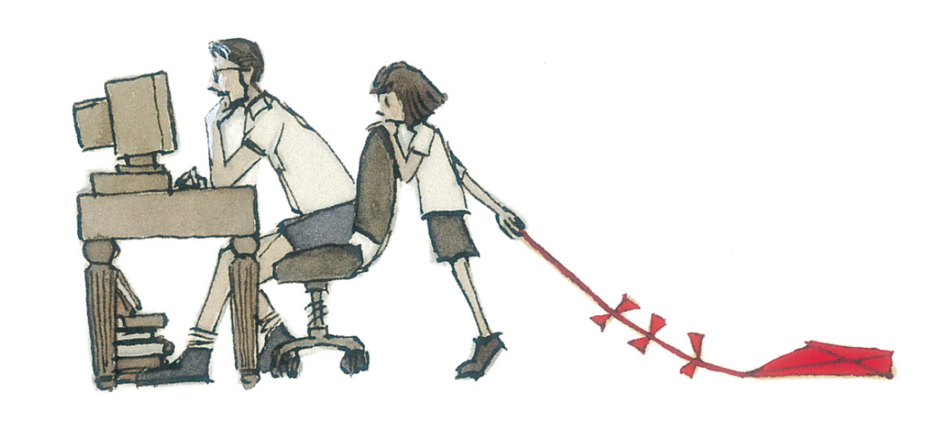  Credit: Aaron Becker (once upon a picture website)  - What is the dad doing?  - Why is the girl standing behind him?  - Has she said anything to him? Does he know she’s there?  - How is she feeling? What is she thinking?  - Do you think this has happened before? Why/why not?  Now read your reading book to someone at home and answer their questions. Why or how questions will help you to practise inference skills. You may also wish to watch a family movie together and ask each other how and why questions.  Remember to read your reading book with someone at home and record this in your reading record. | To revise x12 and revise spellings  wrap  wren  wrapped  wrong  wrote  write  writing  which  where  who  You do not need to record this task in your homework book.  Remember to read your reading book with someone at home and record this in your reading record.

Mathematics

Task 1:  Fluency | Task 2:  Varied Fluency | Task 3:  Reasoning
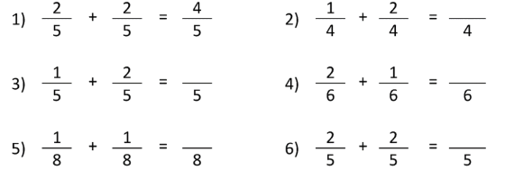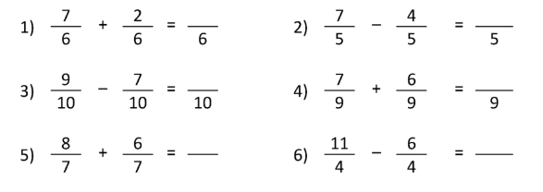 | 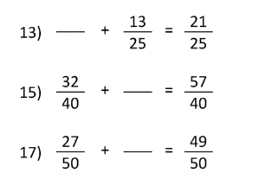  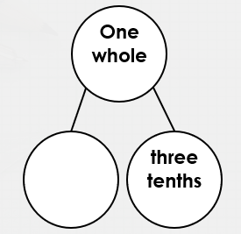  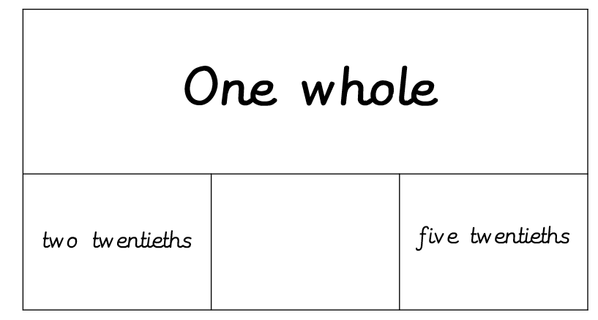 | Find as many ways as you can to complete the calculation below (make the whole using twelfths).  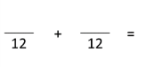

Maths Answers
Fluency answers:
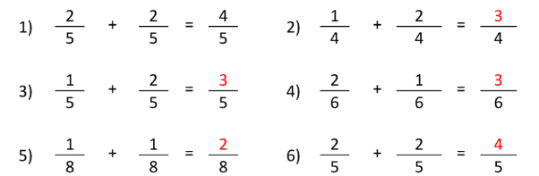
Varied fluency answers:
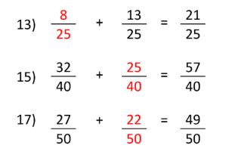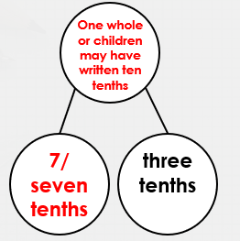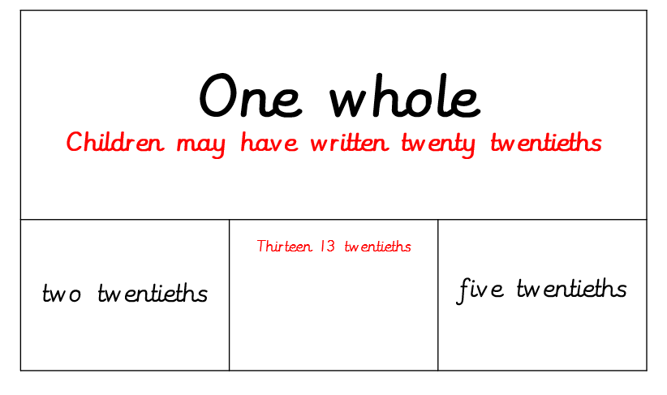
Reasoning answers:
Many answers as long as the numerators add up to 12. (Some children may think outside the box and also use three fractions or more).

English Answers
Grammar and punctuation
- I completed my reading, spelling and tables homework tonight.
- Sam belongs to football, hockey and cricket club.
- Tim needs to buy bread, milk, butter and cheese on the way home tonight.
- The creature had long, gnarled and pointed hands.
- All around were broken pots, damaged boxes and a burst tyre.
- Jack felt his heart pound, his legs shake and his palms became sweaty.

Reading Comprehension
Answers will vary but there are examples below. When children answer inference questions, they must always give a reason why. It may be a particular word they have read in a text or a clue they have seen in a picture/film.
- What is the dad doing?
He is busy working on the computer. He is leaning on his hand thinking about something. He is staring and leaning into the screen. He is wearing a shirt. He is ignoring the girl pulling his chair. He is researching kites so he can help the girl.

- Why is the girl standing behind him?
She wants his attention and he is ignoring her. She wants to show him her kite. She wants him to take her to the park to play with her kite. She is peering at the screen to see what dad is doing.

- Has she said anything to him? Does he know she’s there?
He doesn’t know she is there because he is looking at the screen/ he hasn’t turned around. She is standing behind him. She is pulling on his chair. She is on tiptoes to be seen.
Or she has called him but he is ignoring her so she is pulling on his chair.

- How is she feeling? What is she thinking?
She is feeling a bit bored because she is not playing with her kite. She is thinking that she would like dad to play with her.

- Do you think this has happened before? Why/why not?
This hasn’t happened before because dad would have turned around/ the girl would not stand behind.
Or this has happened before so the dad is leaning forward on his chair/ the girl has brought a toy with her

