Homework
Please find below three English tasks and three Mathematics tasks for children to complete for their homework this week. Our recommendation is that children complete Task 1 for English and Maths on Tuesday, Task 2 for both on Wednesday and Task 3 for both on Thursday. This short, frequent style of homework will support children to consolidate their learning. Please find the answers on the class page. The expectation is that children mark alongside parents/carers or self-mark.
Children are to hand in their homework on Monday morning, alongside their reading record.
English: As Planned
Task 1:  Sentence work |  | Task 2:  Reading |  | Task 3:  Spelling
As a precursor to our work on our new English text we ask the children to have a go at mind mapping some ambitious vocabulary to describe the sea scene. |  | British Bird Reading Comprehension |  | Spellings:  began  best  better  birds  boat  book  Please practise these words throughout the week. We are randomly checking these words with the children.  Please revisit your letter formation. Target individual letters a few times throughout the week.
Mathematics
Task 1: | Task 2: |  | Task 3:
Play the symmetry game to practice identifying a line of symmetry.  https://www.topmarks.co.uk/symmetry/symmetry-matching | Create a poster showing and naming all of the different shapes you can find around the house. |  | 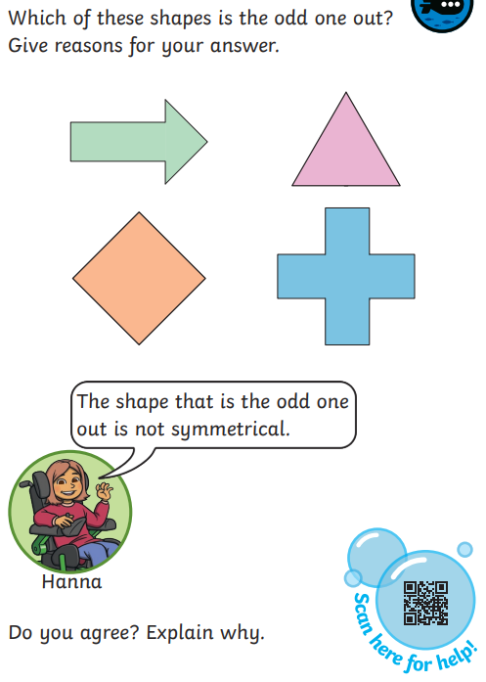

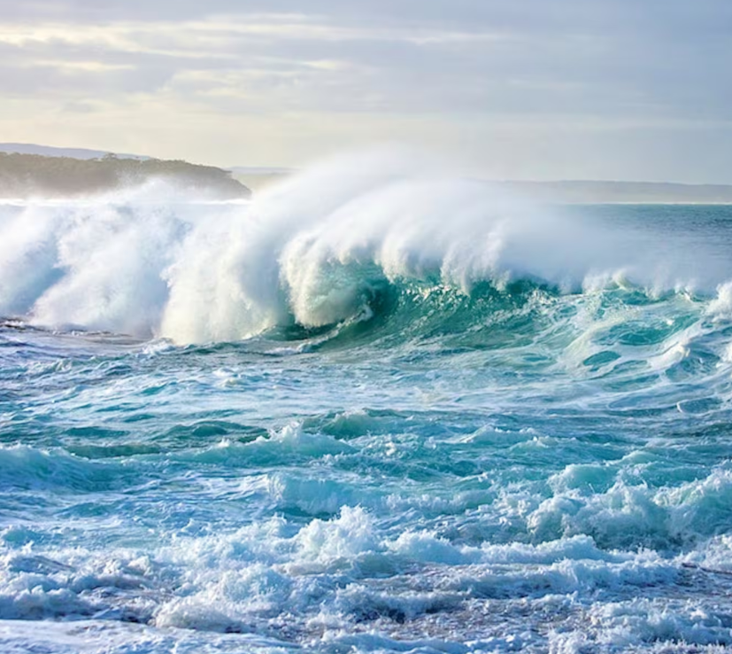

Maths answers


