Year 4 Homework Summer 2 w/c 1.6.26
Please find below three English tasks and three Mathematics tasks for children to complete for their homework this week. Our recommendation is that children complete Task 1 for English and Maths on Tuesday, Task 2 for both on Wednesday and Task 3 for both on Thursday. This short, frequent style of homework will support children to consolidate their learning. Please find the answers on the class page. The expectation is that children mark alongside parents/carers or self-mark.
Children are to hand in their MARKED homework in their pink homework books on Monday morning, alongside their reading record.
English
Task 1:  Grammar and punctuation | Task 2:  Reading comprehension | Task 3:  Spelling Pattern
LI: To identify grammar and punctuation correctly within a sentence.  Look carefully at the question and then identify which sentence demonstrates the correct punctuation and grammar. Tick the correct answer.  Which sentence is correct?  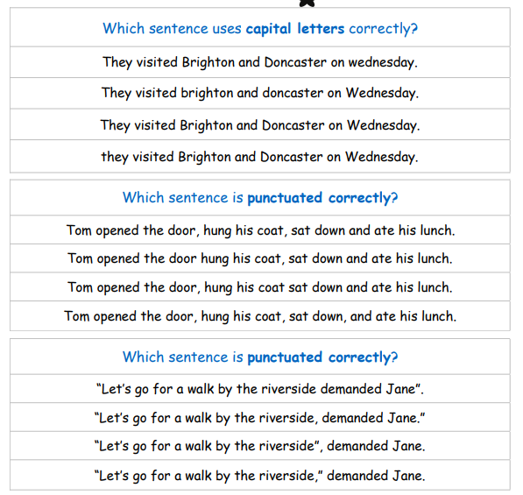  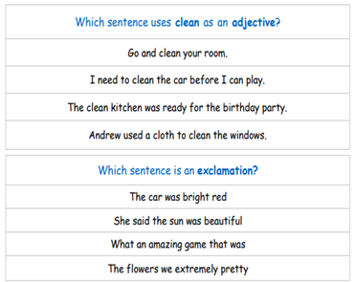 | LI: To read and comprehend  This half term we are learning about light in science. Read the text about Thomas Edison, the man who invented the lightbulb, and answer the following questions:  - Why did Thomas Edison not go to school?  - Explain in your own words how Thomas Edison got his first job.  3. Why did he want to work at night?  - What invention made Thomas famous and what did it do?  - Why did he want to invent the electric lightbulb?  - Why do you think he was known as the ‘Wizard of Menlo Park’? | LI: To practise spelling words  treasure  pleasure  pressure  assure  reassure  mixture  picture  creature  nature  adventure  Please practise the spellings using the Look Cover Spell Write methods  Spelling and tables tests will be held in class each Friday to monitor your progress.

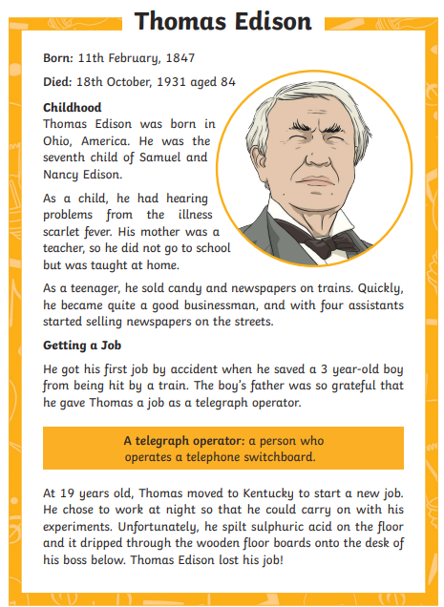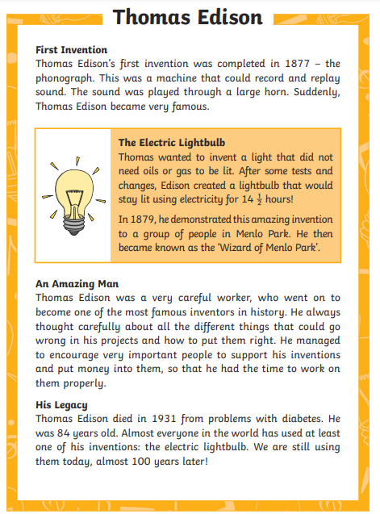

Mathematics
LI: To recall tables up to 12 x 12 instantly
Task 1:  Fluency | Task 2:  Fluency | Task 3:  Fluency
You should now know ALL your tables and be able to recall facts within 6 seconds accurately.  Use Mathsframe at least 5 times or an adult to test you. Write down in your book your best score out of 25.  There are empty tables squares at the end of your homework. Print these and keep copies at home so you can practise every day. | You should now know ALL your tables and be able to recall facts within 6 seconds accurately.  Use Mathsframe at least 5 times and write down in your book your best score out of 25.  There are empty tables squares at the end of your homework. Print these and keep copies at home so you can practise every day. | You should now know ALL your tables and be able to recall facts within 6 seconds accurately.  Use Mathsframe at least 5 times and write down in your book any that you have got wrong.  There are empty tables squares at the end of your homework. Print these and keep copies at home so you can practise every day.

English Answers:
Tuesday:
- They visited Brighton and Doncaster on Wednesday.
- Tom opened the door, hung his coat, sat down and ate his lunch.
- “Let’s go for a walk by the riverside,” demanded Jane.
- The clean kitchen was ready for the birthday party.
- What an amazing game that was!
Wednesday:
1. Why did Thomas Edison not go to school? Thomas Edison did not go to school because he had hearing difficulties from scarlet fever and his mother, who was teacher, taught him from home.
2. Explain in your own words how Thomas Edison got his first job. Pupil’s own response based on Thomas saving a 3 year-old boy from a train accident and the boy’s father being so grateful that he gave Thomas a job.
3. Why did he want to work at night? Thomas wanted to work at night so he could carry on with his experiments.
4. What invention made Thomas famous and what did it do? The invention that made Thomas famous was the phonograph. It recorded and replayed sounds.
5. Why did he want to invent the electric lightbulb? He wanted to invent the electric lightbulb so that lights did not need oils or gas to be lit.
6. Why do you think he was known as the ‘Wizard of Menlo Park’? Pupil’s own response based on the electric light appearing to work like magic and that people thought that he was a wizard.

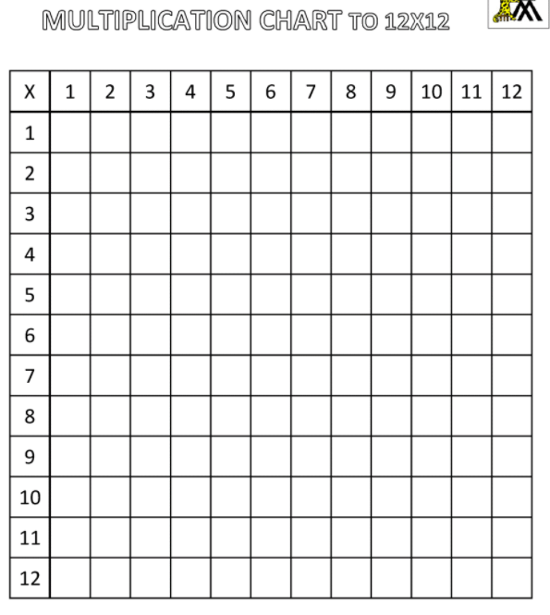

Maths Answers


