Year 5 Homework -Summer Term 1 2.06.25
Please find below three English tasks for children to complete for their homework this week. Our recommendation is that children complete Task 1 for English and Maths on Tuesday, Task 2 for both on Wednesday and Task 3 for both on Thursday. This short, frequent style of homework will support children to consolidate their learning. Please find the answers on the class page. The expectation is that children mark alongside parents/carers or self-mark.
Children are to hand in their MARKED homework in their pink homework books on Monday morning, alongside their reading record.
English
Task 1:  Grammar and punctuation | Task 2:  Reading comprehension | Task 3:  Spelling Pattern
LI: To read and comprehend  Answer questions 1-9 on Phone Trouble.  See below | LI: To read and comprehend  Read the text carefully about Phone Trouble and answer the questions using the information from the text.  (See Separate attachment)  Answer questions 10-14 on the next page. | LI: To practise spelling words  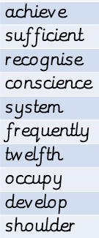  Please practise the spellings using the Look Cover Spell Write methods  Spelling and tables tests will be held in class each Friday to monitor your progress.
Fluency: | Maths  Varied Fluency: | Reasoning:
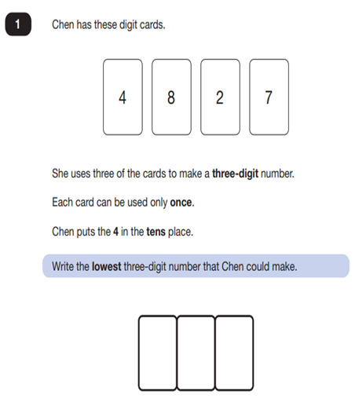 | 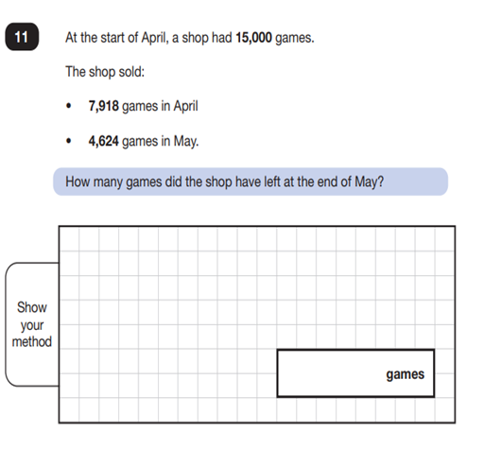 | 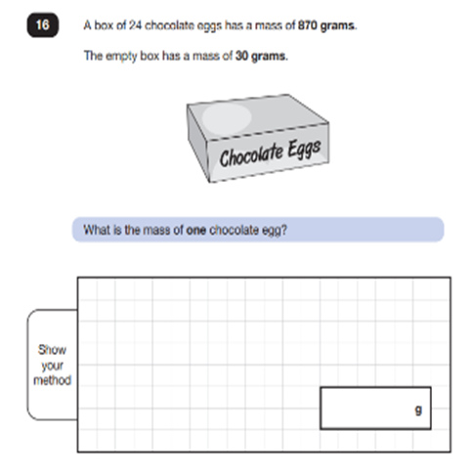

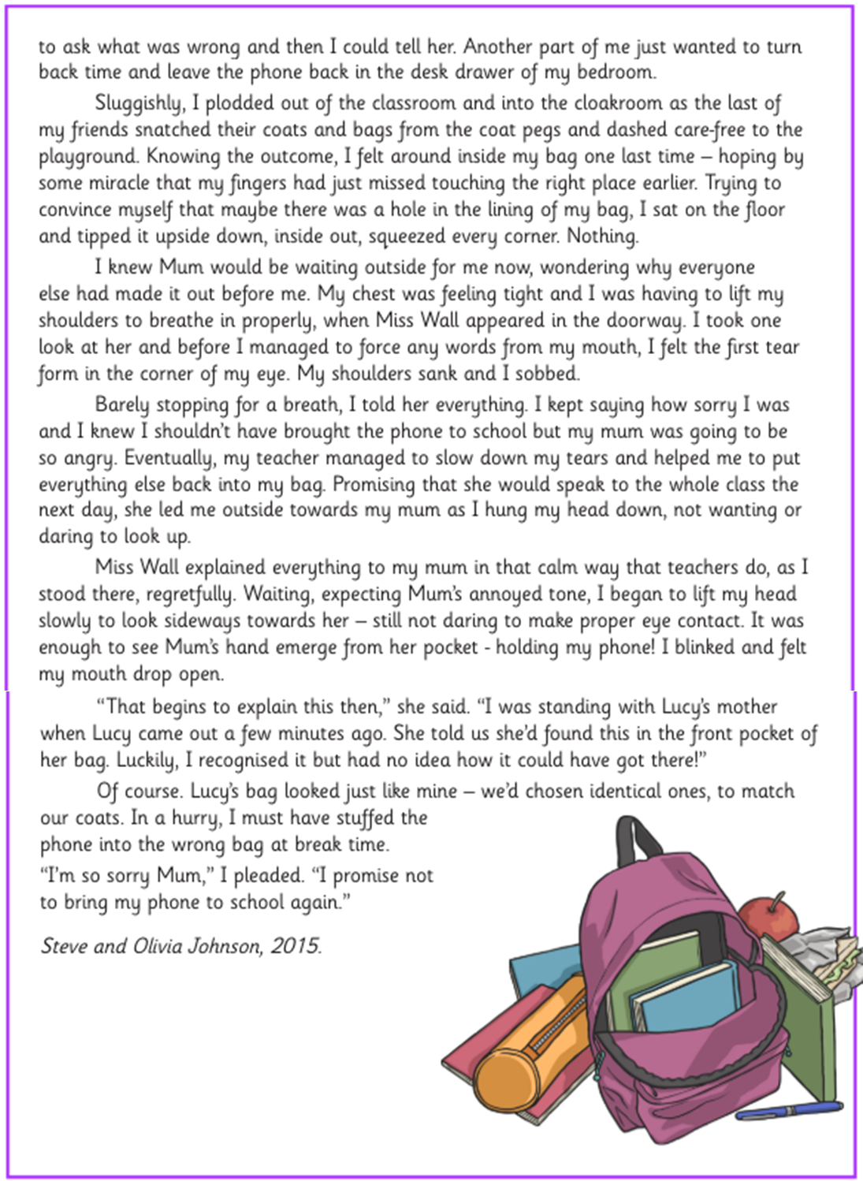
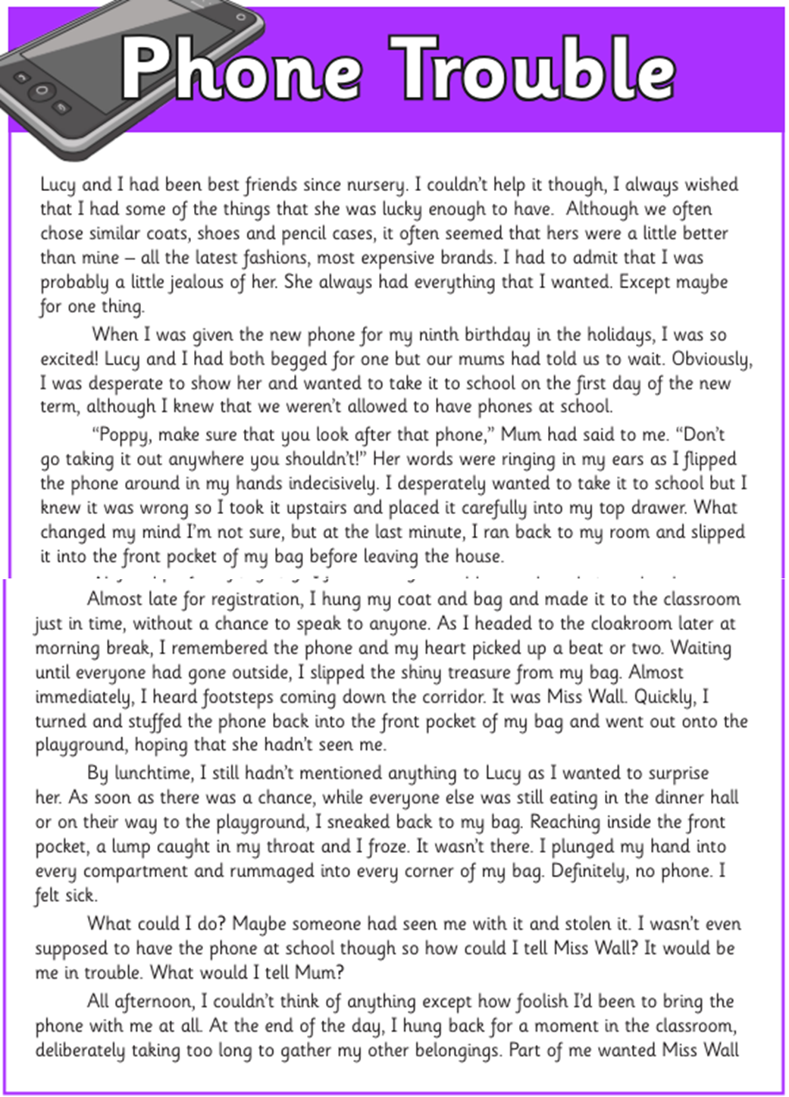
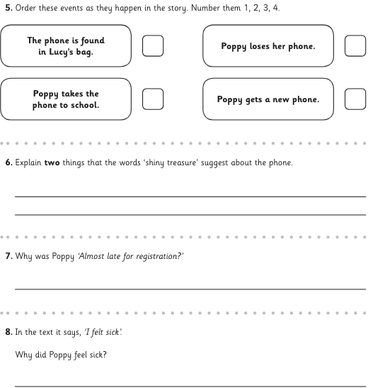
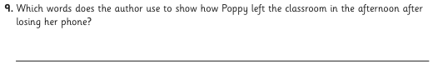
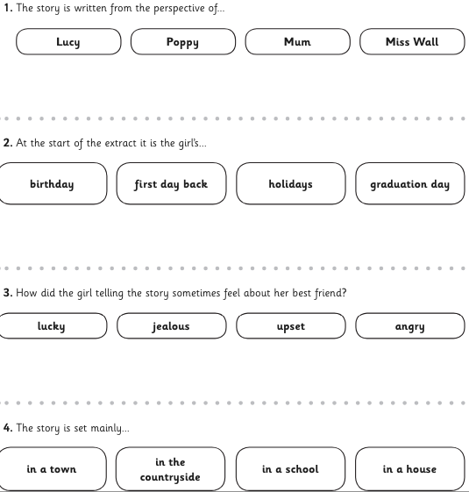

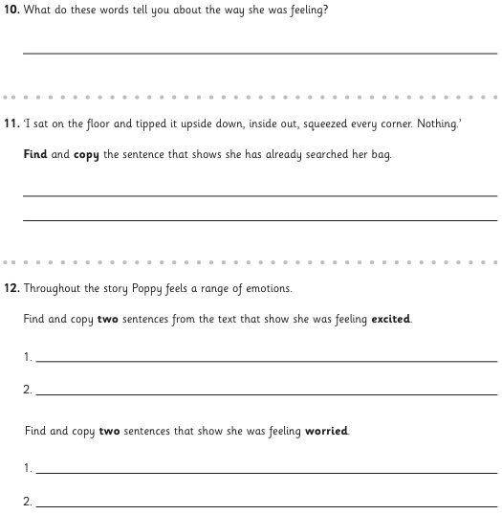
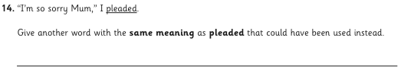
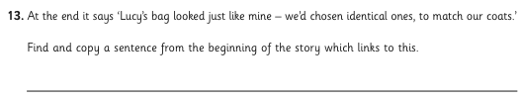

Answers – English Tuesday / Wednesday
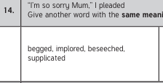
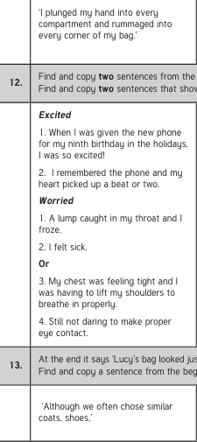
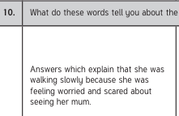
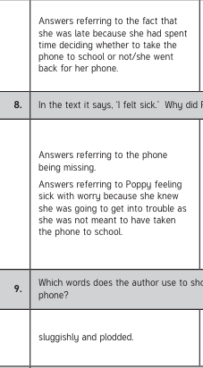
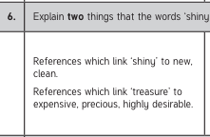
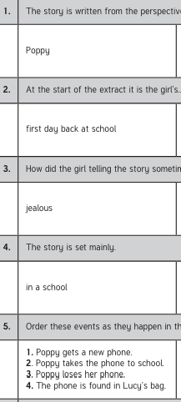

Maths Answers:
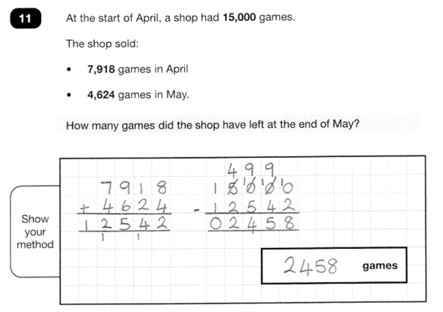
Task 1 Task 2 Task 3


