Year 4 Homework Spring 1st w/c 18.05.2026
Please find below three English tasks and three Mathematics tasks for children to complete for their homework this week. Our recommendation is that children complete Task 1 for English and Maths on Tuesday, Task 2 for both on Wednesday and Task 3 for both on Thursday. This short, frequent style of homework will support children to consolidate their learning. Please find the answers on the class page. The expectation is that children mark alongside parents/carers or self-mark.
Children are to hand in their MARKED homework in their pink homework books on Monday morning, alongside their reading record.
English
Task 1:  Grammar and punctuation | Task 2:  Reading comprehension | Task 3:  Spelling Pattern
LI: To revise apostrophes for contraction  Contractions  You can use apostrophes to show that you have omitted (left out) some letters when you are joining words together.  For example, you can join the words ‘you’ and ‘are’ together. You + are = you're. The apostrophe takes the place of the removed letters. In this example, the letter a.  Sometimes, however, you need to rearrange the letters a bit when you contract the words. For example: will + not = won't.  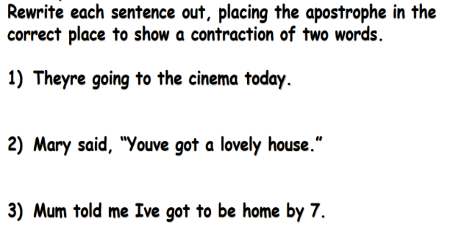  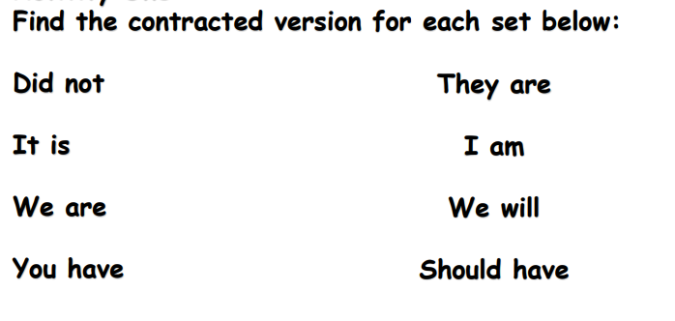  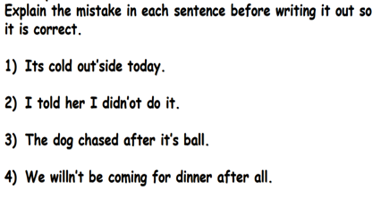 | LI: To read and comprehend  Year 4 are currently exploring persuasive writing and language in English as well as the impact of living things and their habitats in science. Read the text, ‘Rubbish on the School Playground’ and answer the questions using the information from the text to guide your answers.  1. What is the topic of this text?  2. Is the author for or against this topic? How do you know?  3. What reasons does the author give to support their opinion?  4. Who could the author be writing this text to?  5. What emotive words or phrases does the author use to persuade the reader?  6. What connectives (words or phrases) has the author used to sequence the text?  7. List two reasons that support the author’s first argument that there is too much rubbish  on the playground because of laziness.  8. Do you think there is too much rubbish on your school’s playground? Why or why not? | LI: To practise spelling words  babies  babies’  baby’s  carries  tries  catches  chimneys  princess  princesses  princess’s  Please practise the spellings using the Look Cover Spell Write methods  Spelling and tables tests will be held in class each Friday to monitor your progress.

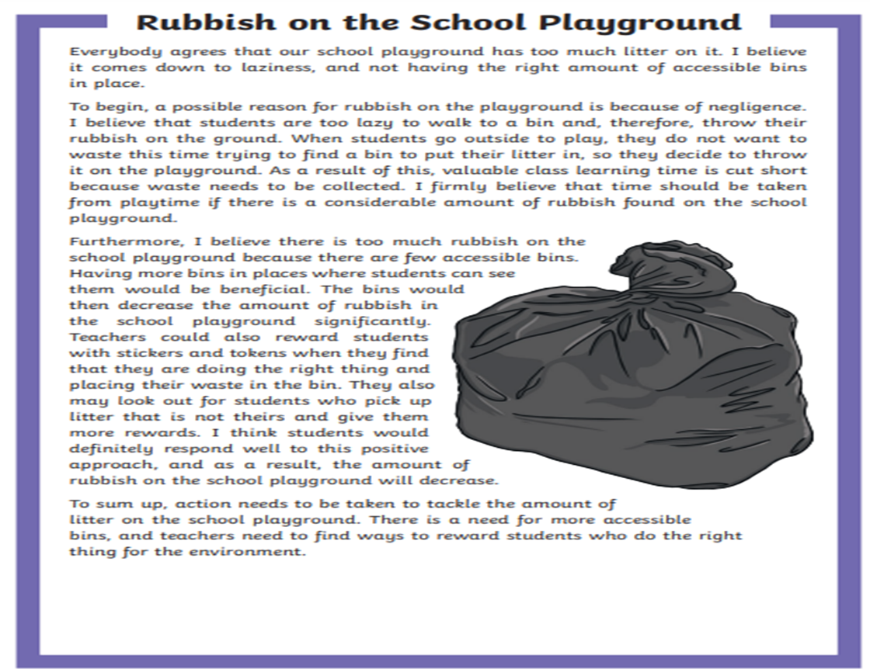
Mathematics
LI: To recall tables up to 12 x 12 instantly
Task 1:  FLUENCY | Task 2:  FLUENCY | Task 3:  FLUENCY
You should now know ALL your tables and be able to recall facts within 6 seconds accurately.  Use Mathsframe at least 5 times or an adult to test you. Write down in your book your best score out of 25.  There are empty tables squares at the end of your homework. Print these and keep copies at home so you can practise every day.  Continue practise these at half term too. | You should now know ALL your tables and be able to recall facts within 6 seconds accurately.  Use Mathsframe at least 5 times and write down in your book your best score out of 25.  There are empty tables squares at the end of your homework. Print these and keep copies at home so you can practise every day.  Continue practise these at half term too. | You should now know ALL your tables and be able to recall facts within 6 seconds accurately.  Use Mathsframe at least 5 times and write down in your book any that you have got wrong.  There are empty tables squares at the end of your homework. Print these and keep copies at home so you can practise every day.  Continue practise these at half term too.

#English Answers:
Tuesday:
Didn’t
It’s
We’re
They’re
I’m
We’ll
2. They’re going to the cinema today.
Mary said, “You’ve got a lovely house.”
Mum told me I’ve got to be home by 7.
3. It’s cold outside today.
I told her I didn’t do it.
The dog chased after its ball.
We won’t be coming to dinner after all.
Wednesday: Reading comprehension.
Answers
1. What is the topic of this text?
The topic of this text is ‘Too Much Rubbish on the School Playground’.
2. Is the author for or against this topic? How do you know?
The author is for this topic. Answers will vary.
3. What reasons does the author give to support their opinion?
4. Who could the author be writing this text to?
Answers will vary, but may include:
5. What emotive words or phrases does the author use to persuade the reader?
• Laziness
• Not having the right number of accessible bins in place
• A teacher writing to persuade their Principal or Head of School
• A teacher writing to persuade their school board, P&C or P&F
• A parent writing to persuade a school
• Everybody agrees … (Paragraph 1)
• …students are too lazy… (Paragraph 2)
• … valuable time… (Paragraph 2)
• I firmly believe… (Paragraph 2)
• …decrease significantly… (Paragraph 3)
• …definitely respond… (Paragraph 3)
• …action needs to be taken… (Paragraph 4)
6. What connectives (words or phrases) has the author used to sequence the text?
• To begin…
• …therefore…
• As a result of this…
• Furthermore…
To sum up…
7. List two reasons that support the author’s first argument that there is too much rubbish on the playground because of laziness.
• Students are too lazy to walk to a bin and, therefore,
throw their rubbish on the ground.
• Students do not want to waste playtime trying to find a bin to put their rubbish in.
8. Do you think there is too much rubbish on your school’s playground? Why or why not?
Answers will vary.

Maths Answers
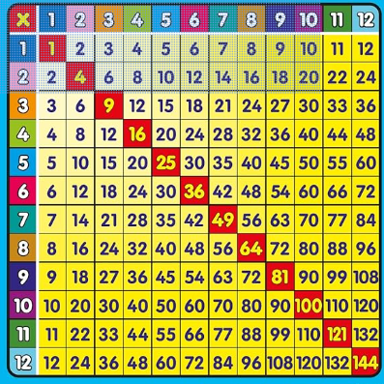
For example, you are able to show times like these on clocks to an adult at home.



