Year 3 Homework Summer 1st Term Week 1 18.05.26
Please find below three English tasks and three Mathematics tasks for children to complete for their homework this week.
It should be completed in the pink homework book that was sent home at the start of the year. Please complete in pencil or blue handwriting pen. Any lines drawn (such as when underlining the date) should be in pencil WITH a ruler/ straight edge.
Each week remember to write and underline the date and rule off the last’s week’s work. This will reinforce the presentation standards we have in class. There is no need to print this sheet. Please only write the answers in the homework book.
Our recommendation is that children complete Task 1 for English and Maths on Tuesday, Task 2 for both on Wednesday and Task 3 for both on Thursday. This short, frequent style of homework will support children to consolidate their learning. Spellings and tables will be tested on Friday. Homework is due on Friday.
The expectation is that children mark alongside parents/carers or self-mark. We use a green pen to tick answers in class and make corrections in purple pen, but please use any pen you have available at home. Answers are below the questions.
Children are to show their completed MARKED homework on FRIDAY morning, alongside their red reading record to show they have read aloud to someone at home.
English
Task 1:  Grammar and punctuation | Task 2:  Reading comprehension | Task 3:  Spelling Pattern/ Tables Focus
LI: To use commas in lists and to separate subordinate clauses  Copy these sentences in joined handwriting and add in the missing commas.  We need to focus on using joined handwriting so we are Year 4 ready.  - Roz saw birds foxes squirrels and rabbits in the forest.  - She found berries nuts seeds and mushrooms to eat.  - The animals included otters deer raccoons and rabbits.  - Roz explored the island but she did not see any humans.  - Before Roz had to find shelter quickly the storm began.  - As the sun rose Roz walked along the beach.  Now mark your answers.  Remember to read your reading book with someone at home and record this in your reading record. | LI: To skim and scan for key words to find answers to questions  Roz stood on the highest point of the island and looked out at the world around her. She saw the ocean on all sides, the forest below, and many animals moving far and wide.  But Roz did not understand how she had come to be here. She did not know that she was built in a factory or that she had crossed the ocean on a cargo ship that sank in a storm. She did not know that a group of curious sea otters had accidentally pressed the button that switched her on. As far as Roz knew, this island was her home.  1. Where is Roz standing?  2. What can Roz see from the high point?  3. Find and copy a phrase that shows Roz  doesn’t know how she got to the island.  4. Find and copy a word that meant the otters didn’t mean to make Roz work.  5. Find and copy a phrase that means the animals were spread throughout the forest.  5. What happened to the cargo ship?  Now mark your answers.  Remember to read your reading book with someone at home and record this in your reading record. | To revise x6 and revise spellings  (Alternative grapheme s spelt ‘sc’ Greek Origin)  scene. scenic, scent, crescent, fascinate, disciple, science, scientist, ascend, descend,  You do not need to record this task in your homework book.  Remember to read your reading book with someone at home and record this in your reading record.

Mathematics

Task 1:  Fluency | Task 2:  Varied Fluency | Task 3:  Reasoning
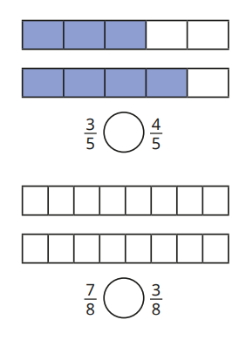  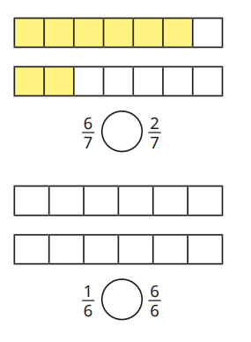  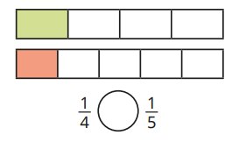 | 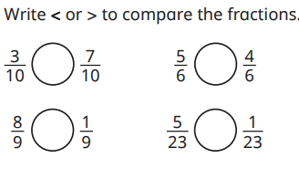  Put in ascending order  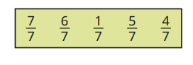  Put in descending order  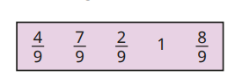 | Tiny says that one third is bigger than one half. Is he correct?  Tiny says that one twelfth is bigger than one fifth. Is he correct?  Timy says that eight eighths is less than one whole. Is he correct?  Tiny has ordered some fractions. is he correct.  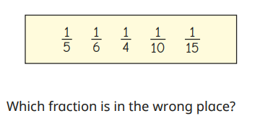

Maths Answers
Fluency
<, >, >, <

Varied Fluency
Problem Solving/ Reasoning
Tiny says that one third is bigger than one half. Is he correct? No
Tiny says that one twelfth is bigger than one fifth. Is he correct? No
Tiny is looking at the denominator and confusing it.
Timy says that eight eighths is less than one whole. Is he correct? No
If the numerator is the same as the denominator then you have a whole number or one.
One quarter is in the wrong place.

English Answers
Grammar and punctuation
- Roz saw birds, foxes, squirrels and rabbits in the forest.
- She found berries, nuts, seeds and mushrooms to eat.
- The animals included otters, deer, raccoons and rabbits.
- Roz explored the island, but she did not see any humans.
- Before Roz had to find shelter quickly, the storm began.
- As the sun rose, Roz walked along the beach.

Reading Comprehension (wording may be different)
Highest point on the island
Oceans, forests and animals
Did not understand how she came to be there
Accidentally
Far and wide
It sank in a storm



