Homework
Please find below three English tasks and three Mathematics tasks for children to complete for their homework this week. Our recommendation is that children complete Task 1 for English and Maths on Tuesday, Task 2 for both on Wednesday and Task 3 for both on Thursday. This short, frequent style of homework will support children to consolidate their learning. Please find the answers on the class page. The expectation is that children mark alongside parents/carers or self-mark.
Children are to hand in their homework on Monday morning, alongside their reading record.
English: As Planned
Task 1:  Sentence work |  | Task 2:  Reading |  | Task 3:  Spelling
Sentence writing. Use the word bank attached. |  | Rosa Park Comprehension  As attached. |  | Spellings:  away  baby  bear  because  been  before  Please practise these words throughout the week. We are randomly checking these words with the children.  Please revisit your letter formation. Target individual letters a few times throughout the week.
Mathematics
Task 1: | Task 2: |  | Task 3:
Play the shape sorting game to apply your knowledge of 2D shapes  https://www.topmarks.co.uk/carroll-diagrams/2d-shapes | 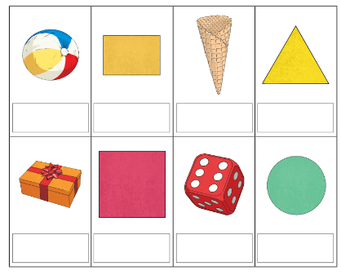  Name the shape. Tell your adult whether they are 2d or 3d shapes. |  | Go on a shape hunt. How many different shapes can you find? List some of them and say whether they are 2d or 3d shapes.  Happy hunting!

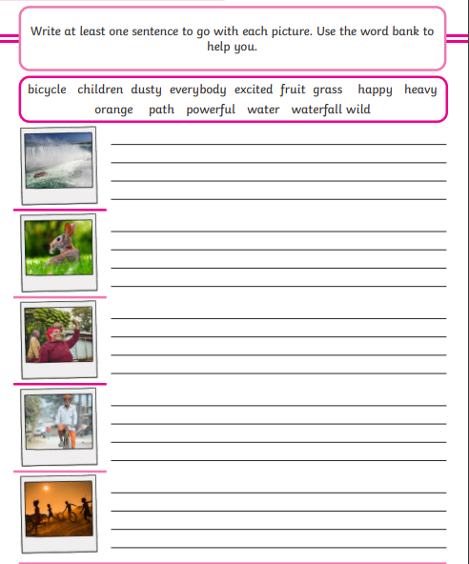
Sentence Writing



