Year 3 Homework Summer 1st Term Week 1 11.05.26
Please find below three English tasks and three Mathematics tasks for children to complete for their homework this week.
It should be completed in the pink homework book that was sent home at the start of the year. Please complete in pencil or blue handwriting pen. Any lines drawn (such as when underlining the date) should be in pencil WITH a ruler/ straight edge.
Each week remember to write and underline the date and rule off the last’s week’s work. This will reinforce the presentation standards we have in class. There is no need to print this sheet. Please only write the answers in the homework book.
Our recommendation is that children complete Task 1 for English and Maths on Tuesday, Task 2 for both on Wednesday and Task 3 for both on Thursday. This short, frequent style of homework will support children to consolidate their learning. Spellings and tables will be tested on Friday. Homework is due on Friday.
The expectation is that children mark alongside parents/carers or self-mark. We use a green pen to tick answers in class and make corrections in purple pen, but please use any pen you have available at home. Answers are below the questions.
Children are to show their completed MARKED homework on FRIDAY morning, alongside their red reading record to show they have read aloud to someone at home.
English
Task 1:  Grammar and punctuation | Task 2:  Reading comprehension | Task 3:  Spelling Pattern/ Tables Focus
We need to focus on using joined handwriting so we are Year 4 ready.  Copy these sentences and put in the missing apostrophes.  LI: To use apostrophes  I cant remember where to put apostrophes.  I hadnt practised for a while.  Ill be great by the end of this activity.  My teachers smile will be massive.  My dogs tail will wag when I have finished.  Todays lesson is completed.  Now mark your answers.  Remember to read your reading book with someone at home and record this in your reading record. | LI: To identify the meaning of new words  This week, look for at least five new words in your reading books and find out their meaning.  Put these words into your own sentence to prove you understand what they mean.  You can tell an adult your sentence rather than writing it in your book as our focus this week is to use new words to show you understand them.  As an extra activity, challenge your grown ups at home to use the new word first by the end of the day.  Now mark your answers.  Remember to read your reading book with someone at home and record this in your reading record. | To revise x6 and revise spellings  Y elsewhere but not the end of a word  myth, eyes, pyramid, mythical, mystery, gym, hymn, goodbye, rhythm, symbol  You do not need to record this task in your homework book.  Remember to read your reading book with someone at home and record this in your reading record.

Mathematics

Task 1:  Fluency | Task 2:  Varied Fluency | Task 3:  Reasoning
What fraction is shaded?  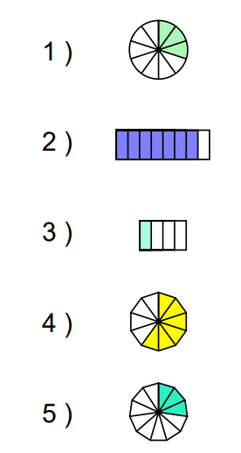  Draw a rectangle with 4 squares in your homework book. Shade in two quarters in different ways.  Practise more questions like these if you are finding them tricky. Here is a website you can use to create a fraction worksheet:  https://www.math-aids.com/Fractions/Fractions_Visual.html | What fraction goes with these to make the whole?  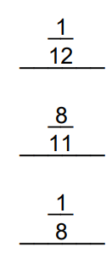  Copy and complete using < or > or =  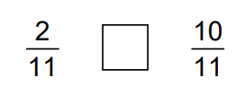  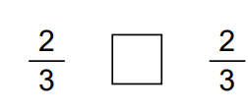  Put these fractions in descending order:  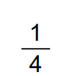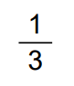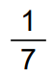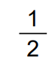 | A postman has completed four fifths of his round, how much has he got left?  I used up seven twelfths of a piece of ribbon. How much is left?  There is three eighths of a birthday cake left. How much was eaten?  A football stadium was filled with seven elevenths of home fans. If every seat in the stadium was taken up, what fraction of away fans were there?  A jug is filled with orange squash. If one quarter was orange, what fraction was water?  Two thirds of a class were boys, so what fraction of the class was not boys?

Maths Answers
Fluency
3/ 10, 7/8, ¼, 6/10, 3/11
Any of the two out of 4 squares coloured. There are many possible answers.
Varied Fluency
11/12, 3/11, 7/8
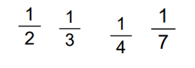
Problem Solving/ Reasoning
One fifth, 5 twelfths, 5 eighths, 4 elevenths, three quarters, one third

English Answers
Grammar and punctuation –
NB Please makes sure apostrophes are in a clear space of their own/ between letters. Children might be tempted to put an apostrophe whenever they write a word containing the letter ‘s’. Please help to ensure they understand that writing thi’s is incorrect.
I can’t remember where to put apostrophes.
I hadn’t practised for a while.

I’ll be great by the end of this activity.
My teacher’s smile will be massive.
My dog’s tail will wag when I have finished.
Today’s lesson will be complete.

Reading Comprehension – answers will be individual



