Year 4 Homework Spring 1st w/c 11.5.2026
Please find below three English tasks and three Mathematics tasks for children to complete for their homework this week. Our recommendation is that children complete Task 1 for English and Maths on Tuesday, Task 2 for both on Wednesday and Task 3 for both on Thursday. This short, frequent style of homework will support children to consolidate their learning. Please find the answers on the class page. The expectation is that children mark alongside parents/carers or self-mark.
Children are to hand in their MARKED homework in their pink homework books on Monday morning, alongside their reading record.
English
Task 1:  Grammar and punctuation | Task 2:  Reading comprehension | Task 3:  Spelling Pattern
LI: To consolidate the use of noun phrases.  An expanded noun phrase gives more detail or information about a noun. This is usually done by adding adjectives to describe the noun in the noun phrase, for example:  She walked through the dark, mysterious forest.  Or by adding a prepositional phrase to add further information about the noun, such as:  The man with the wooden walking stick walked slowly across the road.  Read the following sentences. Underline or circle the expanded noun phrase in each sentence that has been expanded with a prepositional phrase.  - Under the waves, the fish with the jagged fins swam swiftly through the reef.  - The cat under the bush was drenched and shivering.  - From the cave, a dragon with deadly claws came crashing out.  - At the stables, Aisha chose to ride the horse with a black mane.  Re-write the following two sentences by expanding the description of the underlined noun using adjectives to describe them in more detail.  1.In the distance, an octopus meandered through the reef looking for its prey.  2. At the bottom of the ocean, the seaweed gently drifted in the warm currents. | LI: To read and comprehend  This week we are looking more closely at persuasive writing and the vocabulary used by the author to persuade you to do something. Read the text carefully and answer the questions.  1. What time did the show start at the Royal Ball?  2. Which traditional tale has the text TO ALL Trip-Trappers… been inspired by?  3. Look at the text, To All Trip Trappers… Find and copy one word that means the same as beg.  4. According to the advert, why should people use Kon-Krete instead of straw, sticks of bricks?  5. Which text uses a slogan to persuade the reader?  6. Look at the text To All Trip Trappers…How might the language that Mr T Toll has used convince people to stop walking across his bridge?  7. Discuss the texts Kon-Krete and A Review of the Royal Ball. How are they different?  8. Which of the texts do you think is more persuasive? Explain your choice. | LI: To practise spelling words  complete  exercise  describe  surprise  purpose  separate  minute  favourite  piece  believe  Please practise the spellings using the Look Cover Spell Write methods  Spelling and tables tests will be held in class each Friday to monitor your progress.
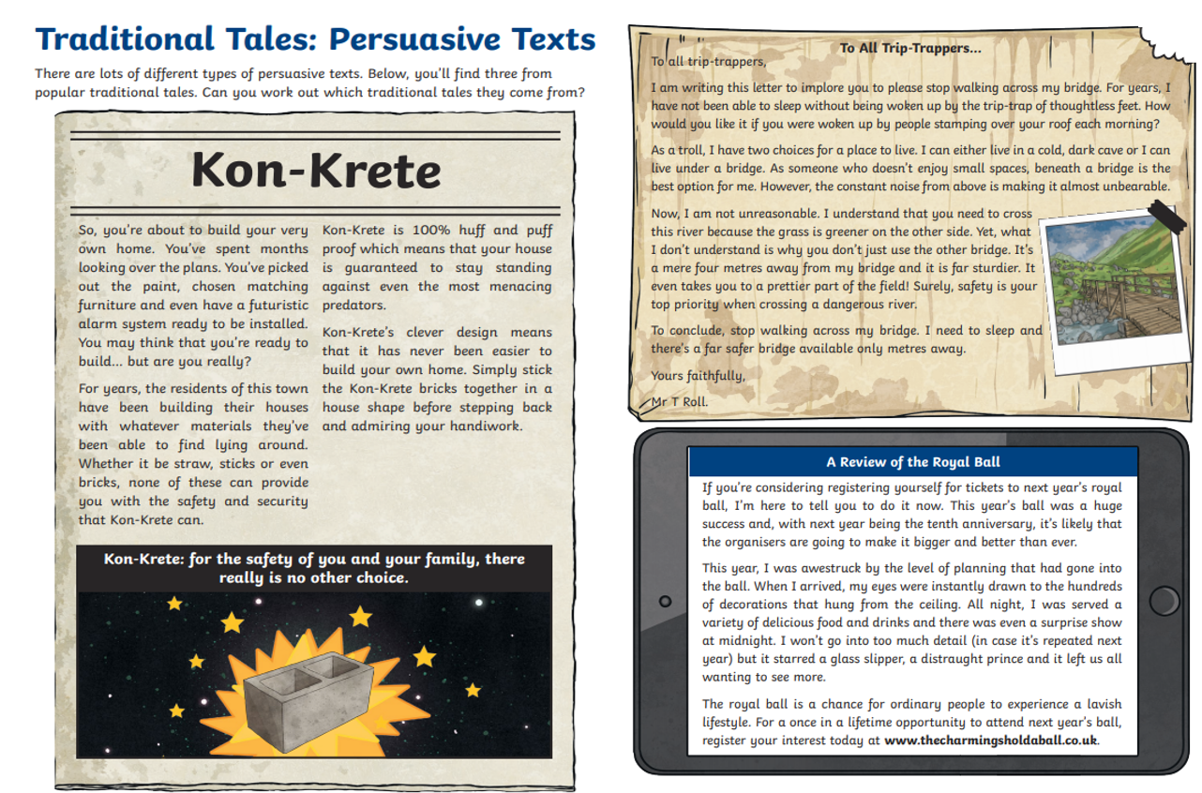

Mathematics
LI: To recall all my table facts up to 12 x 12
Task 1:  Fluency | Task 2:  Varied fluency | Task 3:  Problem solving and reasoning
You should now know ALL your tables and be able to recall facts within 6 seconds accurately.  Use Mathsframe at least 5 times or an adult to test you. Write down in your book your best score out of 25.  There are empty tables squares at the end of your homework. Print these and keep copies at home so you can practise every day. | You should now know ALL your tables and be able to recall facts within 6 seconds accurately.  Use Mathsframe at least 5 times and write down in your book your best score out of 25.  There are empty tables squares at the end of your homework. Print these and keep copies at home so you can practise every day. | You should now know ALL your tables and be able to recall facts within 6 seconds accurately.  Use Mathsframe at least 5 times and write down in your book any that you have got wrong.  Write any questions you have got wrong on paper/ post-its and put them around the house eg on the fridge, the mirror where you brush your teeth, wardrobe door, by the TV, back of the driver’s seat in your car.  Make these your focus tables facts and ask your family to ask you this whenever you’re not expecting it.  Choose from the suggested activities below to help practise your tables. There are more ideas on our webpage.

English Answers:
Tuesday:

Wednesday:
- Midnight
- The Three Billy Goats Gruff
- implore
- straw, sticks and bricks can’t provide you with the safety and security that KonKrete can.
- The text which uses a slogan to persuade the reader is Kon-Krete.
- Pupils’ own responses, such as: Mr T Roll uses words like ‘unbearable’ and ‘thoughtless’ that might make people feel sorry for him and stop using his bridge. He also speaks directly to the reader and asks them a question which might make people feel guilty.
- Accept any response provided that a full explanation is given, such as: I think that Kon-Krete was the most persuasive because it started out by mentioning a problem which was that houses can be unsafe. It then explained how Kon-Krete could solve that problem. It also made Kon-Krete seem simple and easy to use.
Maths Answers
Activities to help your practise your hardest table facts:


