Homework
Please find below three English tasks and three Mathematics tasks for children to complete for their homework this week. Our recommendation is that children complete Task 1 for English and Maths on Tuesday, Task 2 for both on Wednesday and Task 3 for both on Thursday. This short, frequent style of homework will support children to consolidate their learning. Please find the answers on the class page. The expectation is that children mark alongside parents/carers or self-mark.
Children are to hand in their homework on Monday morning, alongside their reading record.
English: As Planned
Task 1:  Sentences | Task 2:  Reading | Task 3:  Spelling
This week we have looked at conjunctions and tried to include them in our writing.  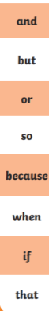  Write some sentences to include the following conjunctions. | Reading Comprehension:  Florence Nightingale | Spellings:  sure  told  water  whole  who  Please practise these words throughout the week. We are randomly checking these words with the children.  Please revisit your letter formation. Target individual letters a few times throughout the week.

Mathematics
Task 1:  Fluency | Task 2:  Varied Fluency | Task 3:  Reasoning
Recall your knowledge of finding ¼  ¼ of 12 =  ¼ of 16 =  ¼ of 24 =  ¼ of 40 = | Find 1/2 of the numbers  ½ of 12 =  ½ of 16 =  ½ of 24 =  ½ of 40 = | Eva says ½ of 20 is more than ¼ of 16? Is she right? Prove your answer.

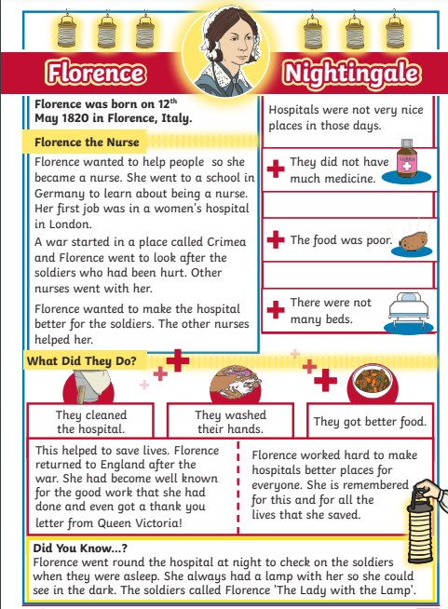

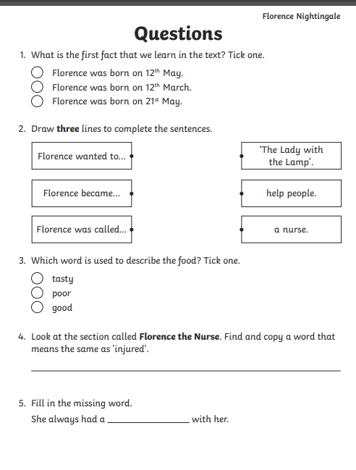
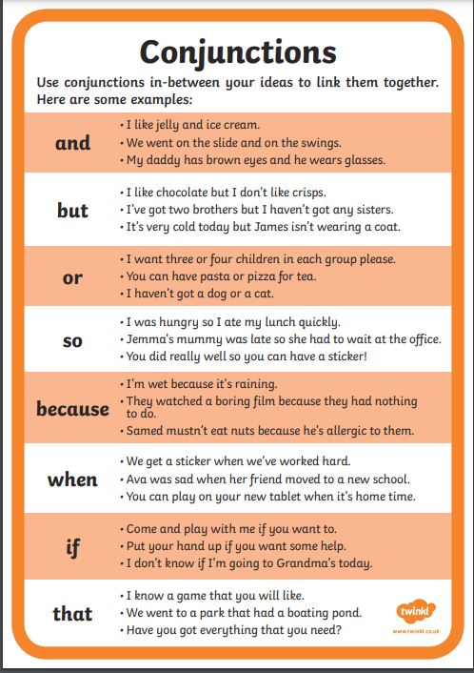
Use the examples to help you think of your own sentences. Write a sentence which includes each of these conjunctions.

