Children are to hand in their MARKED homework in their pink homework books on Monday morning, alongside their reading record.
Maths
Complete the worksheet below (allowing no more than 10 minutes at a time to help with focus, spread out across the week) – continues on next page.

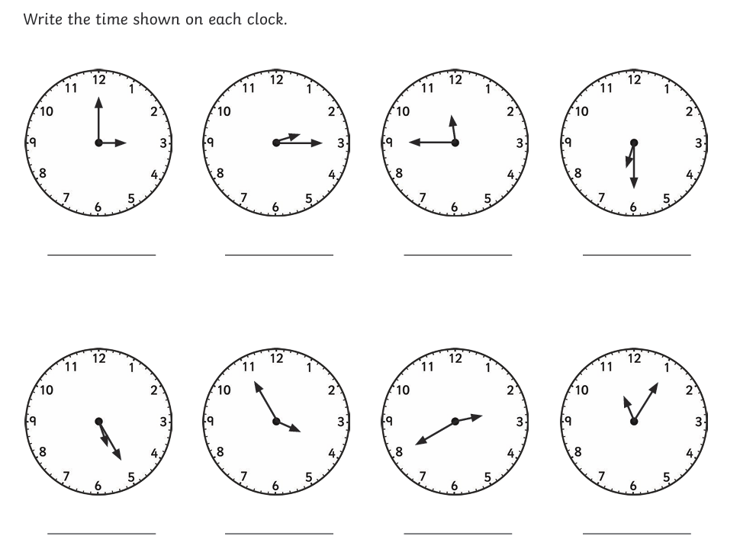

Continued:
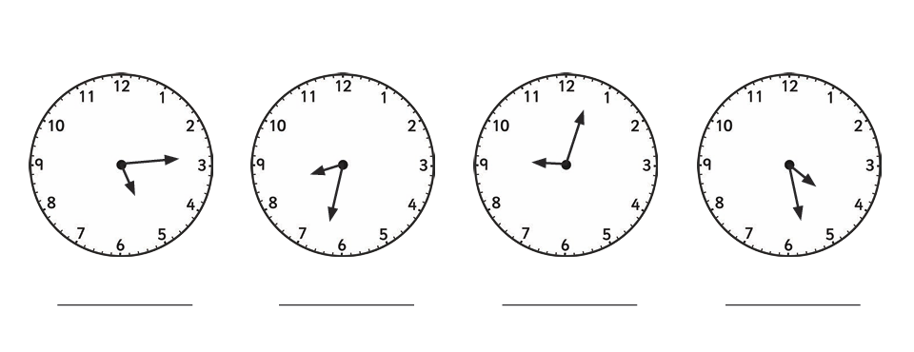

Answers (can be in any format):


