Year 3 Homework Summer 1st Term Week 1 4.05.26
Please find below three English tasks and three Mathematics tasks for children to complete for their homework this week.
It should be completed in the pink homework book that was sent home at the start of the year. Please complete in pencil or blue handwriting pen. Any lines drawn (such as when underlining the date) should be in pencil WITH a ruler/ straight edge.
Each week remember to write and underline the date and rule off the last’s week’s work. This will reinforce the presentation standards we have in class. There is no need to print this sheet. Please only write the answers in the homework book.
Our recommendation is that children complete Task 1 for English and Maths on Tuesday, Task 2 for both on Wednesday and Task 3 for both on Thursday. This short, frequent style of homework will support children to consolidate their learning. Spellings and tables will be tested on Friday. Homework is due on Friday.
The expectation is that children mark alongside parents/carers or self-mark. We use a green pen to tick answers in class and make corrections in purple pen, but please use any pen you have available at home. Answers are below the questions.
Children are to show their completed MARKED homework on FRIDAY morning, alongside their red reading record to show they have read aloud to someone at home.
English
Task 1:  Grammar and punctuation | Task 2:  Reading comprehension | Task 3:  Spelling Pattern/ Tables Focus
LI: To use inverted commas (speech marks)  Copy and add inverted commas.  We need to focus on using joined handwriting so we are Year 4 ready.  - Roz said I must learn to survive on this island.  - The bird chirped Follow me!  - Roz replied Thank you for helping me.  - Roz exclaimed I hope I can make friends here!  - The bird said Come this way!  Now mark your answers.  Remember to read your reading book with someone at home and record this in your reading record. | LI: To understand the meaning of new words  Copy and complete these sentences to show your understanding of new words. Used joined writing.  mechanical • companions • survival • explores • unfamiliar  - Roz is a __________ robot who wakes up alone on a remote island.  - She _________ the wilderness to learn about her surroundings.  - Over time, Roz makes new __________ with the animals on the island.  - The island is full of creatures and places that are __________ to Roz.  - Learning how to adapt is key to her __________ on the island.  Now mark your answers.  Remember to read your reading book with someone at home and record this in your reading record. | To revise x6 and revise spellings  weight, weigh, vein, eighteen, neighbour, grey, sleigh, they, obey, reign  You do not need to record this task in your homework book.  Remember to read your reading book with someone at home and record this in your reading record.

Mathematics

Task 1:  Fluency | Task 2:  Varied Fluency | Task 3:  Reasoning
These answers will have no remainders:  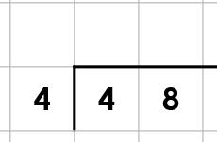  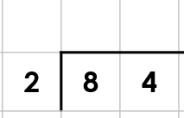  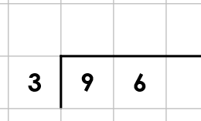  These answers will have a remainder at the end:  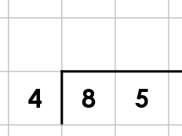  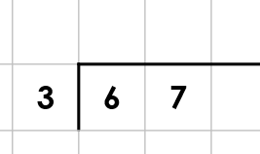  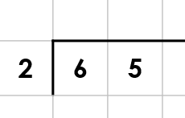  Practise more questions like these instead of task 2/ 3 if you found these tricky.  Now practise dividing by 2,3,4,5,6,8,10.  On your own write out your tables in a list as quickly as you can. | Write out your tables to help you answer these. There will be a remainder.  You won’t need to rewrite all of these as the bus stop method. You will need to decide.  26 ÷ 5 =  76 ÷ 4 =  89 ÷ 8 =  75 ÷ 6 =  88 ÷ 3=  76 ÷ 10 =  Think – are remainders always one? Can they be more?  Note to parents: Please support your child by saying “Draw dots and circle groups to help you work independently if you are stuck”.  Now practise dividing by 2,3,4,5,6,8,10.  Your adults at home may use a number with a remainder eg  How many tens go into 64?  Or how many groups of 4 can you make from 25? | 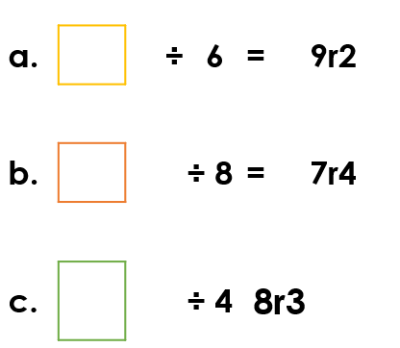  What has Tiny done wrong?  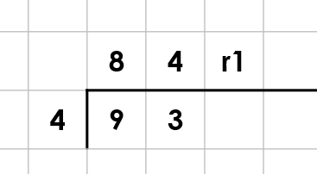  Tiny thinks that 47 divided by 5 will have a remainder> Is he correct? Explain your answer  Tiny thinks any odd number divided by 2 or 4 or 8 will have a remainder, is he correct. Explain your answer.

Maths Answers
Fluency answers:
12
42
32
21r1
22r1
32r1
Varied Fluency
26 ÷ 5 = 5r 1
76 ÷ 4 =19
89 ÷ 8 =11r1
75 ÷ 6 =12r3
88 ÷ 3=29r1
76 ÷ 10 =7r6

Problem Solving/ Reasoning
56
60
35

Tiny has said that 9 tens into groups of 4 is 8 groups. He means 2 groups. (8 tens was the number he grouped without a remainder)
Yes 47 divided by 5 is 9 r 2. Any multiple of 5 must end in 5 or 0. If a number ends with 7 it will have a remainder 2 when dividing by 5.
(Note to parents please help your child to explain in as much detail as the example above)
All multiples of 2,4,8 are even. Therefore if a number is odd it will have a remainder when divided by 2,4,8.

English Answers
Grammar and punctuation
- Roz said, “I must learn to survive on this island.”
- The bird chirped, “Follow me!”
- Roz replied, “Thank you for helping me.”
- Roz exclaimed, “I hope I can make friends here!”
- The bird said, “Come this way!”

Reading Comprehension
mechanical
explores
companions
unfamiliar
survival



