Year 4 Homework Spring 1st w/c 05.05.2026
Please find below three English tasks and three Mathematics tasks for children to complete for their homework this week. Our recommendation is that children complete Task 1 for English and Maths on Tuesday, Task 2 for both on Wednesday and Task 3 for both on Thursday. This short, frequent style of homework will support children to consolidate their learning. Please find the answers on the class page. The expectation is that children mark alongside parents/carers or self-mark.
Children are to hand in their MARKED homework in their pink homework books on Monday morning, alongside their reading record.
English
Task 1:  Grammar and punctuation | Task 2:  Reading comprehension | Task 3:  Spelling Pattern
LI: To identify homophones  Talk about what these homophones mean. How many others can you think of? There are some in this week’s spellings too.  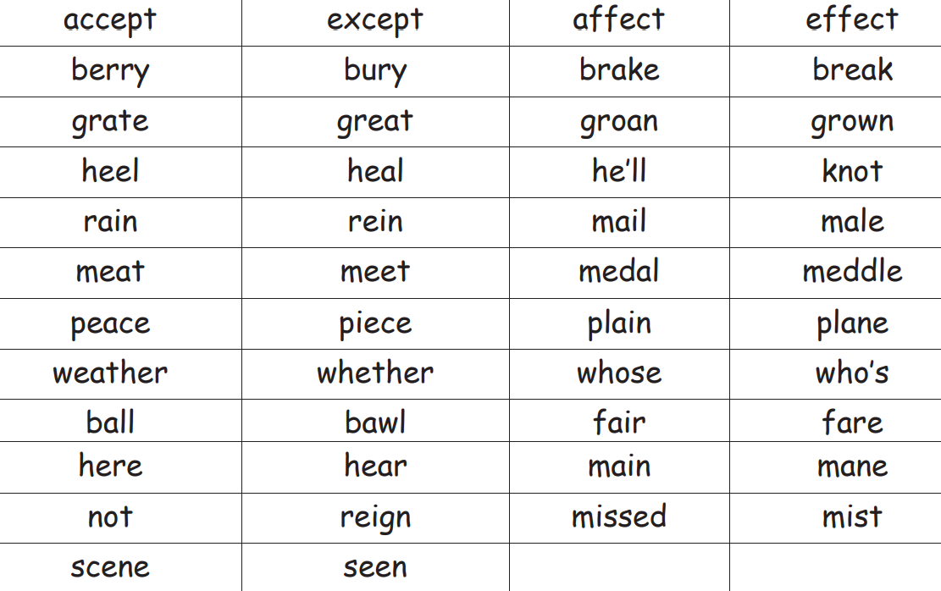 | LI: To read and comprehend  In Science, the children are enjoying learning about ‘Living Things and their Habitats.’ This week’s reading comprehension is all about Bees. Read the text carefully and answer the questions.  - What do bees feed to a larva to make a new queen?  - What are male honeybees called?  - Fill in the missing words. The thorax is into three parts.  - Look at the section called What Is a Bee? Find and copy one word that means the same as ‘well-known’ or ‘easily recognised’.  - What sort of habitat might not have bees? Explain your answer.  - Do bees help fruits grow on trees? Explain your answer.  - Do you think the name ‘worker bee’ is appropriate for that type of bee? Explain your answer. | LI: To practise spelling words  eight  eighteen  eighty  sleigh  vein  neighbour  explain  reign  rain  rein  Please practise the spellings using the Look Cover Spell Write methods  Spelling and tables tests will be held in class each Friday to monitor your progress.

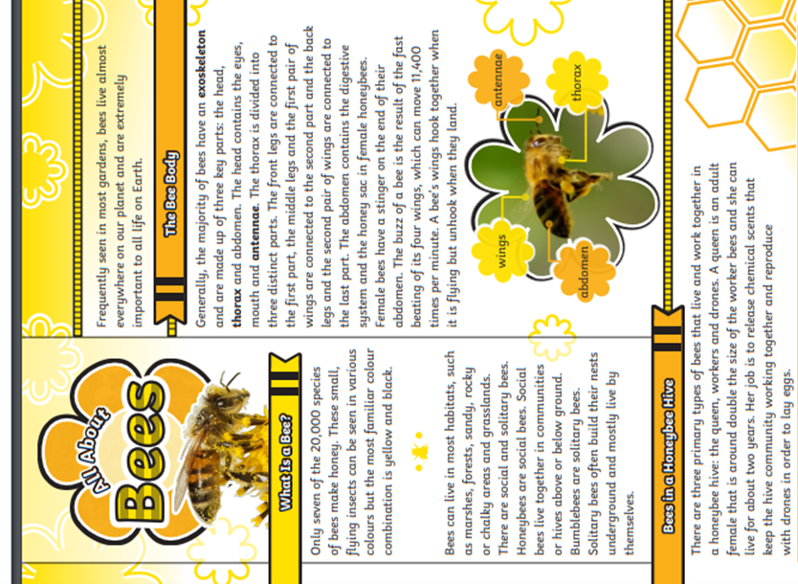
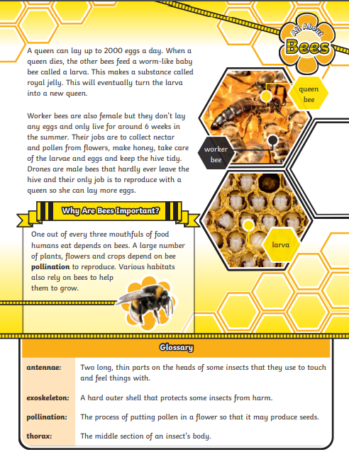

Mathematics
LI: To find/ calculate perimeter
Task 1:  Fluency | Task 2:  Varied fluency | Task 3:  Problem solving and reasoning
Find the perimeter:  NB This means the total length of the outside edges NOT the squares inside.  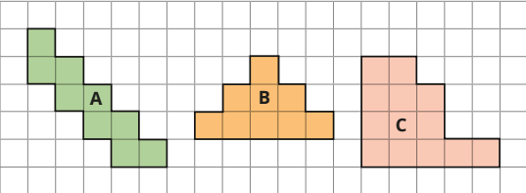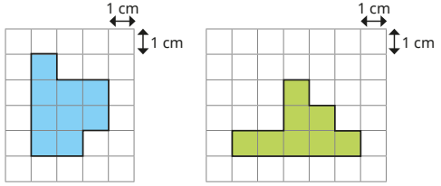  Now use mathsframe to practise your tables:  25 questions.  All tables up to 12 x 12  6 seconds per question.  Practise telling the time for 5 minute intervals. | 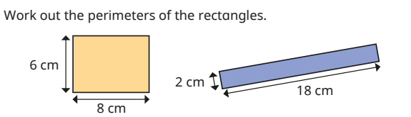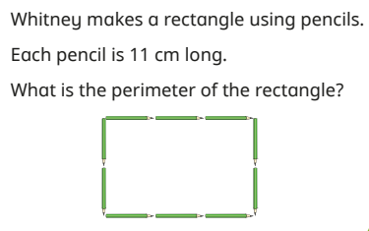  Now use mathsframe to practise your tables:  25 questions.  All tables up to 12 x 12  6 seconds per question.  Practise telling the time for 5 minute intervals. | Test at least three examples to show this statement is always true.  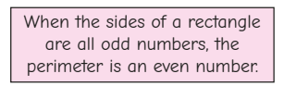  Use the clues to draw this rectangle. Label the sides.  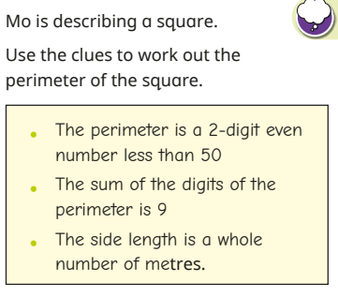  Now use mathsframe to practise your tables:  25 questions.  All tables up to 12 x 12  6 seconds per question.  Practise telling the time for 5 minute intervals.

English Answers:
Reading comprehension:
- Royal jelly
- What are male honeybees called? Male honeybees are called drones.
- Fill in the missing words. The thorax is divided into three distinct parts.
- Look at the section called What Is a Bee? Find and copy one word that means the same as ‘well-known’ or ‘easily recognised’. Familiar
- What sort of habitat might not have bees? Explain your answer. Pupils’ own responses, such as: I think an icy habitat might not have any bees, such as Antarctica. This habitat doesn’t really have flowers or plants that the bees could use for food.
6. Do bees help fruits grow on trees? Explain your answer. Pupils’ own responses, such as: Yes, I think they must help fruit grow on a tree. Fruit trees have blossoms before they have fruit and bees must visit these blossoms for nectar. The blossom falls off and fruit forms with seeds inside.
7. Do you think the name ‘worker bee’ is appropriate for that type of bee? Explain your answer. Pupils’ own responses, such as: Yes, I think the name worker bee is appropriate because this bee does all of the work. Worker bees take care of the babies, visit flowers for nectar and keep the nest tidy.
Maths Answers
Fluency
A= 20 B = 16 C = 18 D = 14 E = 16 then Mathsframe
Varied Fluency
28 cm 30 cm 110 cm (11cm x 10) then Mathsframe
Reasoning/ Problem Solving
Various answers 36 m then Mathsframe

