Year 5 Week 3 27.4.25
Please find below three English tasks for children to complete for their homework this week. Our recommendation is that children complete Task 1 for English and Maths on Tuesday, Task 2 for both on Wednesday and Task 3 for both on Thursday. This short, frequent style of homework will support children to consolidate their learning. Please find the answers on the class page. The expectation is that children mark alongside parents/carers or self-mark.
Children are to hand in their MARKED homework in their pink homework books on Monday morning, alongside their reading record.
English
Task 1:  Grammar and punctuation | Task 2:  Reading comprehension | Task 3:  Spelling Pattern
LI: To write expanded noun phrases  Over the last week we have been reading Varmints by Helen Ward. Write a sentence containing at least one expanded noun phrase about each image. Try to include nouns, adjectives and a prepositional phrase.  Revision:  An expanded noun phrase is:  https://www.bbc.co.uk/bitesize/articles/z3nfw6f  For Example:  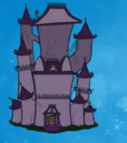  Basic: A haunted house.  Next level: A derelict, haunted house.  Extended: A derelict windowless haunted house, with cobwebbed strewn turrets, stood eerily silent at the top on the hill.  See below for the pictures. It may be useful to brainstorm different words to describe the picture before you begin. | LI: To read and comprehend  Answer the questions about the text (below)  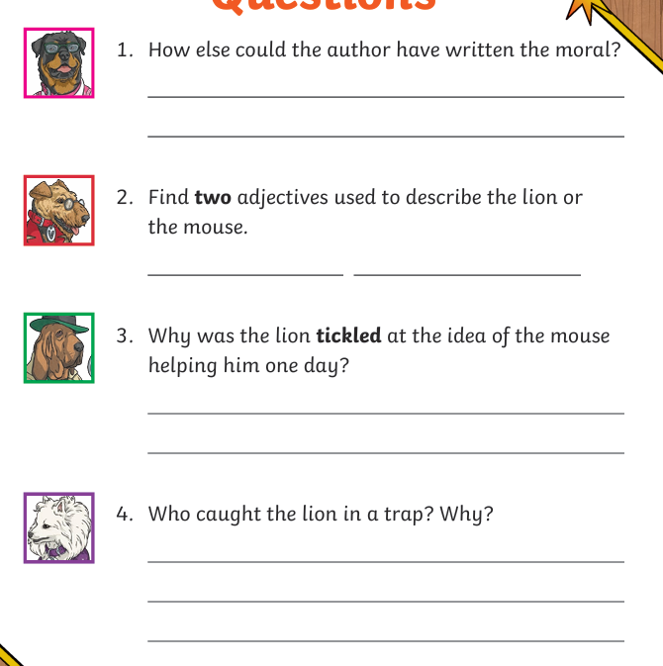 | LI: To practise spelling words  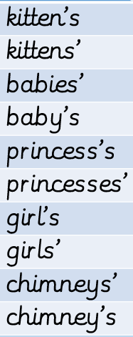  Please practise the spellings using the Look Cover Spell Write methods  Spelling and tables tests will be held in class each Friday to monitor your progress.

Reading Comprehension
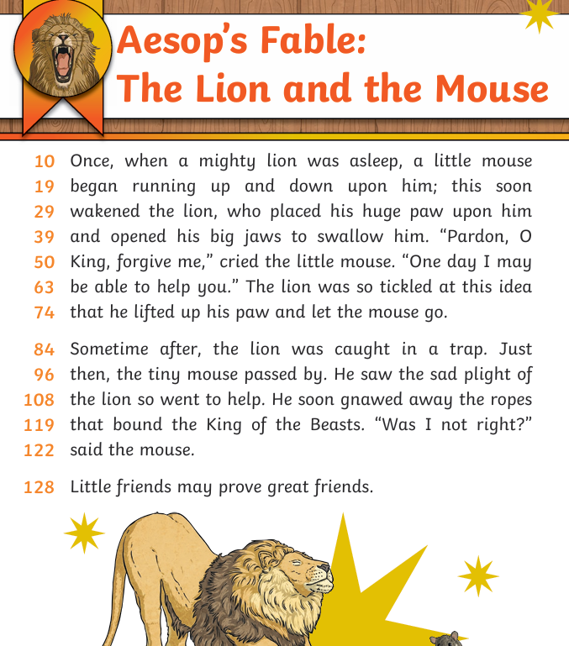

Noun Phrases
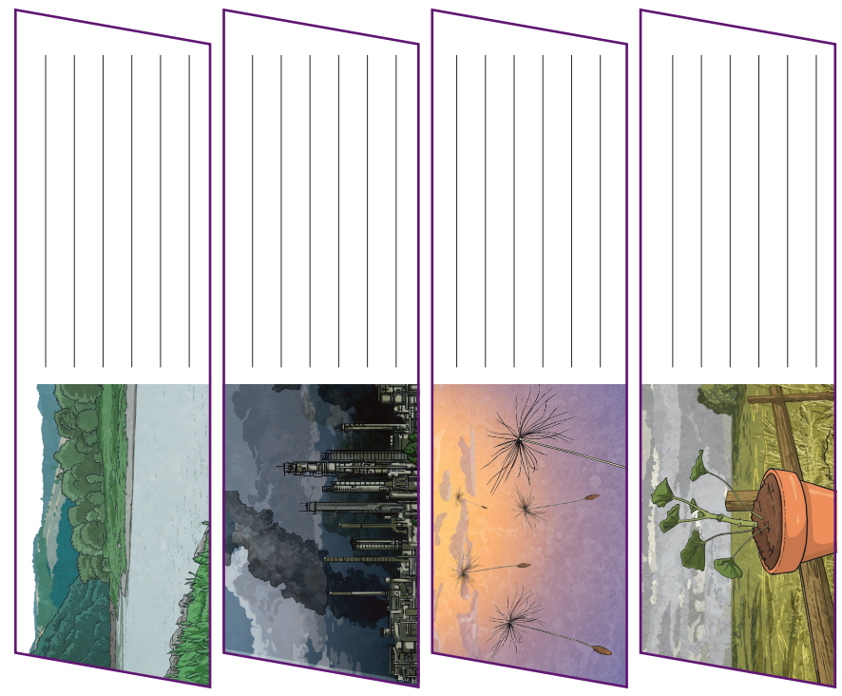
Answers: Reading comprehension



