Year 5 Week 3 27.4.25 - Adapted
Please find below three English tasks for children to complete for their homework this week. Our recommendation is that children complete Task 1 for English and Maths on Tuesday, Task 2 for both on Wednesday and Task 3 for both on Thursday. This short, frequent style of homework will support children to consolidate their learning. Please find the answers on the class page. The expectation is that children mark alongside parents/carers or self-mark.
Children are to hand in their MARKED homework in their pink homework books on Monday morning, alongside their reading record.
English
Task 1:  Grammar and punctuation | Task 2:  Reading comprehension | Task 3:  Spelling Pattern
LI: To write expanded noun phrases  Over the last week we have been reading Varmints by Helen Ward. Write a sentence containing at least one adjective about the pictures below. This is an expanded noun phrase.  Revision:  An expanded noun phrase is:  https://www.bbc.co.uk/bitesize/articles/z3nfw6f  For Example:  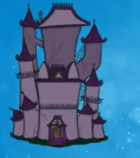  Basic: A house.  Next level: A haunted house.  See below for the pictures. It may be useful to brainstorm different words to describe the picture before you begin. | LI: To read and comprehend  Answer the questions about the text (below)  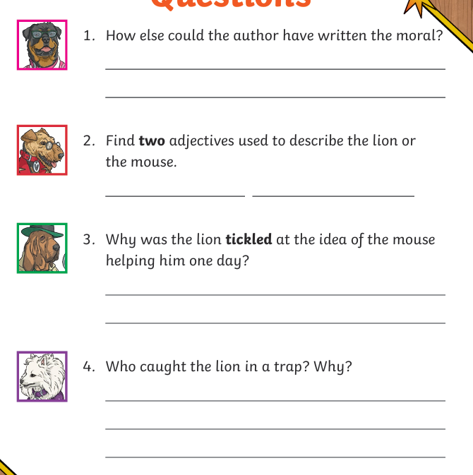 | LI: To practise spelling words  Please practise the below high – frequency words:  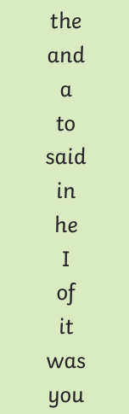

Reading Comprehension
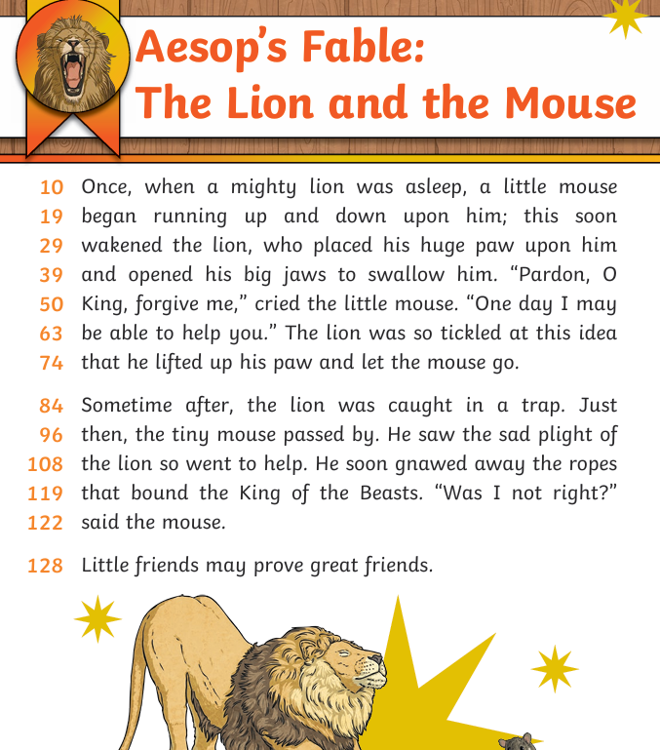

Noun Phrases

Answers: Reading comprehension


