Year 3 Homework Summer 1st Term Week 3 27.04.26
Please find below three English tasks and three Mathematics tasks for children to complete for their homework this week.
It should be completed in the pink homework book that was sent home at the start of the year. Please complete in pencil or blue handwriting pen. Any lines drawn (such as when underlining the date) should be in pencil WITH a ruler/ straight edge.
Each week remember to write and underline the date and rule off the last’s week’s work. This will reinforce the presentation standards we have in class. There is no need to print this sheet. Please only write the answers in the homework book.
Our recommendation is that children complete Task 1 for English and Maths on Tuesday, Task 2 for both on Wednesday and Task 3 for both on Thursday. This short, frequent style of homework will support children to consolidate their learning. Spellings and tables will be tested on Friday. Homework is due on Friday.
The expectation is that children mark alongside parents/carers or self-mark. We use a green pen to tick answers in class and make corrections in purple pen, but please use any pen you have available at home. Answers are below the questions.
Children are to show their completed MARKED homework on FRIDAY morning, alongside their red reading record to show they have read aloud to someone at home.
English
Task 1:  Grammar and punctuation | Task 2:  Reading comprehension | Task 3:  Spelling Pattern/ Tables Focus
LI: To punctuate speech  Copy and add the inverted commas and commas (speech marks)  We need to focus on using joined handwriting so we are Year 4 ready.  - Despereaux whispered I want to see the princess.  - The rat shouted Stay away from the castle!  - Despereaux said I am not afraid of the dark.  - The servant said You must be careful, little mouse.  - Despereaux exclaimed Look at the light!  Now mark your answers.  Remember to read your reading book with someone at home and record this in your reading record. | LI: To skim and scan key words in a question to locate the answer  Tom and his friends were on a treasure hunt in the park.  Before they started, Tom looked at the map carefully. He saw a pond, a playground, and a big oak tree marked on it. The map had a legend that showed symbols for paths, benches, and water fountains.  “Let’s go to the playground first,” said Tom.  His friend Mia pointed to the path on the map. “We need to follow this zigzag path to get there,” she said.  They walked along the path, past the pond, and finally reached the playground. After a short rest, they checked the map again to find the oak tree where the treasure was hidden.  Tom noticed the map had a compass too. “The arrow points north,” he said. “That means the oak tree is to the east of the playground.”  Carefully following the directions, they found the treasure chest under the big oak tree.  Where did Tom and his friends go first? Name two landmarks that were on the map  What did Mia say about the path to the playground?  Why did Tom look at the compass on the map?  In which direction was the oak tree from the playground?  Now mark your answers.  Remember to read your reading book with someone at home and record this in your reading record. | To revise x6 and revise spellings  Revision of 200 high frequency  thought, different, through, laughed, found, another, narrator, grandad, park, something  You do not need to record this task in your homework book.  Remember to read your reading book with someone at home and record this in your reading record.

Mathematics

Task 1:  Fluency | Task 2:  Varied Fluency | Task 3:  Reasoning
Write out your facts like this:  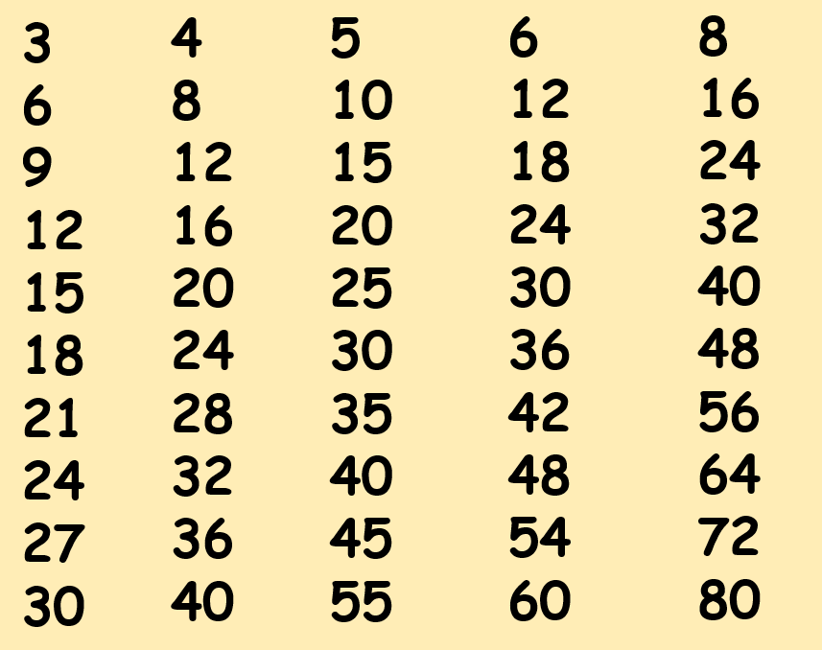  Use the facts above to help you answer these:  24 ÷ 6 =  24 ÷ 8 =  16 ÷ 4 =  25 ÷ 5 =  32 ÷ 8 =  72 ÷ 9 =  Use your answers above to help with these:  240 ÷ 6 =  240 ÷ 8 =  160 ÷ 4 =  250 ÷ 5 =  320 ÷ 8 =  720 ÷ 9 =  If you have found this tricky, continue to practise writing your multiple lists and answering questions.  Continue this instead of task 2 and task 3 this week. | Try these if you found task 1 easy this week.  Remember division questions can be presented in different ways.  360 ÷ 4 =  45 ÷ 5 =  96 ÷ 8 =  120 ÷ 40 =  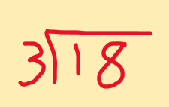  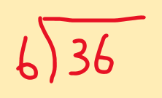  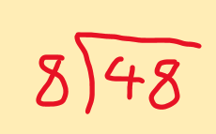  Answer as digits(figure) and as a word (letters)  How many groups of eight are in forty-eight?  How many groups of six make forty-two?  How many times will four go into forty-four?  What is 54 divided by 6? | Try these if you found task 1 and 2 easy this week.  Copy the statement from the left and match it to its (inverse from the right).  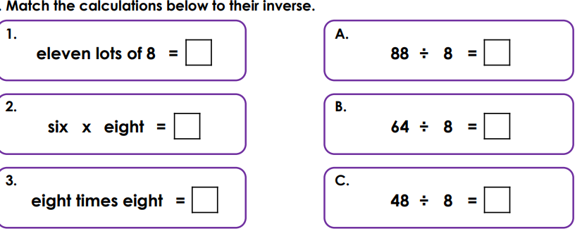  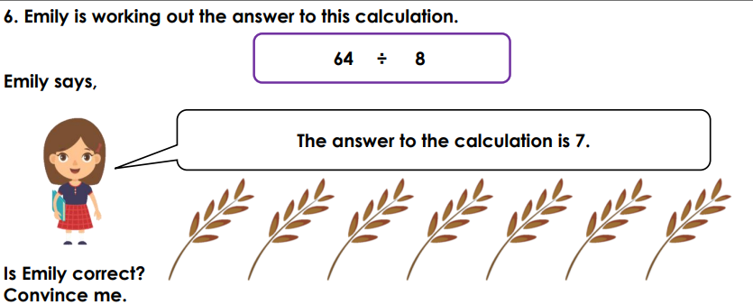  Tiny has drawn this array to find 80 divided by 2.  Write down the facts it shows and if Tiny is correct.  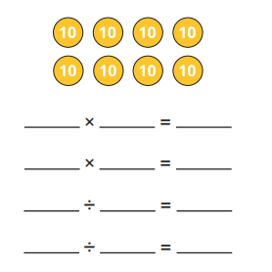

Maths Answers
Fluency answers:
24 ÷ 6 = 4
24 ÷ 8 = 3
16 ÷ 4 = 4
25 ÷ 5 = 5
32 ÷ 8 = 4
72 ÷ 9 = 8
240 ÷ 6 = 40
240 ÷ 8 = 30
160 ÷ 4 = 40
250 ÷ 5 = 50
320 ÷ 8 = 40
720 ÷ 9 = 80

Varied fluency answers:
360 ÷ 4 = 90
45 ÷ 5 = 9
96 ÷ 8 = 12
120 ÷ 40 = 3
8 8 7
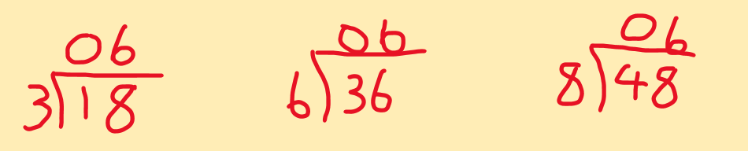
How many groups of eight are in forty-eight? 6 / six
How many groups of six make forty-two? 7/ seven
How many times will four go into forty-four? 11/ eleven
What is 54 divided by 6? 9/nine

Reasoning answers:
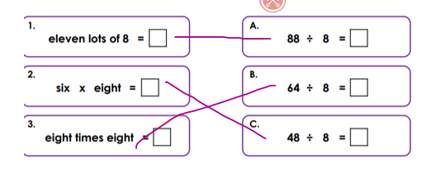

Emily is wrong. 8 x8 = 64
I know this because …
She has only drawn 7 lots of 8 or she has only drawn 56 and she needed to draw 64.

Tiny is correct. It shows 80 divided into 2 equal rows
It shows these related facts:
2 x40 = 80 40 x 2 = 80
80 ÷ 2 = 40 80 ÷ 40 = 2

English Answers
Grammar and punctuation
- Despereaux whispered, “I want to see the princess.”
- The rat shouted, “Stay away from the castle!”
- Despereaux said, “I am not afraid of the dark.”
- The servant said, “You must be careful, little mouse.”
- Despereaux exclaimed, “Look at the light!”
Reading Comprehension
The playground
Pond or big oak tree or playground
We must follow the zig zag path
To see which direction/ To locate north
East



