Homework – Summer 1 Week 3
Please find below three English tasks and three Mathematics tasks for children to complete for their homework this week. Our recommendation is that children complete Task 1 for English and Maths on Tuesday, Task 2 for both on Wednesday and Task 3 for both on Thursday. This short, frequent style of homework will support children to consolidate their learning. Please find the answers on the class page. The expectation is that children mark alongside parents/carers or self-mark.
Children are to hand in their homework on Monday morning, alongside their reading record.
English
Task 1:  Grammar and punctuation | Task 2:  Reading comprehension | Task 3:  Spelling Pattern
See below | 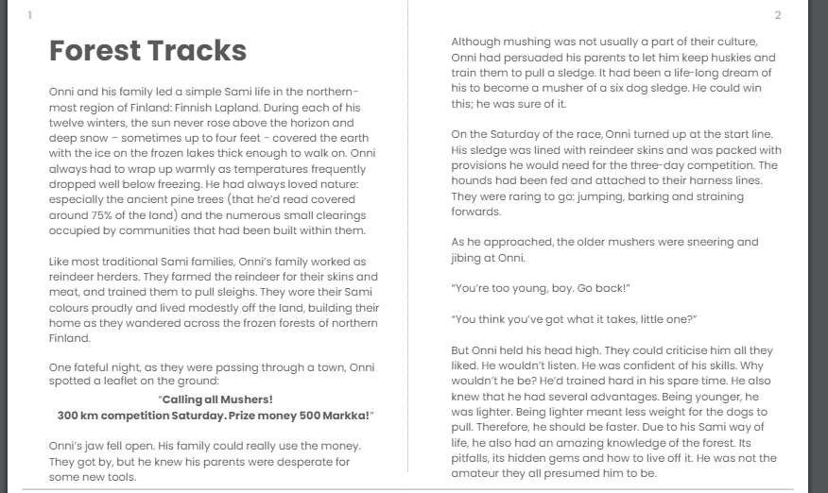  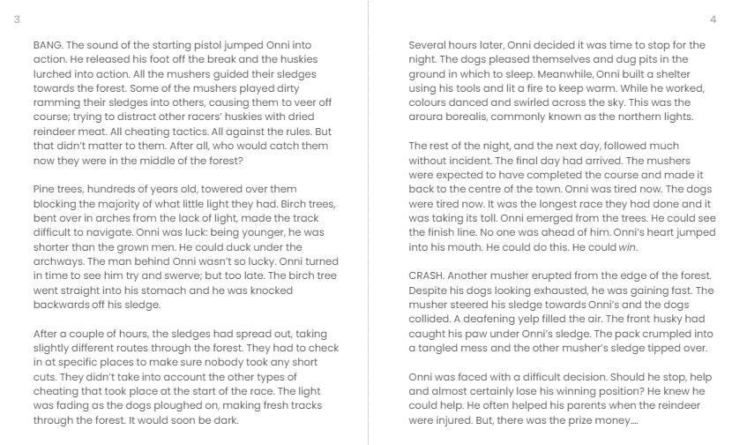  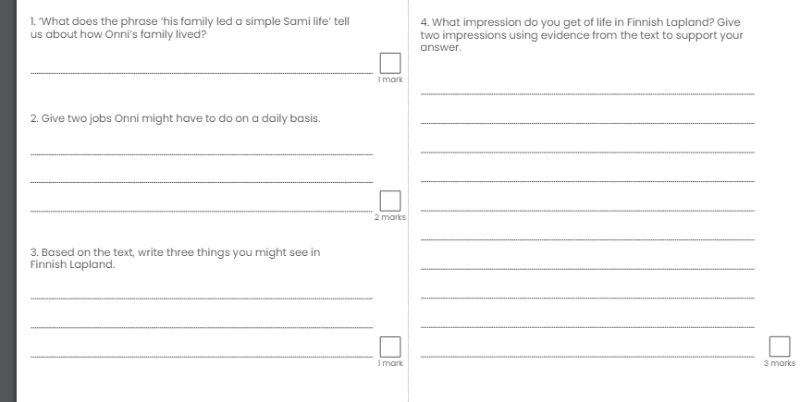 | 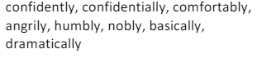
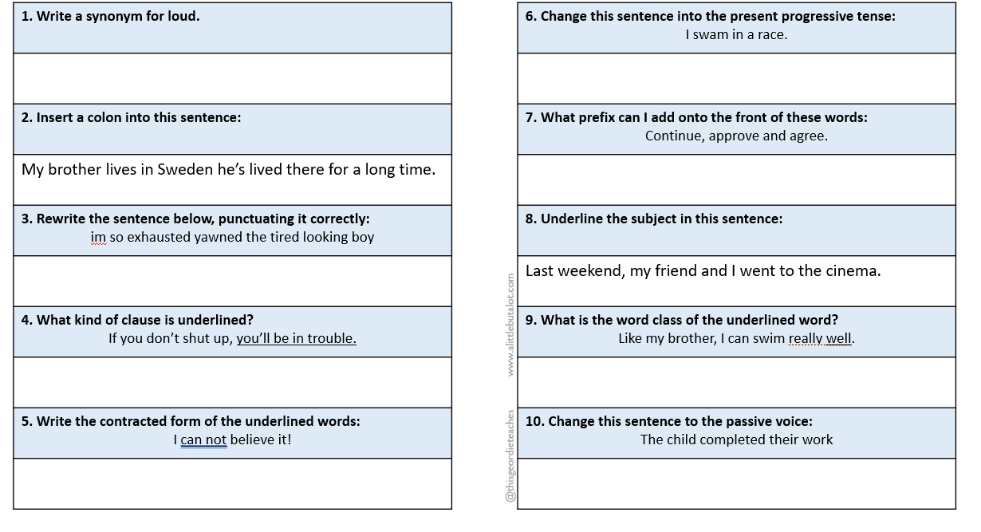

Answers SPAG
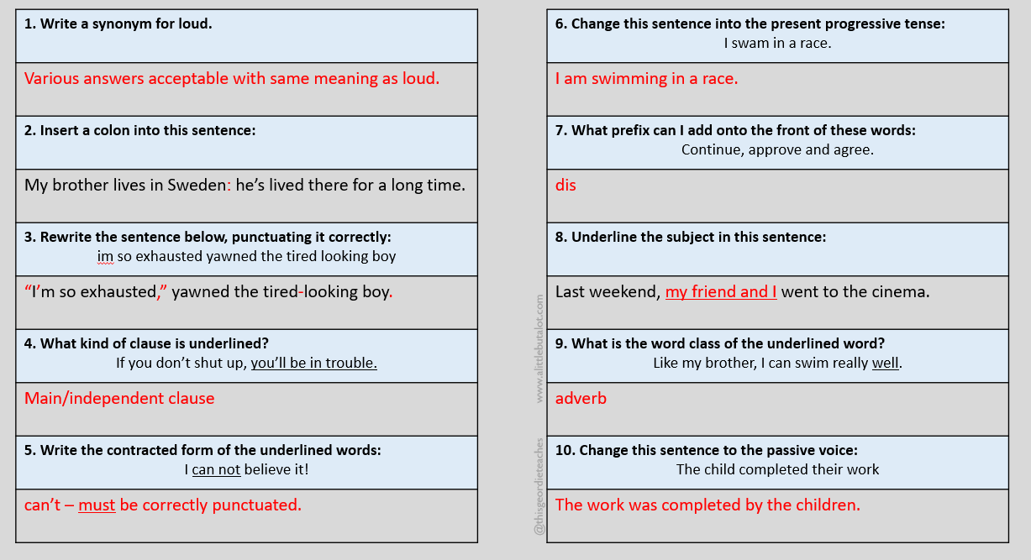
Reading answers

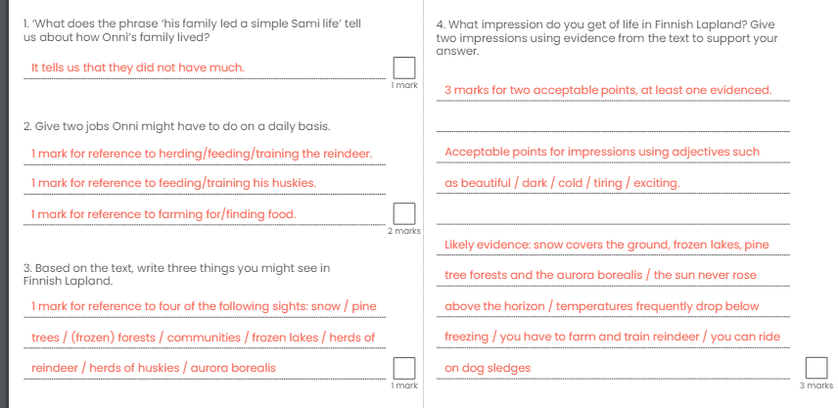
Mathematics
Task 1:  Fluency | Task 2:  Varied Fluency |  | Task 3:  Reasoning
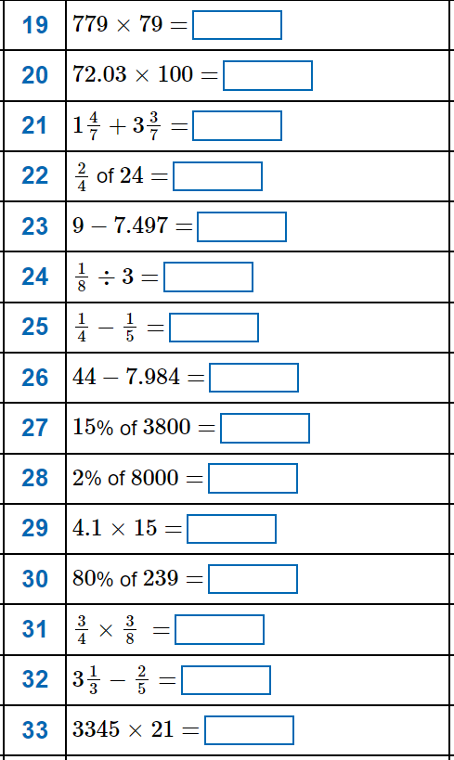 | 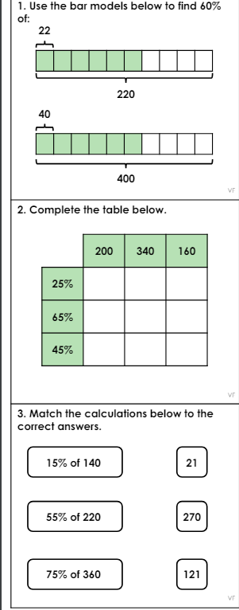 |  | 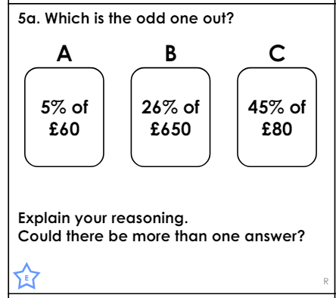  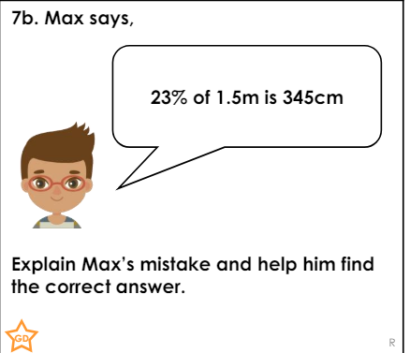

Maths fluency answers
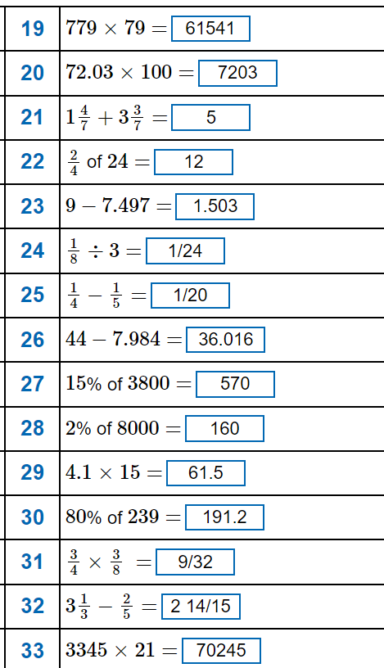

Varied Fluency answers
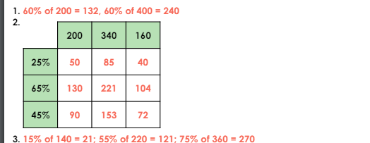
Reasoning answers


