20.4.26 - Please find below a maths worksheet for children to complete for their homework this week. Homework is reduced this week due to the children being on their residential at Flatford Mill.
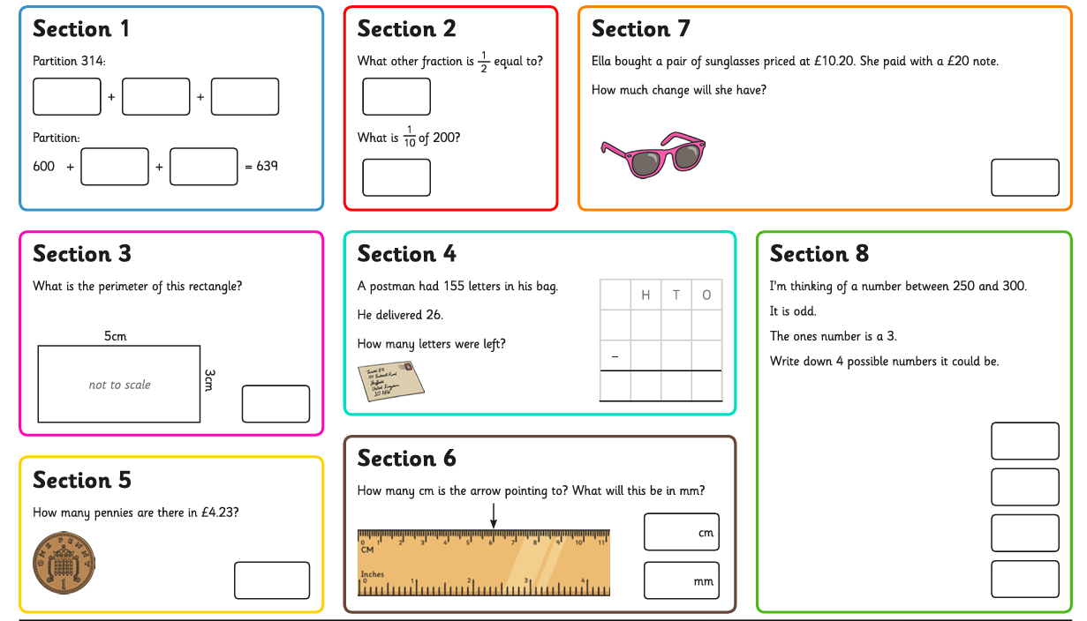
Children are to hand in their MARKED homework in their pink homework books on Monday morning, alongside their reading record.
Task 1: Complete the maths mat below (answers on next page)
Answers


