20.4.26
Please find below two English tasks for children to complete for their homework this week. Homework is reduced this week due to the children being on their residential at Flatford Mill.
Children are to hand in their MARKED homework in their pink homework books on Monday morning, alongside their reading record.
Task 1:  Grammar and punctuation | Task 2:  Spelling Pattern
LI: To read and comprehend  Answer questions on the next page.  1-9 | LI: To practise spelling words  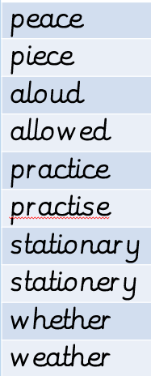  Please practise the spellings using the Look Cover Spell Write methods  Spelling and tables tests will be held in class each Friday to monitor your progress.

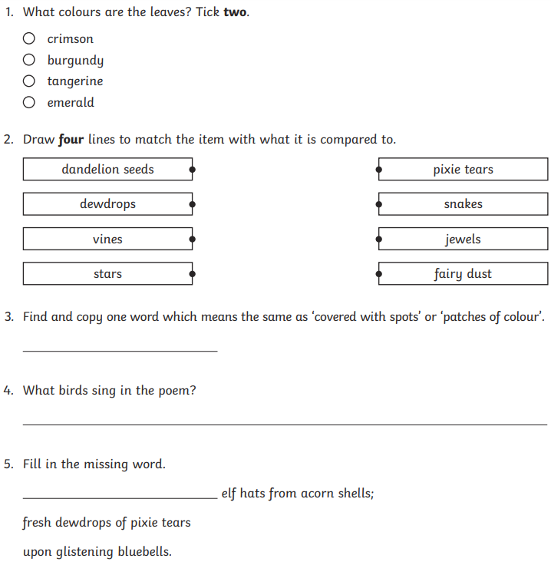
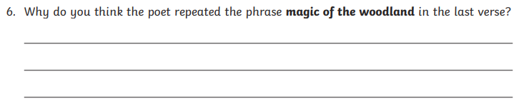

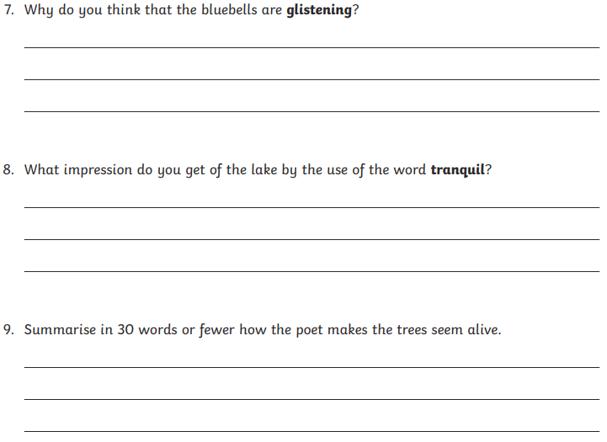

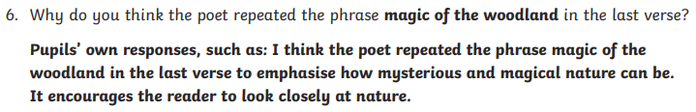
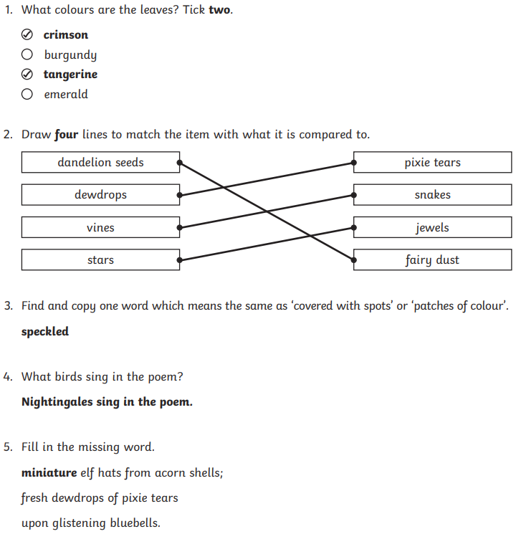
Answers


