Year 3 Homework Summer 1st Term Week 2 20.04.26
Please find below three English tasks and three Mathematics tasks for children to complete for their homework this week.
It should be completed in the pink homework book that was sent home at the start of the year. Please complete in pencil or blue handwriting pen. Any lines drawn (such as when underlining the date) should be in pencil WITH a ruler/ straight edge.
Each week remember to write and underline the date and rule off the last’s week’s work. This will reinforce the presentation standards we have in class. There is no need to print this sheet. Please only write the answers in the homework book.
Our recommendation is that children complete Task 1 for English and Maths on Tuesday, Task 2 for both on Wednesday and Task 3 for both on Thursday. This short, frequent style of homework will support children to consolidate their learning. Spellings and tables will be tested on Friday. Homework is due on Friday.
The expectation is that children mark alongside parents/carers or self-mark. We use a green pen to tick answers in class and make corrections in purple pen, but please use any pen you have available at home. Answers are below the questions.
Children are to show their completed MARKED homework on FRIDAY morning, alongside their red reading record to show they have read aloud to someone at home.
English
Task 1:  Grammar and punctuation | Task 2:  Reading comprehension | Task 3:  Spelling Pattern/ Tables Focus
LI: To recognise the subordinate clause  A main clause makes sense on its own eg The dog barked.  A subordinate clause does not make sense on its own and will start with a conjunction eg because it was hungry.  We need to focus on using joined handwriting so we are Year 4 ready.  Rewrite these sentences so the subordinate clause comes first. Remember to include a comma.  The children played inside because it was raining.  The boy ran home before the storm began.  The girl wore boots as the ground was so muddy.  I will help you if you get stuck.  The children did their homework even though it was sunny outside.  Now mark your answers.  Remember to read your reading book with someone at home and record this in your reading record. | LI: To answer questions about the text  Read the passage carefully:  Despereaux crept through the dark, narrow tunnel. Every sound seemed louder down there. He could hear water dripping, his tiny feet scratching against the cold stone, and far away, a faint echo of voices. The tunnel twisted and turned, and Despereaux felt a shiver of fear—but also excitement. He was determined to see where it led, even though he knew it was dangerous.  - Where is Despereaux in this passage?  - Find and copy a word that shows he is afraid.  - Find and copy a phrase that shows he is afraid.  - Which senses does Despereaux use in the tunnel?  - How do you know Despereaux was brave?  Now mark your answers.  Remember to read your reading book with someone at home and record this in your reading record. | To revise x6 and revise spellings  Fury, Furious, fame, famous, vary, various, anxious, hideous, serious, precious  You do not need to record this task in your homework book.  Remember to read your reading book with someone at home and record this in your reading record.

Mathematics

Task 1:  Fluency | Task 2:  Varied Fluency | Task 3:  Reasoning
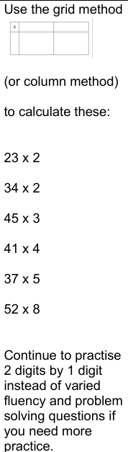  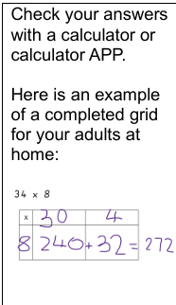 | Practice your division facts…  480 ÷ 4 = 320 ÷ 4 = 240 ÷ 4 =  280 ÷ 4 = 80 ÷ 4 = 160 ÷ 4 =  180 ÷ 6 =  240 ÷ 6 =  300 ÷ 6 = | 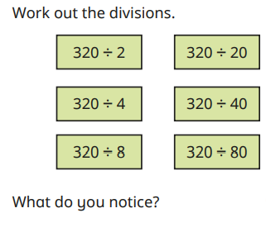  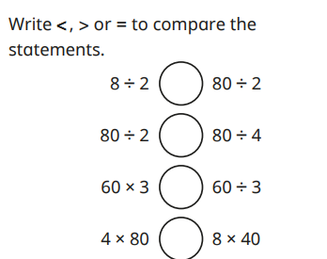

Maths Answers
Fluency answers:
23 x 2 = 46
34 x 2 = 68
45 x 3= 135
41 x 4 = 164
37 x 5 = 185
52 x 8 = 416
Varied fluency answers:
480 ÷ 4 = 120 320 ÷ 4 = 80 240 ÷ 4 = 60
280 ÷ 4 = 70 80 ÷ 4 = 20 160 ÷ 4 = 40

180 ÷ 6 = 30
240 ÷ 6 = 40
300 ÷ 6 = 50

Reasoning answers:
160, 80, 40,
16, 8, 4

English Answers
Grammar and punctuation
Because it was raining, the children played inside because it was raining.
Before the storm bgan, the boy ran home.
As the ground was so muddy, the girl wore boots
If you get stuck, I will help you
Even though it was sunny outside, the children did their homework

Reading Comprehension
In a tunnel
Crept
Felt a shiver of fear
Hearing and feeling (not sight as it says the tunnel was dark)
He was determined to follow the tunnel even though he knew it was dangerous.



