Year 4 Homework Spring 1 w/c 20.4.26
Please find below three English tasks and three Mathematics tasks for children to complete for their homework this week. Our recommendation is that children complete Task 1 for English and Maths on Tuesday, Task 2 for both on Wednesday and Task 3 for both on Thursday. This short, frequent style of homework will support children to consolidate their learning. Please find the answers on the class page. The expectation is that children mark alongside parents/carers or self-mark.
Children are to hand in their MARKED homework in their pink homework books on Monday morning, alongside their reading record.
English
Task 1:  Grammar and punctuation | Task 2:  Reading comprehension | Task 3:  Spelling Pattern
To Practise your weekly spellings and read to an adult. Record your reading in your Red Reading Record  LI: To identify prefixes linked to spelling rules  A prefix attaches to the beginning of a word to change its meaning. Eg: Happy is the root word but un+happy becomes unhappy which has an opposite meaning.  Remind yourself what prefixes are by watching the following Bitesize clip:  https://www.bbc.co.uk/bitesize/topics/z8mxrwx/articles/z9hjwxs  Add the prefixes (highlighted in colour) to the nouns to change their meaning. Which one uses the most? You could cut them out and match them together or write them on a piece of paper.   | LI: To read and comprehend  This week, we celebrated St George’s Day. St George was the Patron Saint of England. Read the text carefully and answer the questions about St George. Then research 5 facts about St George that you did not know – this could be from the text you have read or additional research.  - How old was Saint George when his mother died?  - In which city did Saint George join the Roman army?  - What did Saint George do while he was in prison?  - St. George’s Day is celebrated annually on 23rd April. In this sentence, what does the word ‘annually’ mean?  - In which century did stories about Saint George slaying a dragon begin to be told?  - List three things offered to Saint George by Diocletian in return for abandoning his faith.  - Find and copy a phrase from the text which shows that the facts we know about Saint George may be inaccurate.  - Explain what the dragon commonly associated with Saint George represents and why it is important.  Write down 5 facts about St George. | LI: To practise spelling words  quarter  important  forwards  caught  author  history  warm  backwards  stalk  water  Please practise the spellings using the Look Cover Spell Write methods  Spelling and tables tests will be held in class each Friday to monitor your progress.

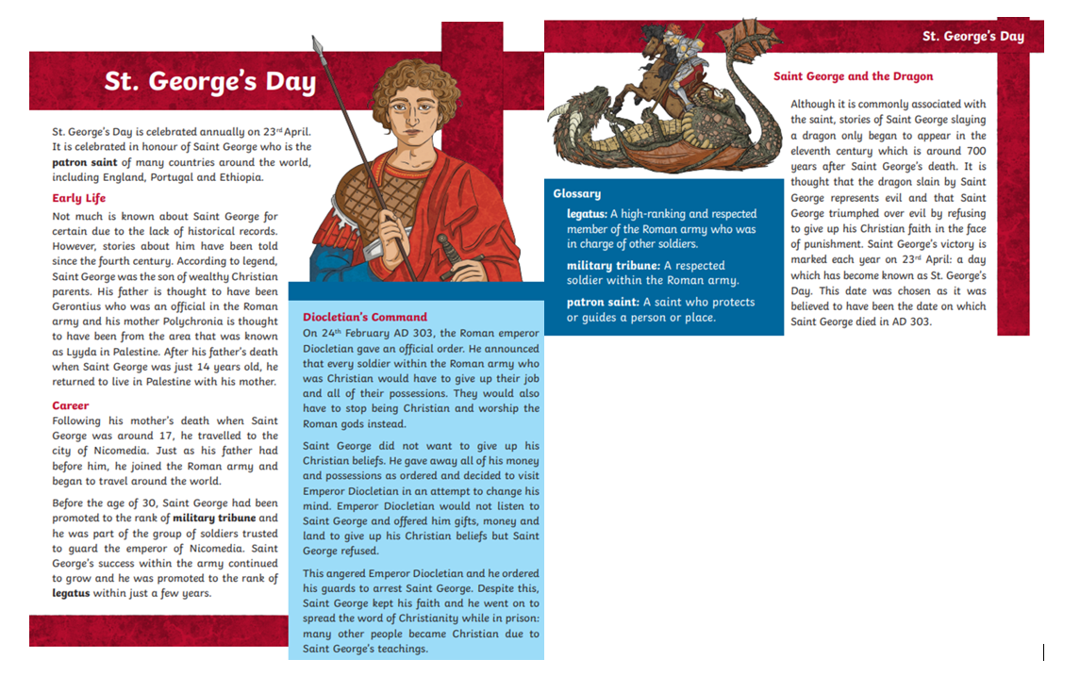

Mathematics
LI: To subtract from mixed numbers
Task 1:  Fluency | Task 2:  Varied fluency | Task 3:  Problem solving and reasoning
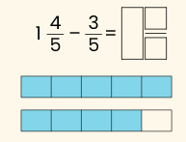  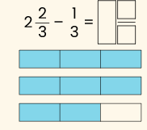  Here’s an example of how we set these next questions out in class. They will bridge the whole number. Partition the fraction the most efficient way (so you can count back to the nearest whole number).  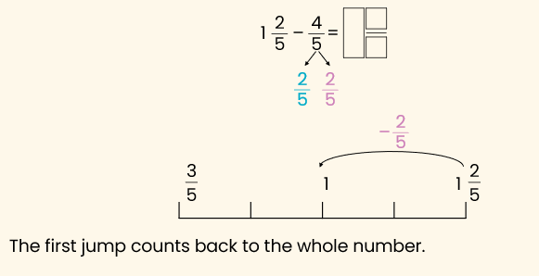  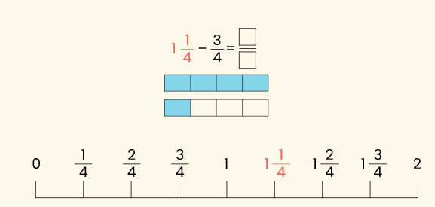  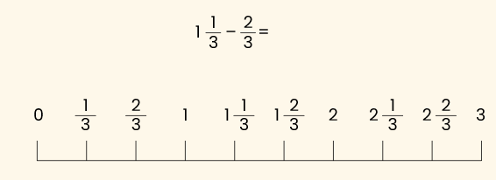  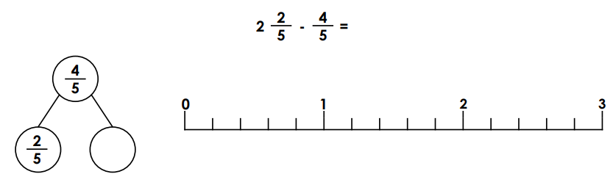 | Draw a number line if you need help to work these out. Remember to partition the second number and count back to the whole number.  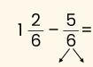  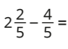  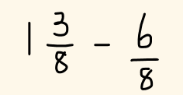  Practise more examples like those above with someone at home if you’re not feeling confident.  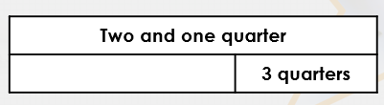  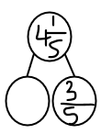 | Are these correct? Explain your answer    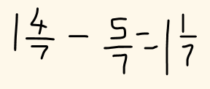    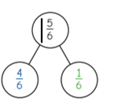

English Answers:
Tuesday:
Autograph, submarine, superhuman, antifreeze, autobiography, superfoods, anticlockwise, superhero, antisocial, supermarket, superstar, supersonic, automobile, autopilot, subtropical.
Wednesday:
1. St George was 17 when his mother died.
2.St George joined the Roman army in the city of Nicomedia.
3. while St George was in prison he continued to spread the word of Christianity.
4. annually means ‘each year’ or ‘yearly’.
5. The eleventh century
6. Gifts, money and land.
7. Accept any one of the following: Not much is known about Saint George for certain; According to legend; is thought to have been
8. Pupils’ own responses, such as: The dragon associated with Saint George represents
evil. It is important because Saint George defeated evil by refusing to give up his faith
in the face of punishment.
Maths Answers
Fluency
1 and 1/5
2 and 1/3
3/5
2/4 or ½
2/3
1 and 3/5
Varied Fluency
3/6 or ½
1 and 3/5
5/8
1 and 2/4 or 1 and ½
3 and 3/5
If you have practised further examples, please use a scientific calculator with a fraction button or download a fraction calculator APP onto your tablet/ phone to check your answers.

Reasoning/ Problem Solving
False there should be bridging. The answer is 6/7
False. He’s forgotten about the whole number. It should say either 1 and 4/6 or 1 and 1/6

