WHY do we
‘Action our Faith’?
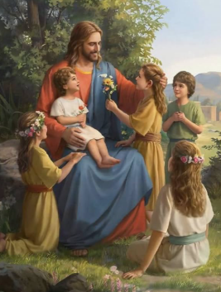
Jesus said, ‘Whatever you do to the little ones of mine you do to me.’

