13.4.26
Please find below three Maths tasks for children to complete for their homework this week. Our recommendation is that children complete Task 1 for English and Maths on Tuesday, Task 2 for both on Wednesday and Task 3 for both on Thursday. This short, frequent style of homework will support children to consolidate their learning. Please find the answers on the class page. The expectation is that children mark alongside parents/carers or self-mark.
Children are to hand in their MARKED homework in their pink homework books on Monday morning, alongside their reading record.
Maths
Task 1 | Task 2 | Task 3
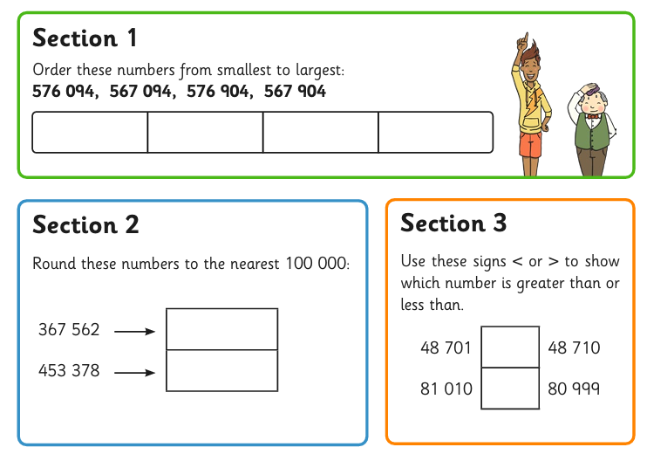 | 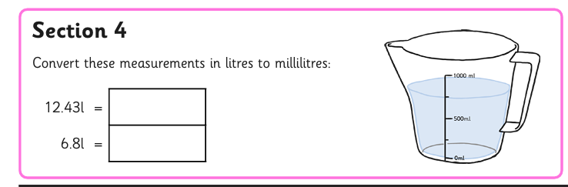  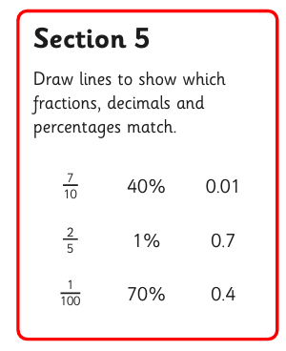  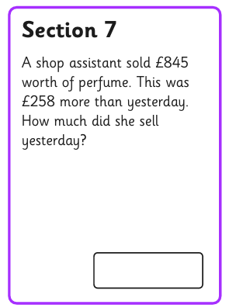 | 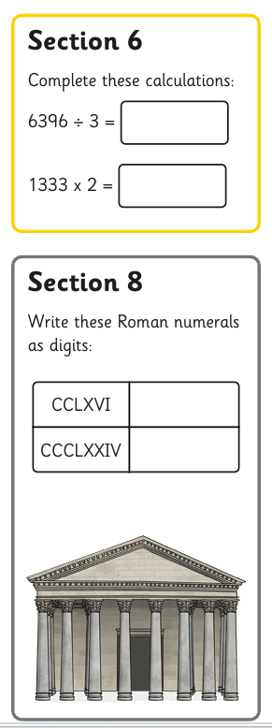

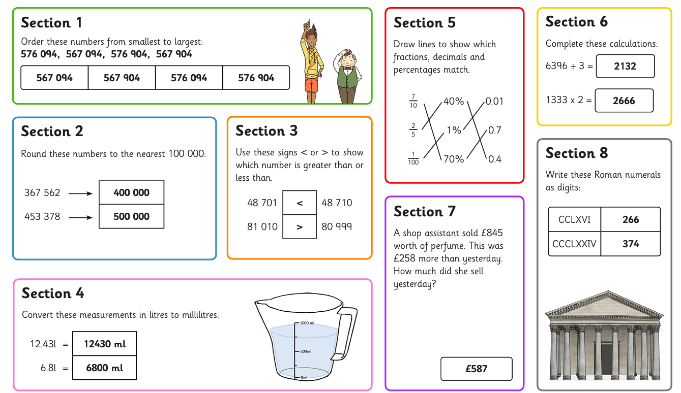Answers

