Year 4 Homework Summer 1 w/c 13.04.2026
Please find below three English tasks and three Mathematics tasks for children to complete for their homework this week. Our recommendation is that children complete Task 1 for English and Maths on Tuesday, Task 2 for both on Wednesday and Task 3 for both on Thursday. This short, frequent style of homework will support children to consolidate their learning. Please find the answers on the class page. The expectation is that children mark alongside parents/carers or self-mark.
Children are to hand in their MARKED homework in their pink homework books on Monday morning, alongside their reading record.
English
Task 1:  Grammar and punctuation |  | Task 2:  Reading comprehension | Task 3:  Spelling Pattern
LI: To identify noun phrases  A noun phrase is a simple phrase built around a noun. It contains a determiner and a noun.  For example: a tree, some sweets, the castle  An expanded noun phrase adds more detail to the noun by adding one or more adjectives. An adjective is a word that describes a noun.  For example: a huge tree, some colourful sweets, the large, royal castle  Watch this video to learn more about expanded noun phrases.  Watch the two clips on BBC Bitesize to remind you:  https://www.bbc.co.uk/bitesize/articles/zmqh2v4  Using the examples below and thinking about our learning in the classroom. Identify the noun phrases in the sentences.  Then write three sentences that include a noun phrase of your own. Use the examples to help you. | LI: To read and comprehend  This term, Year 4 will be studying a Geography unit based on Norway. Read the information carefully about the Northern Lights, which can often be seen in Norway, and answer the questions carefully.  1. Which areas should you visit if you want to see the northern lights?  2. Look at the first paragraph. Find and copy one word that shows that people on Earth have been interested in the northern lights for a long time.  3. Fill in the missing words.  Our planet’s_______________________ field diverts these solar winds, sending them towards the _____________________.  4. What does STEVE stand for?  5. Why do you think aurora australis can be seen at a different time from aurora borealis?  6. Why do you think STEVE is made up of arcs and streaks and the northern lights are made up of waves?  7. The Norse people thought the lights were a reflection of sunlight and the Finnish people thought the lights were fiery footprints. If you were writing a folk tale, explain what else you think they could be. |  | LI: To practise spelling words  busy  business  happy  unhappily  extreme  extremely  begin  beginning  natural  naturally  Please practise the spellings using the Look Cover Spell Write methods  Spelling and tables tests will be held in class each Friday to monitor your progress.
Tuesday’s English

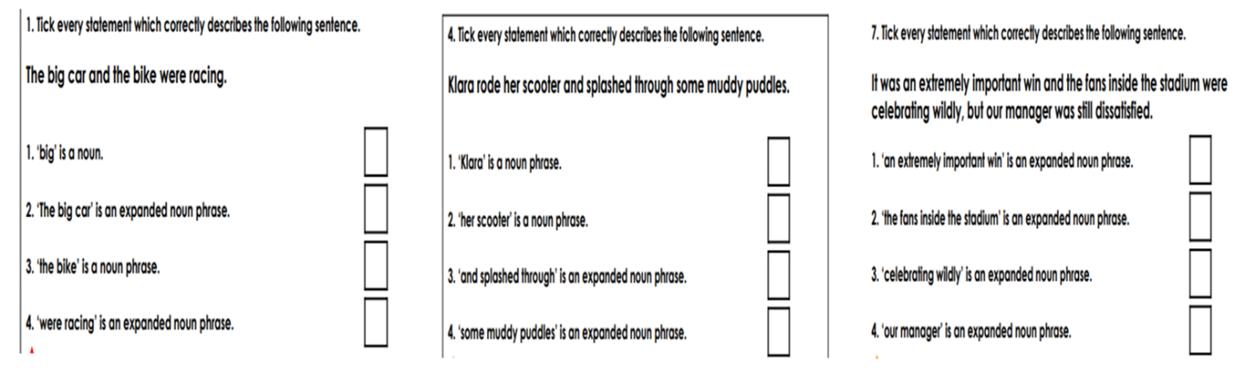
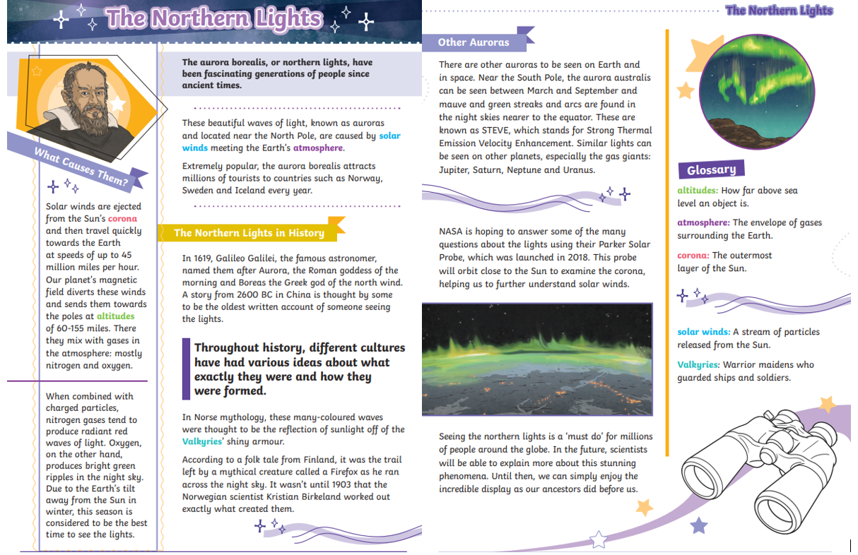
Wednesday’s English

Mathematics
LI: To
Task 1:  Fluency | Task 2:  Varied fluency | Task 3:  Problem solving and reasoning
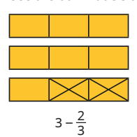  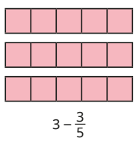  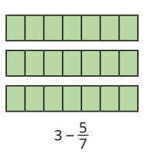  Now practise your tables using the maths frame link on this website. 25 questions. 6 seconds per question. | 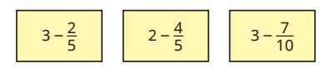  Now practise your tables using the maths frame link on this website. 25 questions. 6 seconds per question. | 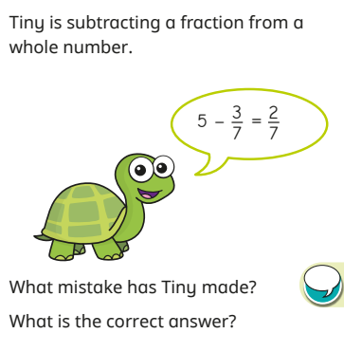  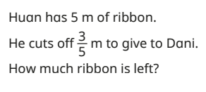  Now practise your tables using the maths frame link on this website. 25 questions. 6 seconds per question.

English Answers:
Reading Comprehension:
- Norway, Sweden and Iceland
- Ancient
- Magnetic, poles
- Strong thermal emissions velocity enhancement
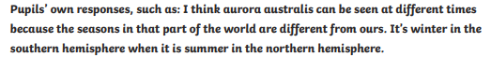

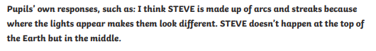
6.

7.

Maths Answers
Fluency
2 and 1/3 or 7/3 2 and 2/5 or 12/5 2 and 2/7 or 16/7
Varied Fluency
2 and 3/5 or 13/5 1 and 1/5 or 6/5 2 and 3/10 or 23/10
Reasoning/ Problem Solving
Tiny needs to change 5 to 35 /7 or remember that 5 whole is not the same as 5/7
Huan has 4 and 2/5 m or 22 /5 m

