Year 5 Homework Week 6 16.3.26 - Adapted
Please find below three English tasks and three Mathematics tasks for children to complete for their homework this week. Our recommendation is that children complete Task 1 for English and Maths on Tuesday, Task 2 for both on Wednesday and Task 3 for both on Thursday. This short, frequent style of homework will support children to consolidate their learning. Please find the answers on the class page. The expectation is that children mark alongside parents/carers or self-mark.
Children are to hand in their homework on Monday morning, alongside their reading record.
English
Task 1:  Grammar and punctuation | Task 2:  Reading comprehension | Task 3:  Spelling Pattern
LI: To write a set of instructions  Can you write a basic set of instructions on how to make a cup of tea?  ‘How to Make a Cup of Tea.’  Think carefully about the equipment you will need and asking an adult to help you when using the kettle. Do NOT use the kettle without adult supervision!  Below we have written a check list of what instructions should include to act as your success criteria chose 5 of the most important ones with your adult and have a go at writing them.  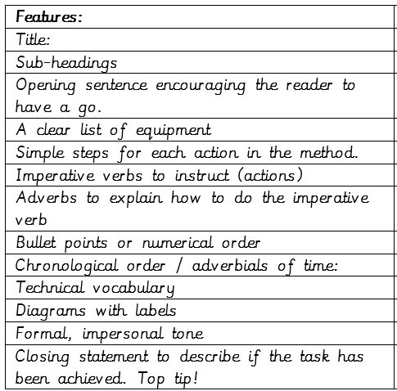 | LI: To read and comprehend  Read the instructional text on ‘how to play the guitar’ and answer the questions using evidence from the text to form your answer.  How to Play the Guitar  1. What kind of music is a power chord used for?  2. Why is a power chord good for that style of music?  3. How many notes is a power chord made up of?  4. What fingers do you need to use to play a | LI: To practise and consolidate spelling words  Please revise the below spellings:  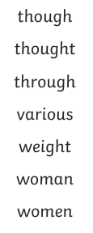

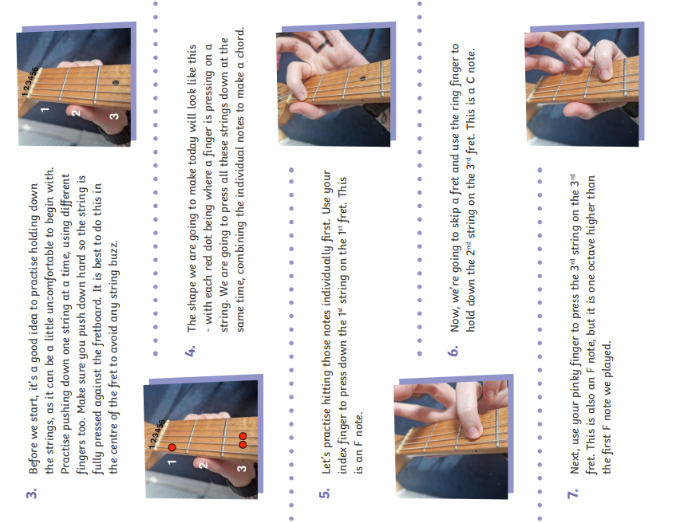
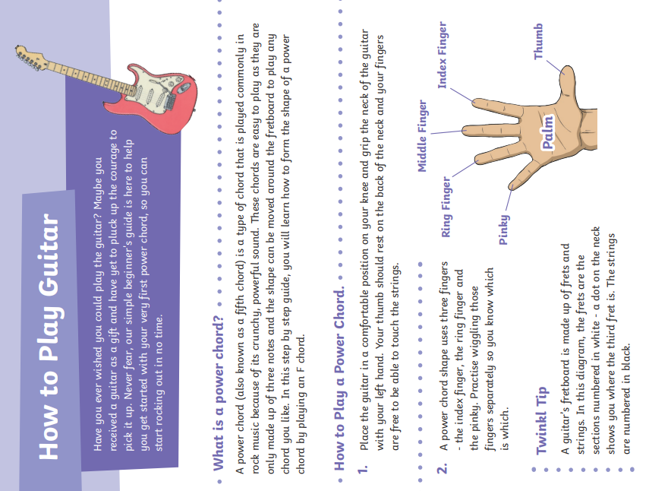

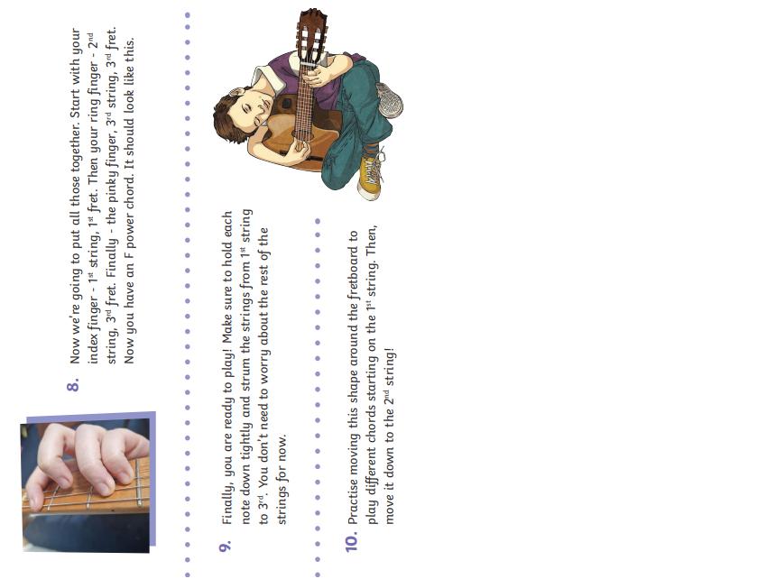

Mathematics
Task 1:  Fluency | Task 2:  Varied Fluency | Task 3:  Reasoning
LI: To revise and consolidate number operations that include the four operations
Please ask your teacher if you need this printed at school

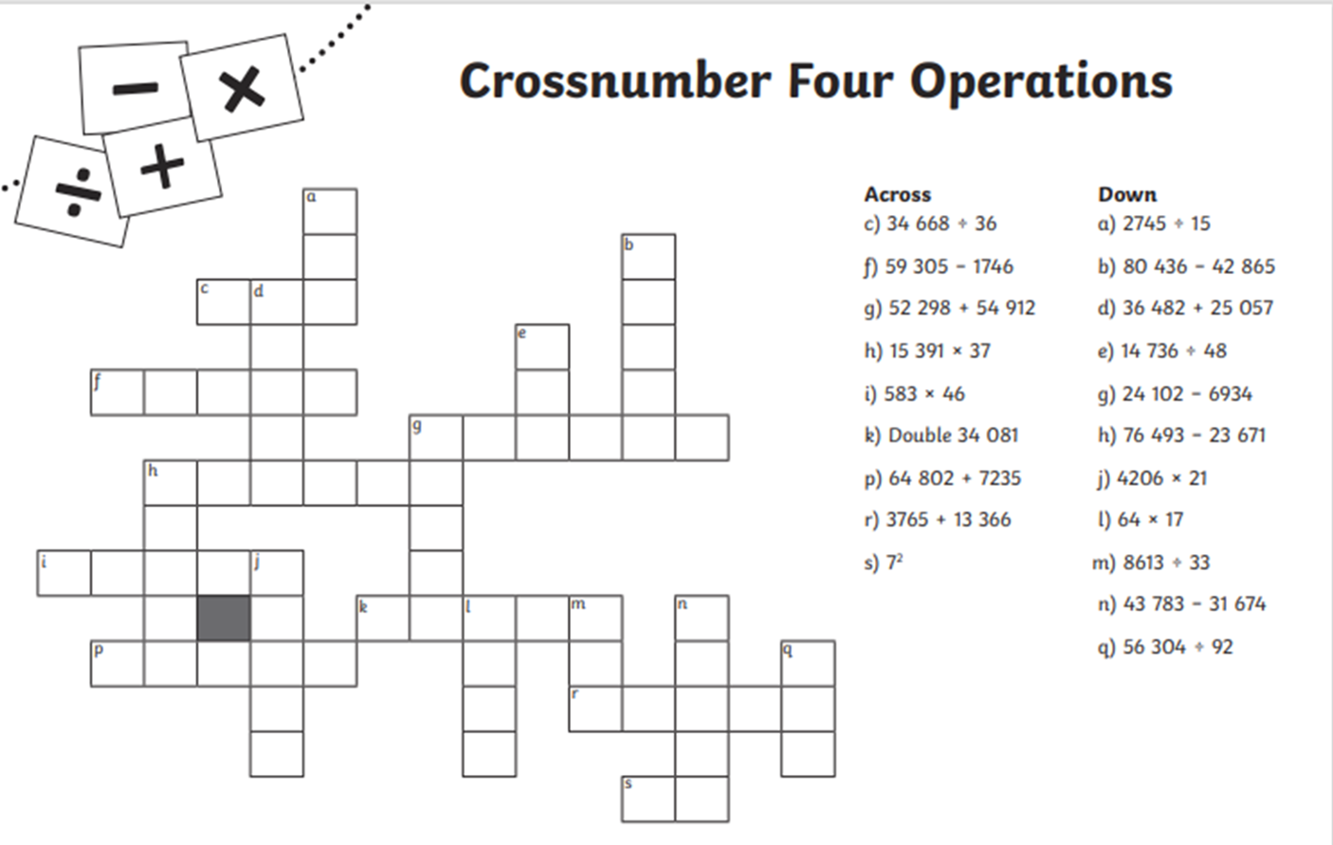

Answers
Tuesday Comprehension:
1. What kind of music is a power chord used for? Rock music.
2. Why is a power chord good for that style of music? It is crunchy and powerful.
3. How many notes is a power chord made up of? Three.
4. What fingers do you need to use to play a power chord? Index finger, ring finger and pinky finger.
5. Why do you think it is important to practise playing the notes individually first? So, you can practise pressing the strings down and finding the notes.
6. Why might a power chord be good to learn for beginners? One shape can be used for lots of chords.
7. What do you think ‘strum’ means? Play the strings.
8. Why do you think it is called a ‘power’ chord? It sounds powerful.
9. Who might find these instructions useful? People who like rock music, who want to learn to play guitar quickly.
10. What could the writer have included to make these instructions even simpler? A glossary of the technical words.

Maths Answers: See below


