Year 3 Homework Spring 2nd Term Week 4 16.03.26
Please find below three English tasks and three Mathematics tasks for children to complete for their homework this week.
It should be completed in the pink homework book that was sent home at the start of the year. Please complete in pencil or blue handwriting pen. Any lines drawn (such as when underlining the date) should be in pencil WITH a ruler/ straight edge.
Each week remember to write and underline the date and rule off the last’s week’s work. This will reinforce the presentation standards we have in class. There is no need to print this sheet. Please only write the answers in the homework book.
Our recommendation is that children complete Task 1 for English and Maths on Tuesday, Task 2 for both on Wednesday and Task 3 for both on Thursday. This short, frequent style of homework will support children to consolidate their learning. Spellings and tables will be tested on Friday. Homework is due on Friday.
The expectation is that children mark alongside parents/carers or self-mark. We use a green pen to tick answers in class and make corrections in purple pen, but please use any pen you have available at home. Answers are below the questions.
Children are to show their completed MARKED homework on FRIDAY morning, alongside their red reading record to show they have read aloud to someone at home.
English
Task 1:  Grammar and punctuation | Task 2:  Reading comprehension | Task 3:  Spelling Pattern/ Tables Focus
LI: To identify the main/ independent clause in a sentence  A main/ independent clause in a sentence is the most important part. If it was covered up, the sentence would not make sense on its own. If a main clause comes first in a sentence, it is linked to the subordinate clause with a conjunction. See below for more examples.  Copy these sentences neatly into your book. Underline the main clause.  Jim plays in the park with his friends during school holidays and at the weekends.  Tim loves to draw and paint while his older sister completes her homework.  Bathtime is fun in my house because of all the toys and bubbles.  Before we have lunch, we learn about maths.  The children, who had worked hard, had finished their sentences.  The subordinate clause may come anywhere in a sentence and not always at the end. It might even be embedded in the middle of a sentence.  Now mark your answers.  Now look in your reading books, Tell an adult the main clause and subordinate clause for any complex sentences you read.  Remember to read your reading book with someone at home and record this in your reading record. | LI: To use skimming and scanning to locate information  SKIM and SCAN the key word from each question.  Roman Soldiers’ Equipment  Roman soldiers were well equipped and trained. Each soldier carried a short sword called a gladius, which was used for close fighting. They also carried a pilum, a heavy spear designed to bend when it hit a shield so the enemy could not throw it back.  Roman soldiers wore armour to protect themselves. Many wore a metal helmet and body armour made of metal strips or chain mail. They also carried a large curved shield called a scutum, which protected most of the body and helped soldiers fight together in tight formations.  This equipment helped the Roman army stay organised and powerful. Because soldiers were protected and used their weapons in planned ways, the Roman army was able to conquer and control large areas of land.  Questions  - What was the gladius used for?  - Why was the pilum designed to bend?  - Name two pieces of armour Roman soldiers wore.  - How did the scutum help soldiers work together?  - What do you think the equipment they had tells us about Roman military success?  Now mark your answers.  Remember to read your reading book with someone at home and record this in your reading record. | To revise x3 and revise spellings divide, division, invade, invasion, decide, decision, tense, tension, erode, erosion  You do not need to record this task in your homework book.  Remember to read your reading book with someone at home and record this in your reading record.

Mathematics

Task 1:  Fluency | Task 2:  Varied Fluency | Task 3:  Reasoning
Practice your 8 times tables.  How quickly can you recite them?  Can you write them all out up to 8 x 12?  Have a go at answering the following questions…  8 x 5 =  8 x 2 =  8 x 9 =  11 x 8 =  1 x 8 =  8 x 3 =  4 x 8 =  7 x 8 =  8 x 8 =  10 x 8 =  8 x 6 =  Now mark your answers. | Use what you completed in the fluency section to answer the following questions…  16 ÷ 8 =  48 ÷ 8 =  72 ÷ 8 =  8 ÷ 8 =  56 ÷ 8 =  32 ÷ 8 =  40 ÷ 8 =  96 ÷ 8 =  88 ÷ 8 =  Now mark your answers. | Fix my mistakes and finish the questions!  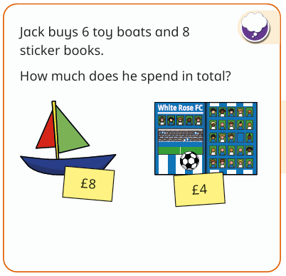  Now mark your answers.
  8 x 12 = 86 | 8 x 11 =
  2 x 8 = 12 | 8 x 4 =
  1 x 8 = 0 | 8 x 3 =

Maths Answers
Fluency answers:
40, 16, 72, 88, 8, 24, 32, 56, 64, 80, 48
Varied fluency answers:
2, 6, 9, 1, 7, 4, 5, 9, 11
Reasoning answers:
96, 16, 8, 88, 32, 24
£80
English Answers
Grammar and punctuation
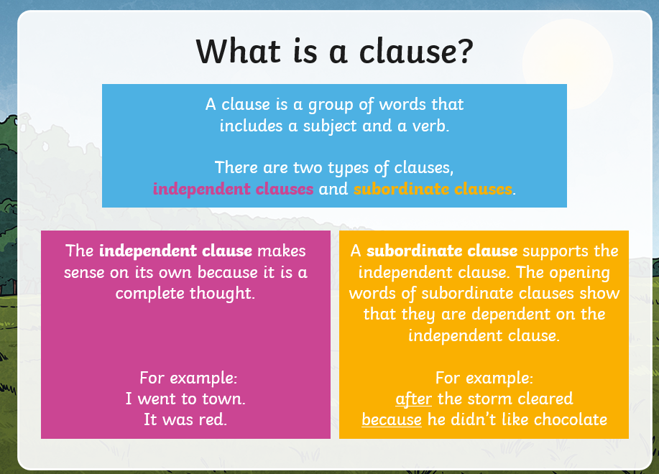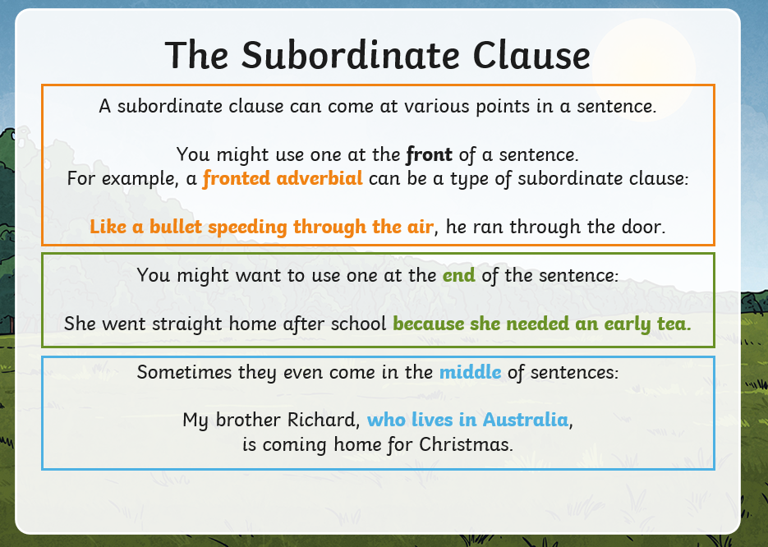

Jim plays in the park with his friends during school holidays and at the weekends.
Tim loves to draw and paint while his older sister completes her homework.
Bathtime is fun in my house because of all the toys and bubbles.
Before we have lunch, we learn about maths
The children, who had worked hard, had finished their sentences.

Reading Comprehension (wording may be different)
- What was the gladius used for? close fighting
- Why was the pilum designed to bend? so when it hit a shield, the enemy could not throw it back
- Name two pieces of armour Roman soldiers wore. A metal helmet or body armour made of metal strips or chain mail. They also carried a large curved shield called a scutum
- How did the scutum help soldiers work together? They could work together in tight formation.
- What do you think the equipment they had, tells us about Roman military success?
The Roman army was able to conquer and control large areas of land. They were organised and powerful which meant they were successful in battles.

.

